HW5

Задание 6

CREATE TABLE Patients

(

Id INT Primary key identity(1,1),

FirstName NVARCHAR(30),

LastName NVARCHAR(30) ,

SSN INT UNIQUE,

EMAIL AS CONCAT(UPPER(LEFT(FirstName,1)), LOWER(LEFT(LastName,3)),'@gmail.coml'),

TEMP DEC(3,1),

CreatedDate DATE

)

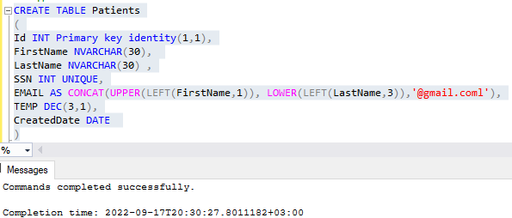

Задание 7

INSERT dbo.patients

VALUES ('Peter', 'Ivanov', 1, 36.6, CAST('2021-12-31' As DATE)),

('Richard', 'Pailo', 2, 39.2, CAST('2020-01-23' As DATE)),

('Nikitos', 'Staralsja', 3, 36.2, CAST('2022-02-23' as DATE)),

('Jora', 'Cust', 4, 37.3, CAST('2012-12-21' as DATE)),

('Nicolas', 'Cletka', 5, 38.8, CAST('2011-11-11' as DATE)),

('Viktor', 'Vihodkin', 6, 37.0, CAST('2022-12-22' as DATE)),

('Afrodita', 'Starshebogova', 7, 36.7, CAST('2022-03-02' as DATE))

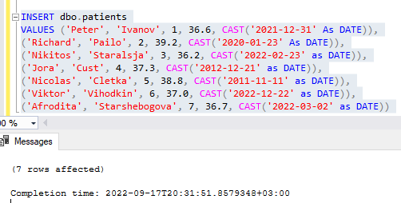

SELECT *

FROM dbo.Patients

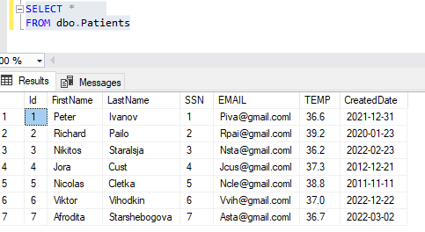

Задание 8

ALTER TABLE dbo.Patients

ADD TempType AS

CASE WHEN TEMP > 37 THEN '>37°C'

WHEN TEMP < 37 THEN '<37°C'

WHEN TEMP =37 THEN '=37°C'

END

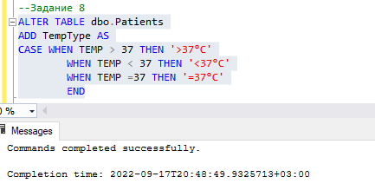

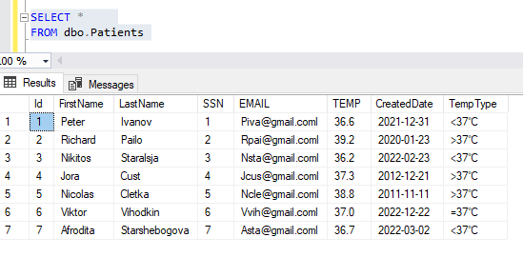

Задание 9

CREATE VIEW dbo.vPatients

AS

SELECT TEMP*(9/5)+32 as FarengheitTemp

From Dbo.Patients

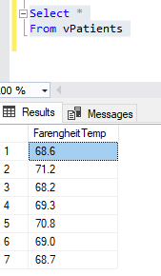

Задание 10

CREATE FUNCTION udfFarTemp(@TEMP DEC(3,1))

RETURNS DEC(3,1)

AS

BEGIN

RETURN @TEMP*(9/5)+32

END

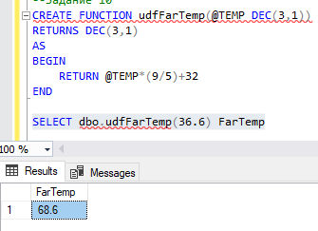

Задание 11

DECLARE @DAY1 DATE

DECLARE @Number_of_day INT

SET @Number_of_day = DATEPART(DW, DATEADD(DAY,1,EOMONTH(GETDATE(),-1)))

SET @DAY1 = DATEADD(DAY,1,EOMONTH(GETDATE(),-1))

SELECT @DAY1 as fist_day_of_mounth, @Number_of_day as Day_Number,

CASE

WHEN @Number_of_day >=5 THEN @DAY1

ELSE DATEADD(DAY,(7-@Number_of_day+1),@DAY1)

END as FirstWorkingDay

