Задание 2

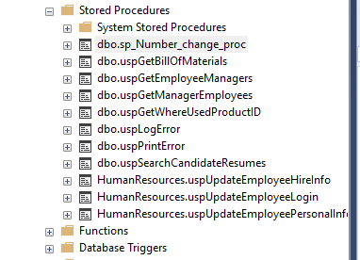

Задание 3

CREATE PROC sp_Number_change_proc

@BusinessEntityID INT,

@NationalIDNumber INT

AS

UPDATE HumanResources.Employee

SET NationalIDNumber= @NationalIDNumber

WHERE BusinessEntityID= @BusinessEntityID

DROP PROC sp_Number_change_proc

EXEC sp_Number_change_proc '15', '879341111'

SELECT NationalIDNumber

FROM HumanResources.Employee

WHERE BusinessEntityID=15

