6.

CREATE TABLE Person

([ID] INT IDENTITY (1,1),

[FirstNme] NVARCHAR(100),

[LasrName] NVARCHAR(100),

[SSN] uniqueidentifier,

[Email] AS (UPPER(LEFT ([FirstNme],1))+LOWER(LEFT([LasrName],3))+'@mail.com'),

[TEMP] FLOAT,

[CreatedDate] DATE)

7.

INSERT INTO dbo.Person ([FirstNme], [LasrName], [TEMP], [CreatedDate])

VALUES ('Karyna', 'Holubeva', '36.5', '2022-09-14'), ('Artyom', 'Kharlap', '36.3', '2022-09-13')

8.

ALTER TABLE dbo.Person

ADD TempType AS CASE WHEN [TEMP] <37 THEN '<37°C'

WHEN [TEMP] >37 THEN '>37°C'

END

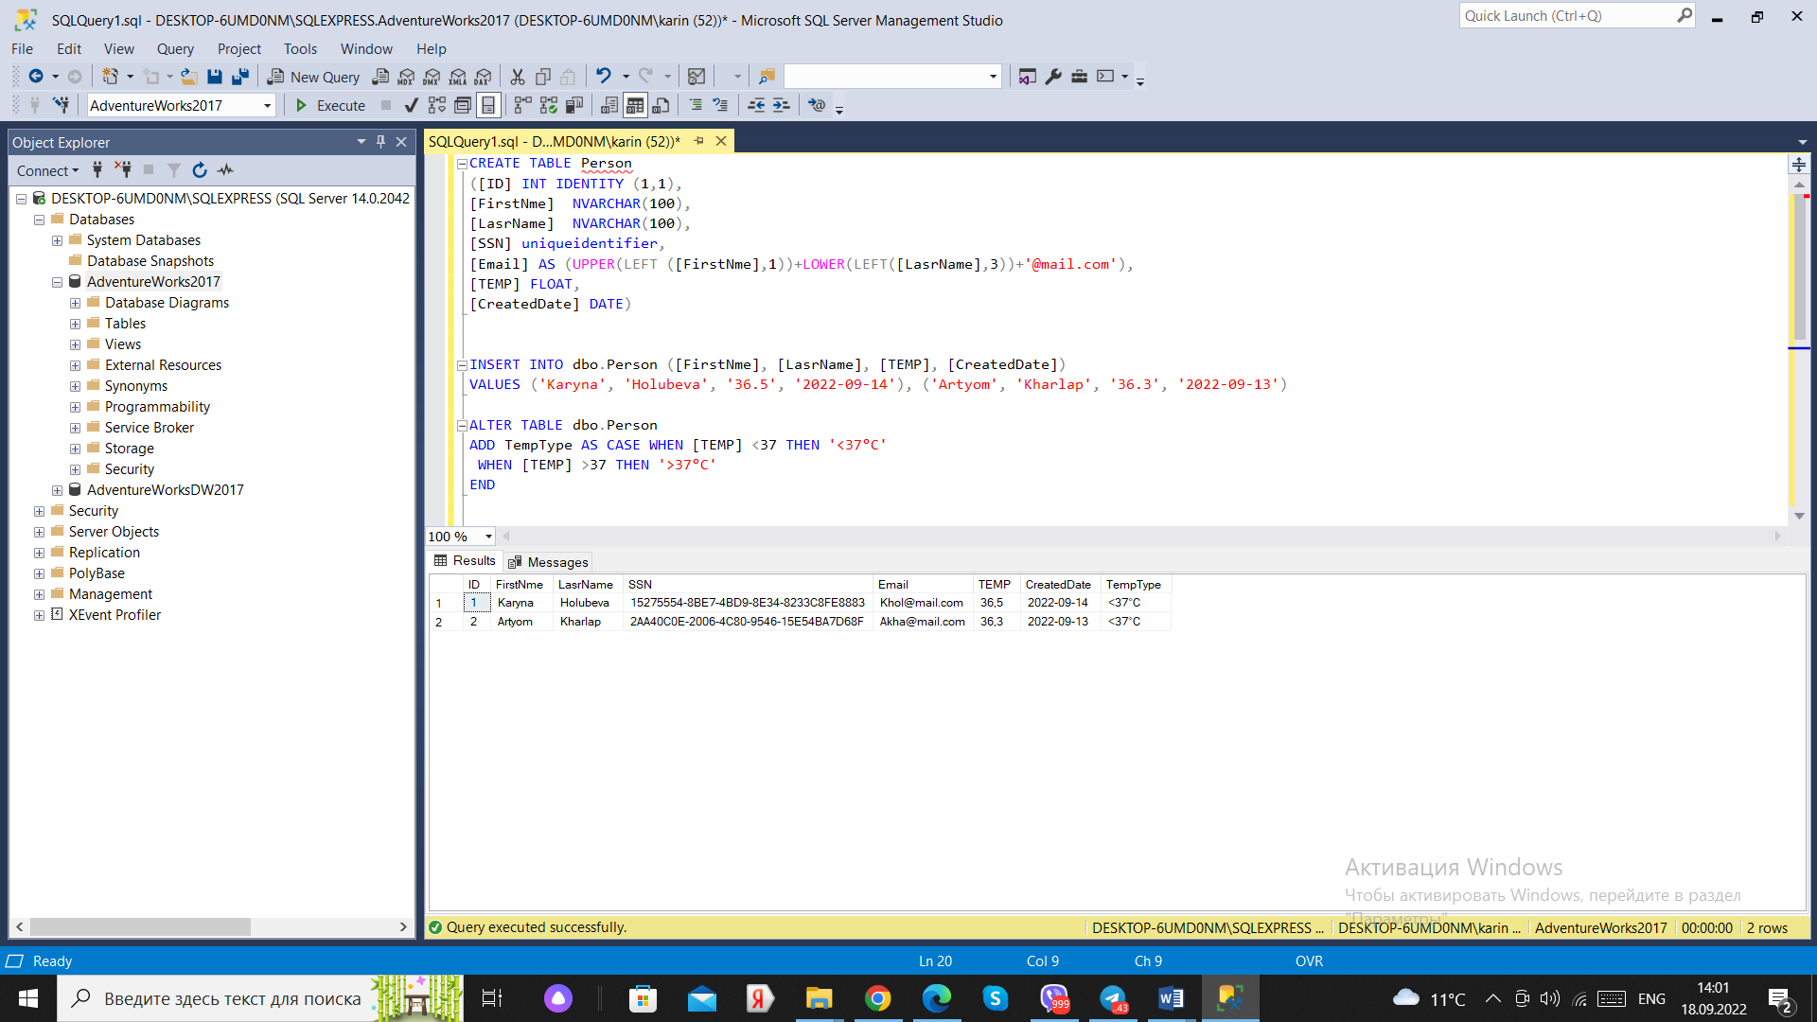

9.

CREATE VIEW Patients_v

AS SELECT [FirstNme], [LasrName], ([TEMP]*9/5+32) AS FAHRENHEIT

FROM dbo.Person

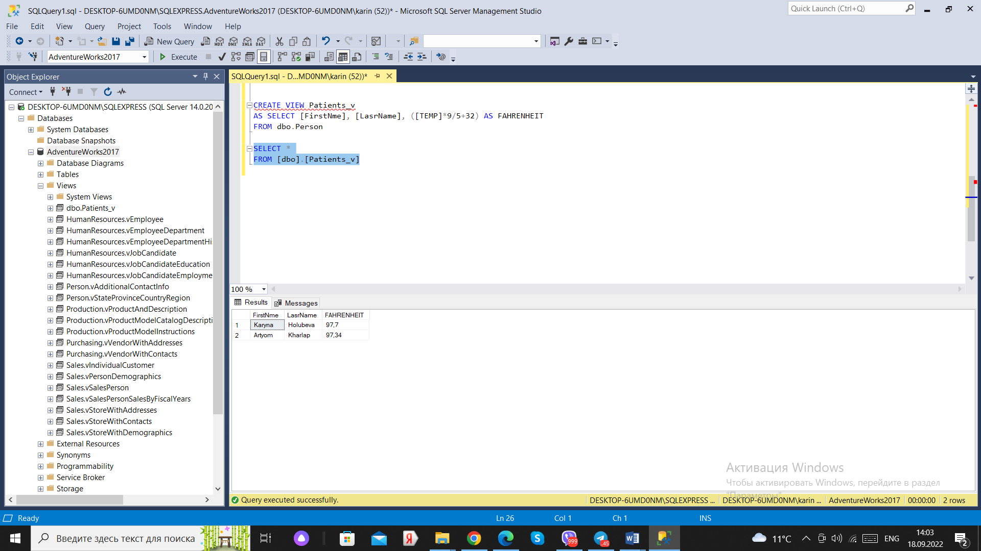

10.

CREATE FUNCTION udfFAHRENHEIT

(@TEMP DEC(5,2))

RETURNS DEC (5,2)

AS

BEGIN RETURN @TEMP*9/5+32

END

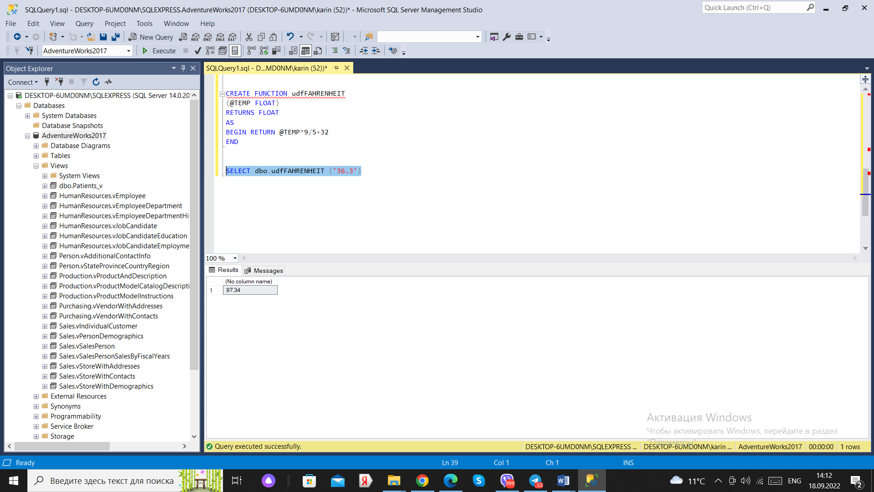

11.

DECLARE @FirstDayOfMonth DATE

SET @FirstDayOfMonth=DATEADD(DAY, 1, EOMONTH(GETDATE(), -1))

SELECT @FirstDayOfMonth AS first_day_of_month,

DATEPART(DW, @FirstDayOfMonth) AS [it's number],

CASE WHEN DATEPART(DW, @FirstDayOfMonth)<=5

THEN @FirstDayOfMonth

ELSE DATEADD(DAY, (7-DATEPART(DW, @FirstDayOfMonth)+1), @FirstDayOfMonth)

END AS first_working_day