2

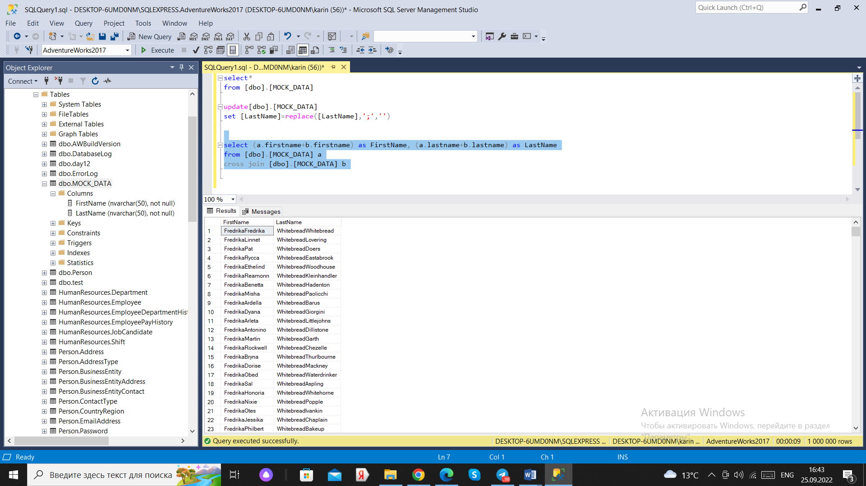

3.

When can we use this structure?

When we have many subqueries.

How is it different from a subquery?

More readable in queries with a subquery. C assigns a name to the subquery, so you don't have to rewrite the subquery each time, you can only write the name.