Задание 1
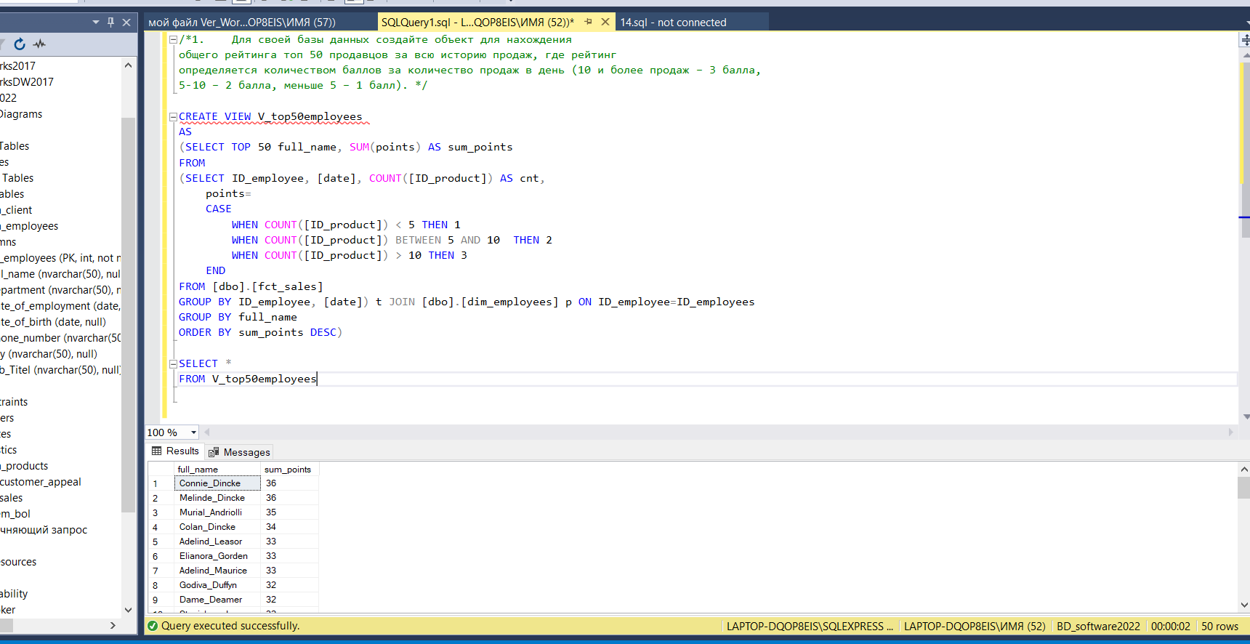

Задание 2
A
-No need for shadow
-Getting rid of the legend
-One color is enough to confirm the difference in calories
-Background color interfered with perception

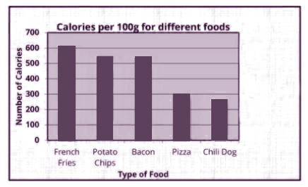
b
-The figure of the cone is not the best solution
-False data is used. У-axis does not start at 0

C
-Use different font
-Not informative. It is not clear what exactly this report should disclose.
-I would like to see the designation of the columns horizontally

