-- hw11

--task3)

|  |
| --- |
| Пробовала написать код, чтобы было коротко, но код выполняется непозволительно долго (не могу дождаться окончания), вроде, нет бесконечного цикла. Поэтому пошла по долгому пути.  DECLARE @ColumnName AS NVARCHAR(50) = 'Alex';  DECLARE @TestCount AS INT = 1;  WHILE @TestCount < 10  IF @TestCount = 2 SET @ColumnName = 'Barbara'  IF @TestCount = 3 SET @ColumnName = 'Chris'  IF @TestCount = 4 SET @ColumnName = 'Donna'  IF @TestCount = 5 SET @ColumnName = 'Elton'  IF @TestCount = 6 SET @ColumnName = 'Fred'  IF @TestCount = 7 SET @ColumnName = 'George'  IF @TestCount = 8 SET @ColumnName = 'Harry'  IF @TestCount = 9 SET @ColumnName = 'Irys'  BEGIN  MERGE [dbo].[TotalTable] AS target  USING (SELECT @ColumnName AS Function_name  FROM [dbo].[data_for_merge])  AS source  ON (target.Function_name = source.Function_name)  WHEN MATCHED THEN  UPDATE SET [Function_count] += 1  WHEN NOT MATCHED AND source.Function_name IS NOT NULL THEN  INSERT ([Function_name], [Function_count])  VALUES (Function_name, 1);  SET @TestCount += 1  END |

Пока сделала слишком топорно, но результат получен:

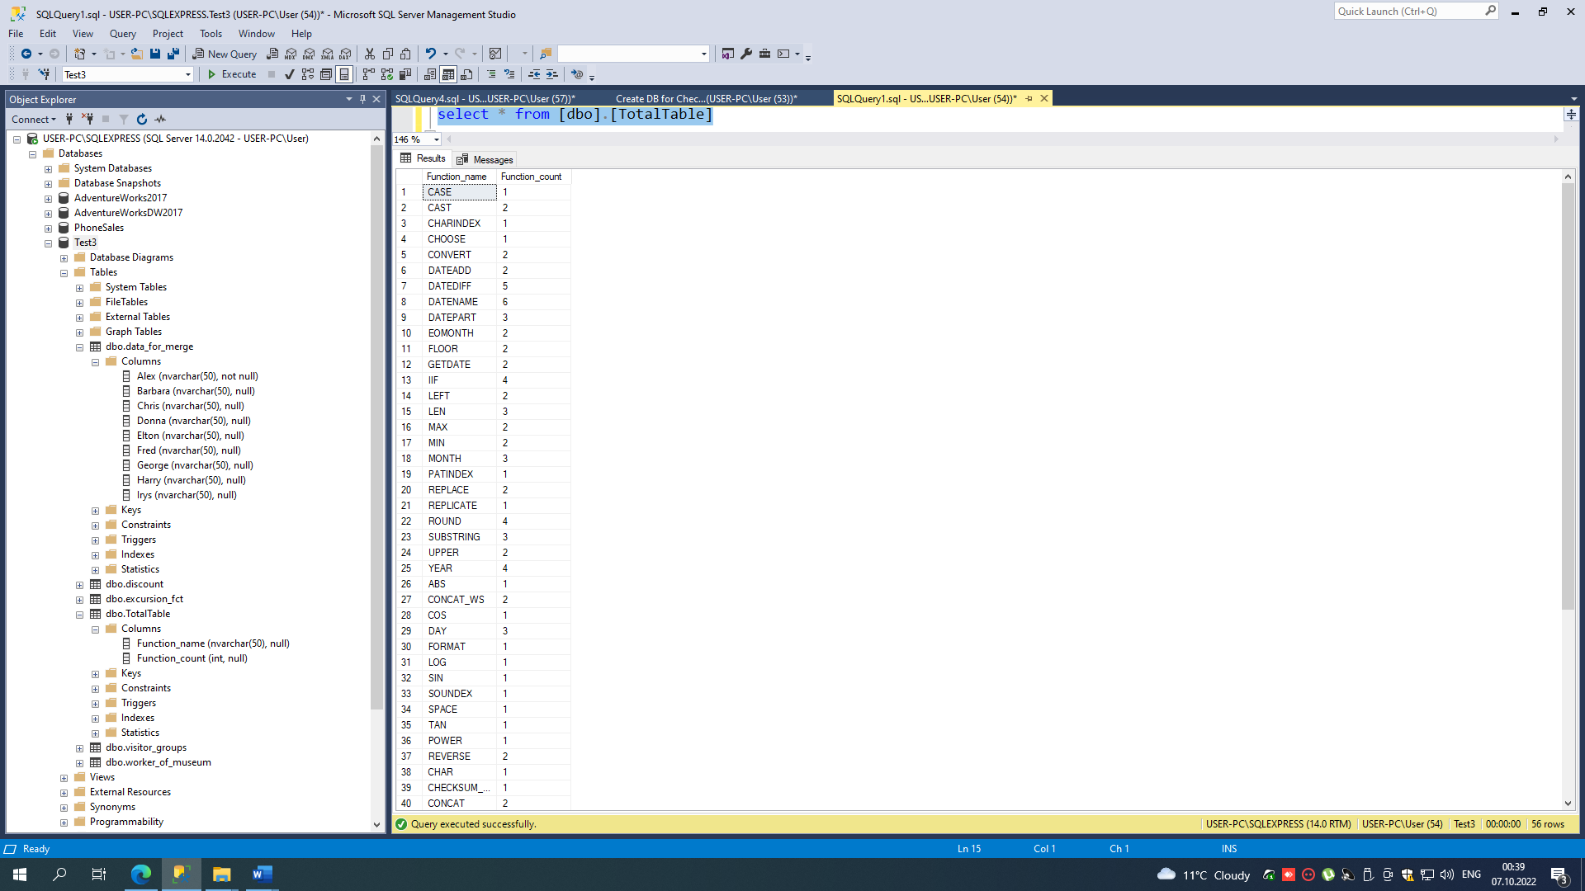

MERGE [dbo].[TotalTable] AS target

USING (SELECT Alex AS Function_name

FROM [dbo].[data_for_merge])

AS source

ON (target.Function_name = source.Function_name)

WHEN MATCHED THEN

UPDATE SET [Function_count] += 1

WHEN NOT MATCHED THEN

INSERT ([Function_name], [Function_count])

VALUES (Function_name, 1);

MERGE [dbo].[TotalTable] AS target

USING (SELECT [Barbara] AS Function_name

FROM [dbo].[data_for_merge])

AS source

ON (target.Function_name = source.Function_name)

WHEN MATCHED THEN

UPDATE SET [Function_count] += 1

WHEN NOT MATCHED AND source.Function_name IS NOT NULL THEN

INSERT ([Function_name], [Function_count])

VALUES (Function_name, 1);

MERGE [dbo].[TotalTable] AS target

USING (SELECT [Chris] AS Function_name

FROM [dbo].[data_for_merge])

AS source

ON (target.Function_name = source.Function_name)

WHEN MATCHED THEN

UPDATE SET [Function_count] += 1

WHEN NOT MATCHED AND source.Function_name IS NOT NULL THEN

INSERT ([Function_name], [Function_count])

VALUES (Function_name, 1);

MERGE [dbo].[TotalTable] AS target

USING (SELECT [Donna] AS Function_name

FROM [dbo].[data_for_merge])

AS source

ON (target.Function_name = source.Function_name)

WHEN MATCHED THEN

UPDATE SET [Function_count] += 1

WHEN NOT MATCHED AND source.Function_name IS NOT NULL THEN

INSERT ([Function_name], [Function_count])

VALUES (Function_name, 1);

MERGE [dbo].[TotalTable] AS target

USING (SELECT [Elton] AS Function_name

FROM [dbo].[data_for_merge])

AS source

ON (target.Function_name = source.Function_name)

WHEN MATCHED THEN

UPDATE SET [Function_count] += 1

WHEN NOT MATCHED AND source.Function_name IS NOT NULL THEN

INSERT ([Function_name], [Function_count])

VALUES (Function_name, 1);

MERGE [dbo].[TotalTable] AS target

USING (SELECT [Fred] AS Function_name

FROM [dbo].[data_for_merge])

AS source

ON (target.Function_name = source.Function_name)

WHEN MATCHED THEN

UPDATE SET [Function_count] += 1

WHEN NOT MATCHED AND source.Function_name IS NOT NULL THEN

INSERT ([Function_name], [Function_count])

VALUES (Function_name, 1);

MERGE [dbo].[TotalTable] AS target

USING (SELECT [George] AS Function_name

FROM [dbo].[data_for_merge])

AS source

ON (target.Function_name = source.Function_name)

WHEN MATCHED THEN

UPDATE SET [Function_count] += 1

WHEN NOT MATCHED AND source.Function_name IS NOT NULL THEN

INSERT ([Function_name], [Function_count])

VALUES (Function_name, 1);

MERGE [dbo].[TotalTable] AS target

USING (SELECT [Harry] AS Function_name

FROM [dbo].[data_for_merge])

AS source

ON (target.Function_name = source.Function_name)

WHEN MATCHED THEN

UPDATE SET [Function_count] += 1

WHEN NOT MATCHED AND source.Function_name IS NOT NULL THEN

INSERT ([Function_name], [Function_count])

VALUES (Function_name, 1);

MERGE [dbo].[TotalTable] AS target

USING (SELECT [Irys] AS Function_name

FROM [dbo].[data_for_merge])

AS source

ON (target.Function_name = source.Function_name)

WHEN MATCHED THEN

UPDATE SET [Function_count] += 1

WHEN NOT MATCHED AND source.Function_name IS NOT NULL THEN

INSERT ([Function_name], [Function_count])

VALUES (Function_name, 1);