-- hw3

--task2 a)

SELECT Name,

CASE

WHEN StandardCost = 0 OR StandardCost IS NULL THEN 'Not for sale'

WHEN StandardCost > 0 AND StandardCost < 100 THEN '<$100'

WHEN StandardCost >= 100 AND StandardCost < 500 THEN '<$500'

ELSE '>=$500'

END AS PriceRange

FROM Production.Product

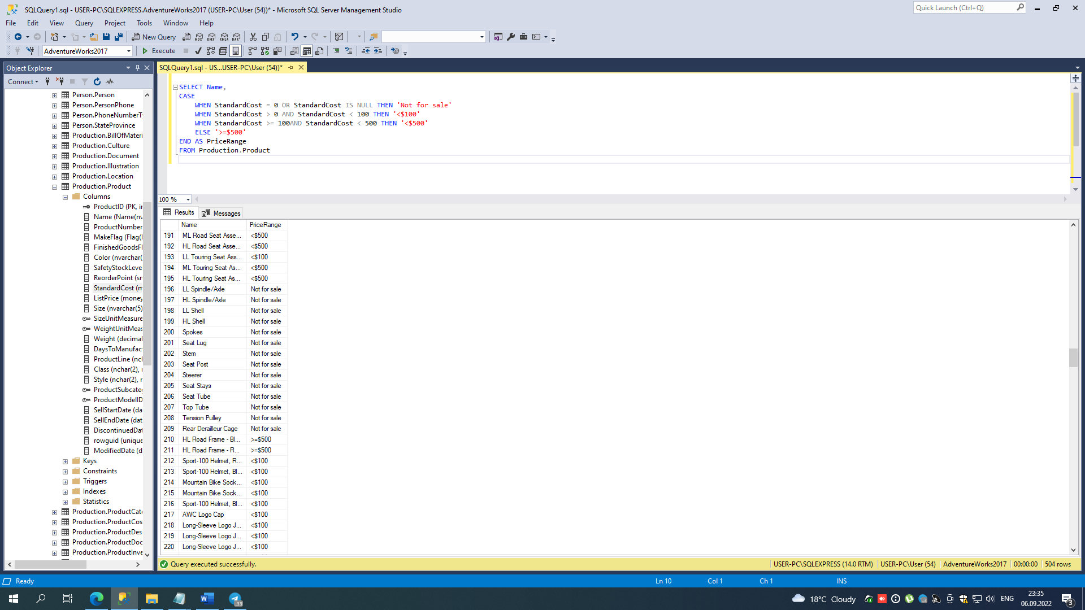

--task2 b)

SELECT p.ProductID, p.BusinessEntityID, v.Name

FROM Purchasing.ProductVendor p JOIN Purchasing.Vendor v

ON p.BusinessEntityID = v.BusinessEntityID

WHERE p.StandardPrice > $10 AND (v.Name LIKE '%x%' OR v.Name LIKE 'N%')

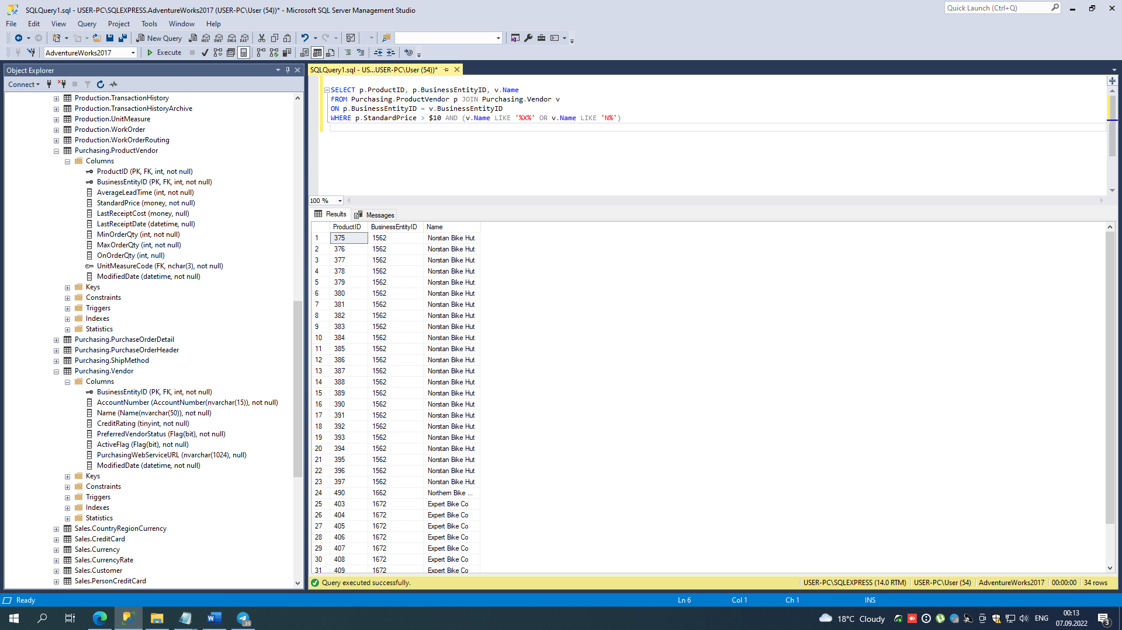

--task2 c)

SELECT Name

FROM Purchasing.Vendor v LEFT JOIN Purchasing.ProductVendor p

ON p.BusinessEntityID = v.BusinessEntityID

WHERE p.BusinessEntityID IS NULL

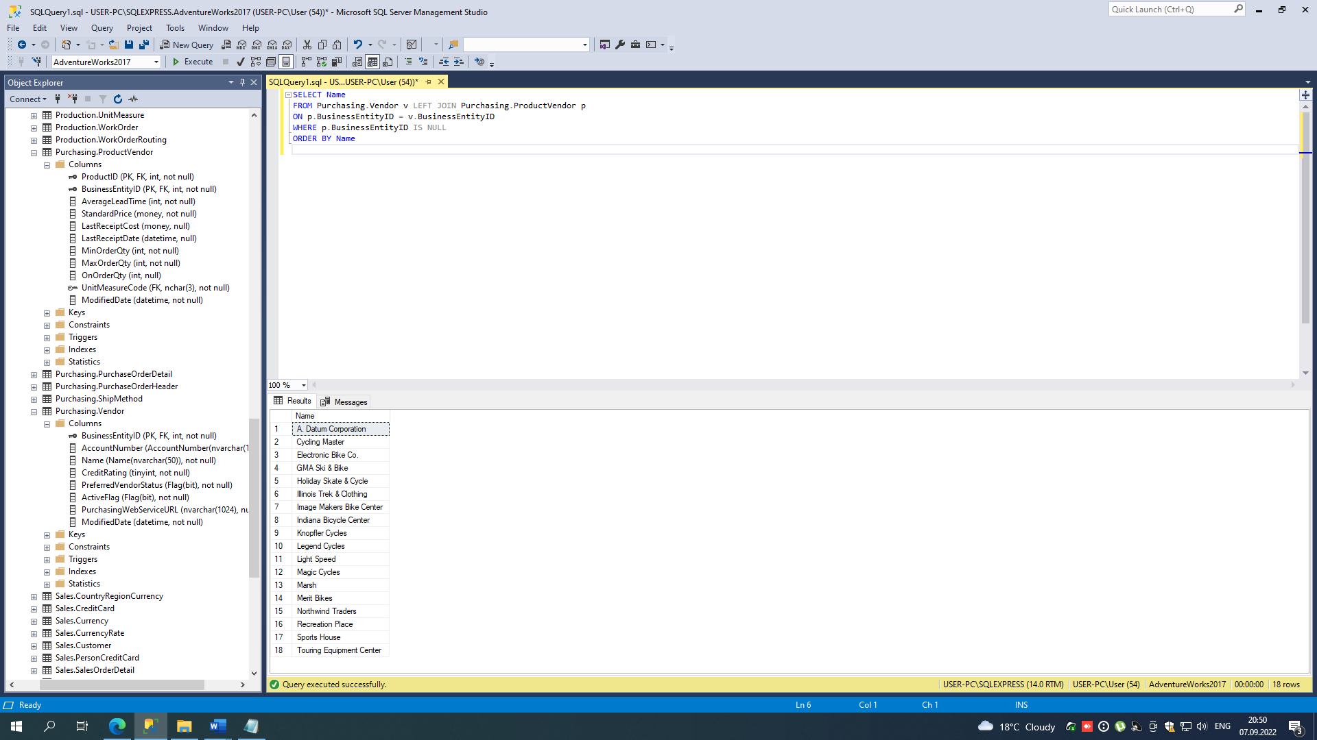

SELECT Name

FROM Purchasing.Vendor

EXCEPT

SELECT v.Name

FROM

Purchasing.ProductVendor p JOIN Purchasing.Vendor v

ON p.BusinessEntityID = v.BusinessEntityID

