-- hw3

--task3 a)

SELECT p.Name, p.ListPrice

FROM Production.Product p JOIN Production.ProductModel m

ON p.ProductModelID = m.ProductModelID

WHERE m.Name LIKE 'LL%'

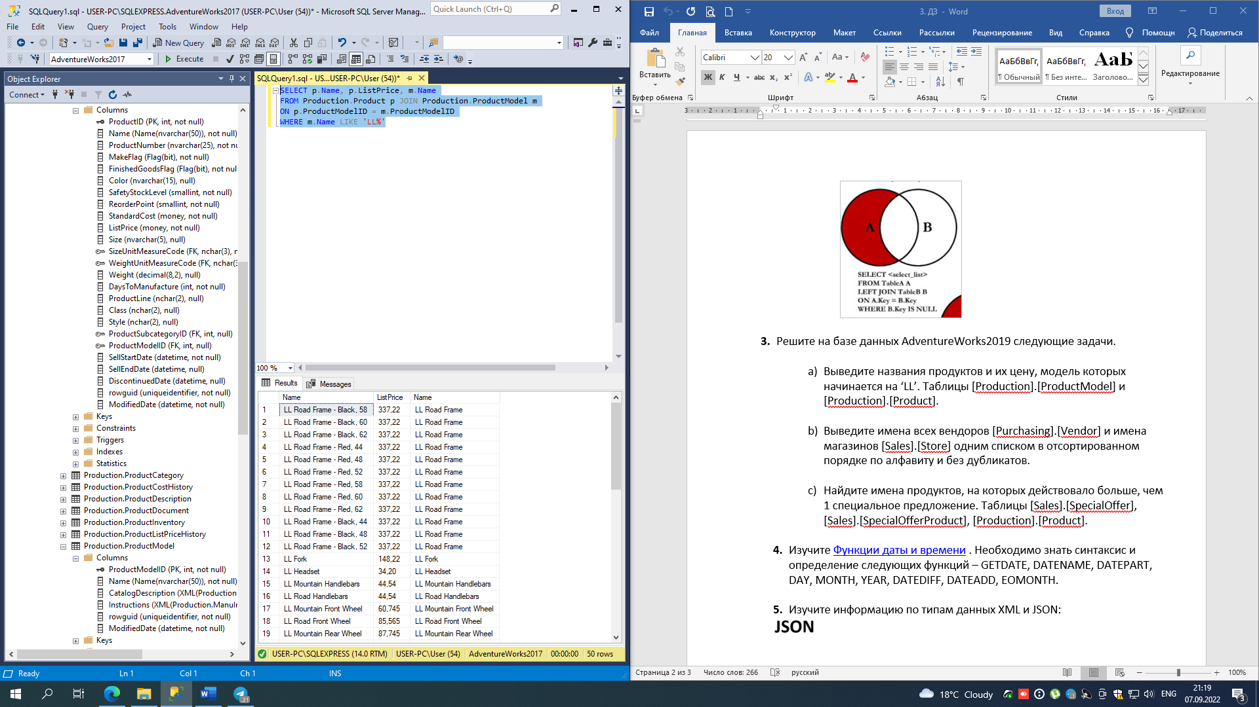

--task3 b)

SELECT Name

FROM Purchasing.Vendor

UNION

SELECT Name

FROM Sales.Store

ORDER BY Name

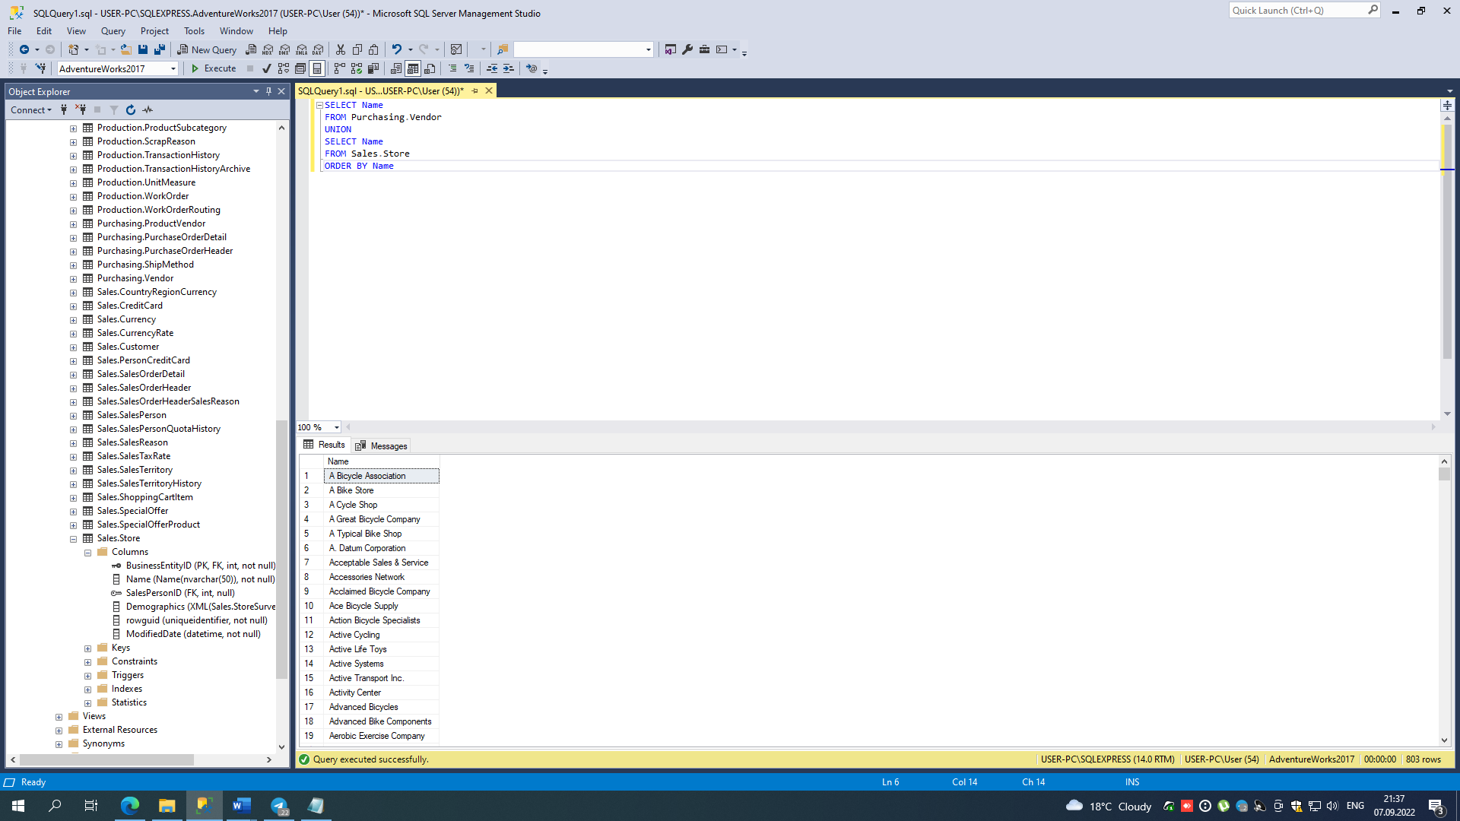

--task3 c)

SELECT Name

FROM Production.Product

WHERE ProductID IN (

SELECT ProductID

FROM Sales.SpecialOfferProduct s JOIN Sales.SpecialOffer o

ON s.SpecialOfferID = o.SpecialOfferID

WHERE o.DiscountPct > 0

GROUP BY ProductID

HAVING Count(1) > 1

)

