-- hw4

--task3)

Оконные функции Row Number, Rank и Dense Rank вернут одинаковый результат, если в поле таблицы нет повторений (все значения уникальны), например:

*SELECT price, ROW_NUMBER() OVER(ORDER BY price) rn,*

*RANK() OVER(ORDER BY price) r,*

*DENSE_RANK() OVER(ORDER BY price) dr*

*FROM table*

*ORDER BE price*

|  |  |  |  |
| --- | --- | --- | --- |
| **price** | **rn** | **r** | **dr** |
| 25 | 1 | 1 | 1 |
| 30 | 2 | 2 | 2 |
| 32 | 3 | 3 | 3 |
| 459 | 4 | 4 | 4 |
| 1052 | 5 | 5 | 5 |
| 2548 | 6 | 6 | 6 |

--task4 a)

D таблице Production.UnitMeasure нет UnitMeasureCode, начинающиеся на букву ‘Т’

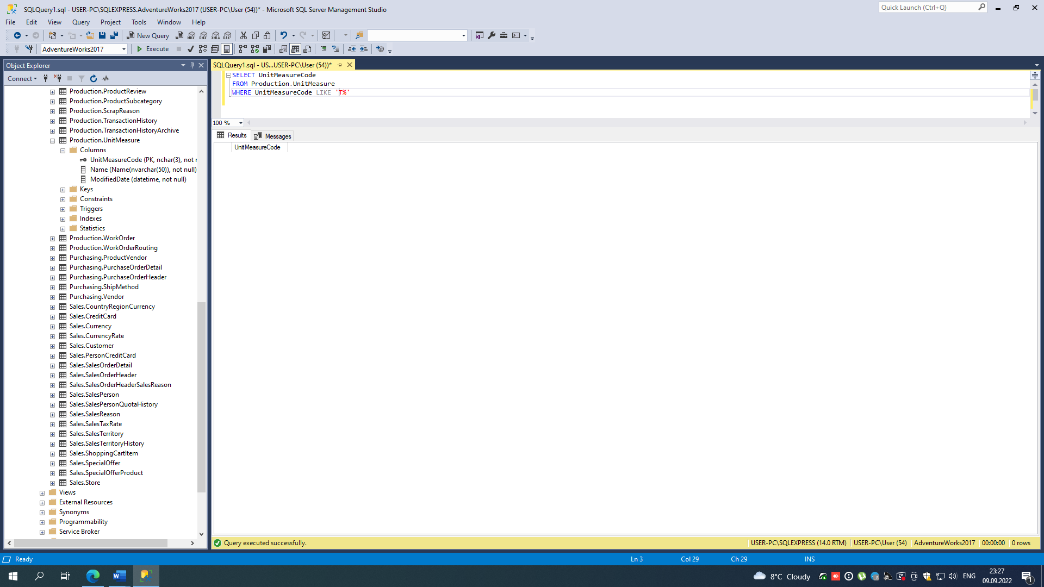

Всего 38 различных кодов:

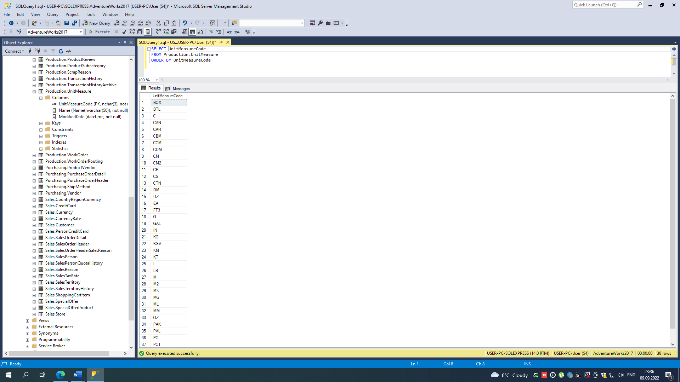

INSERT INTO Production.UnitMeasure

VALUES ('TT1', 'Test 1', '2020-09-09'),

('TT2', 'Test 2', GETDATE())

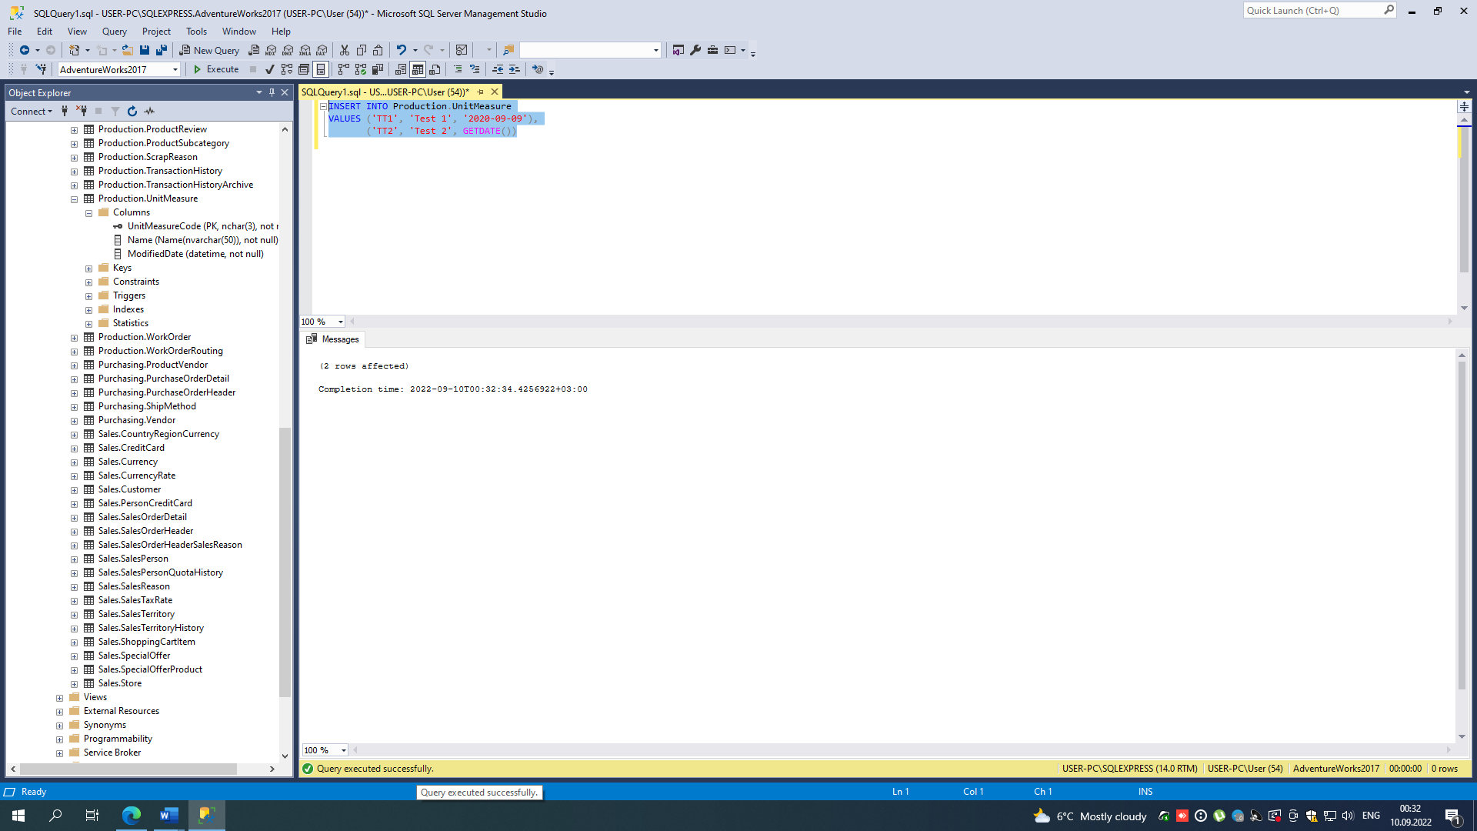

SELECT COUNT(1) AS code

FROM Production.UnitMeasure

WHERE UnitMeasureCode LIKE 'T%'

SELECT *

FROM Production.UnitMeasure

WHERE UnitMeasureCode LIKE 'T%'

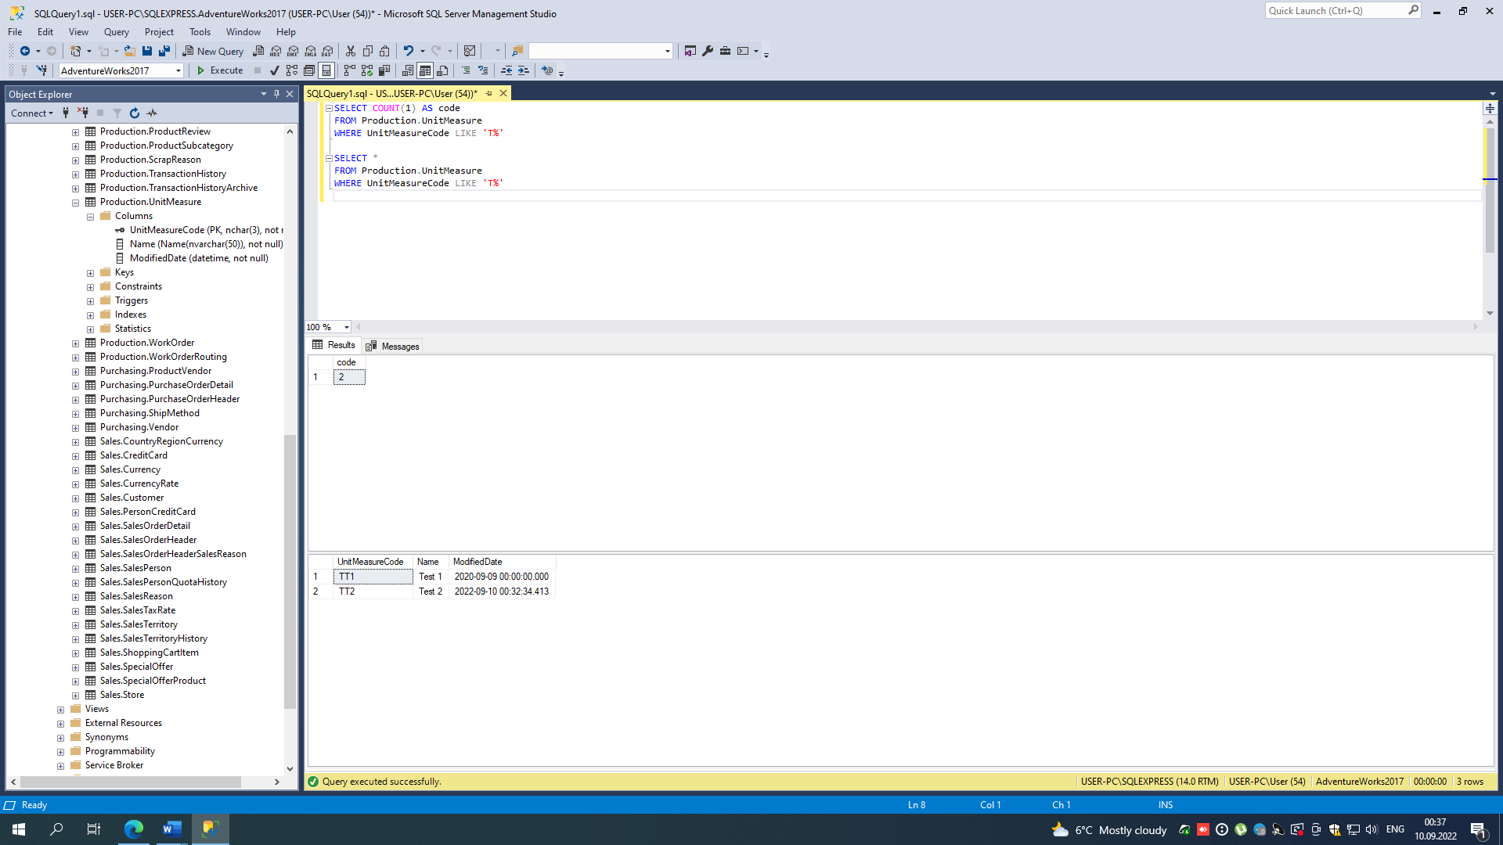

--task4 b)

SELECT *

INTO Production.UnitMeasureTest

FROM Production.UnitMeasure

WHERE UnitMeasureCode LIKE 'T%' OR UnitMeasureCode = 'CAN'

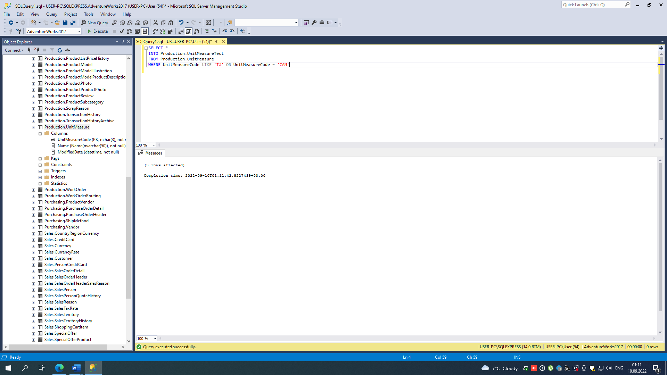

SELECT *

FROM Production.UnitMeasureTest

ORDER BY UnitMeasureCode

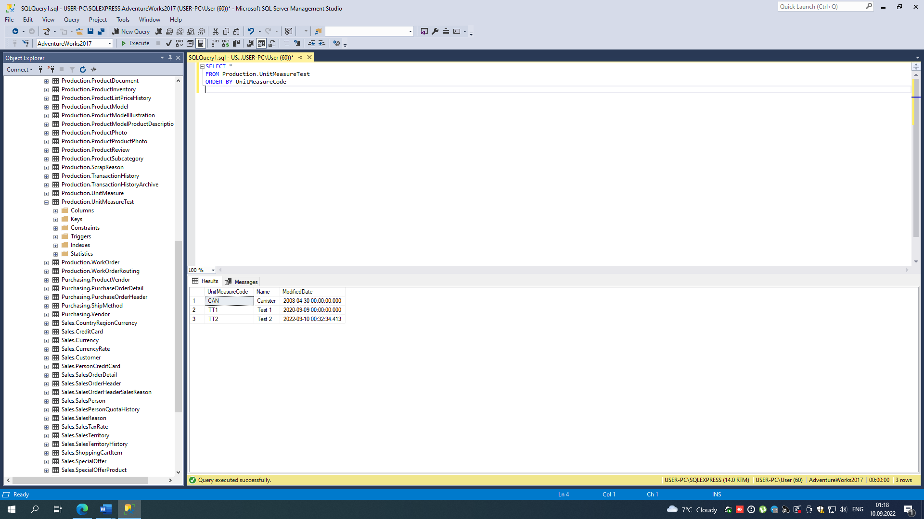

--task4 c)

UPDATE Production.UnitMeasureTest

SET UnitMeasureCode = 'TTT'

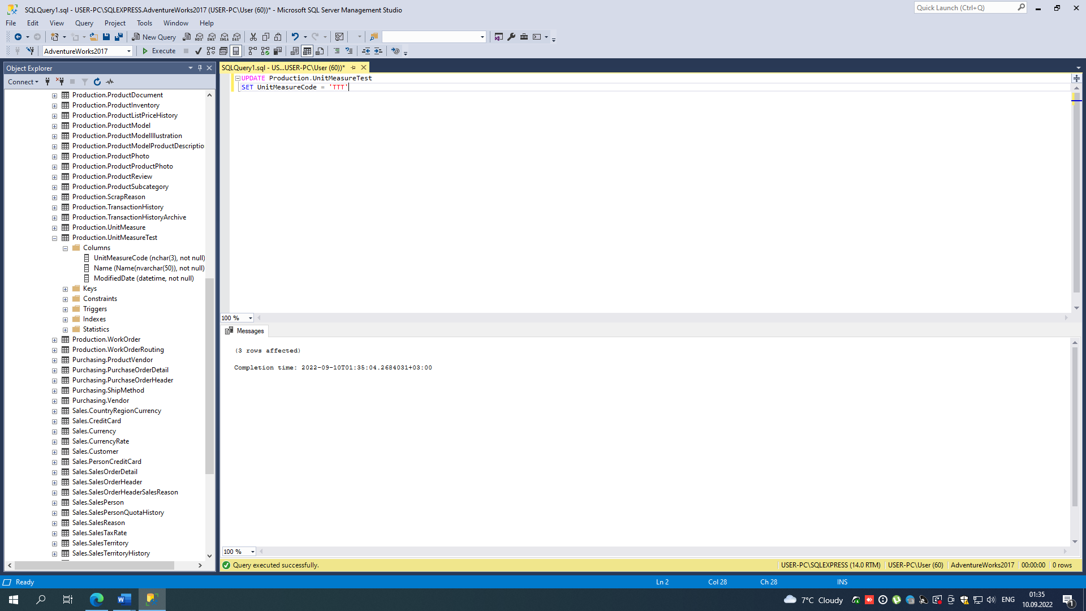

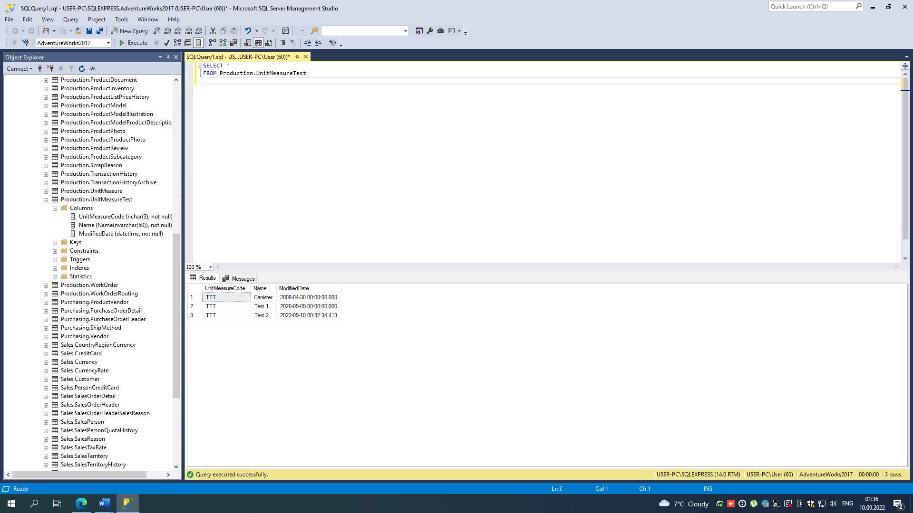

--task4 d)

DELETE FROM Production.UnitMeasureTest

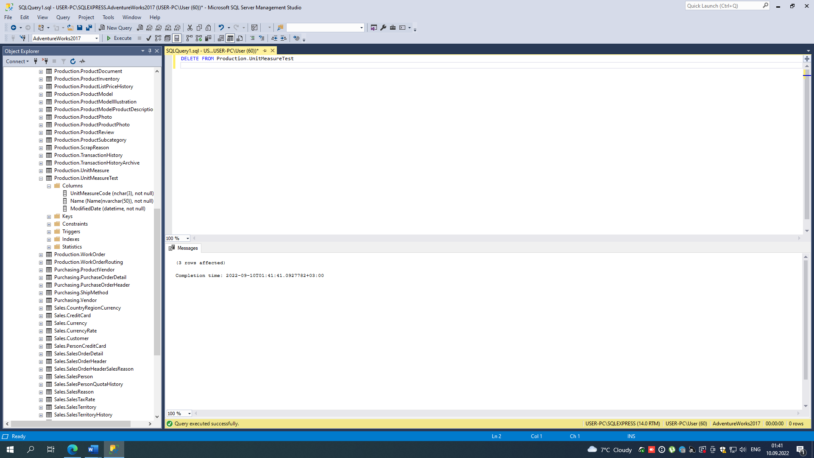

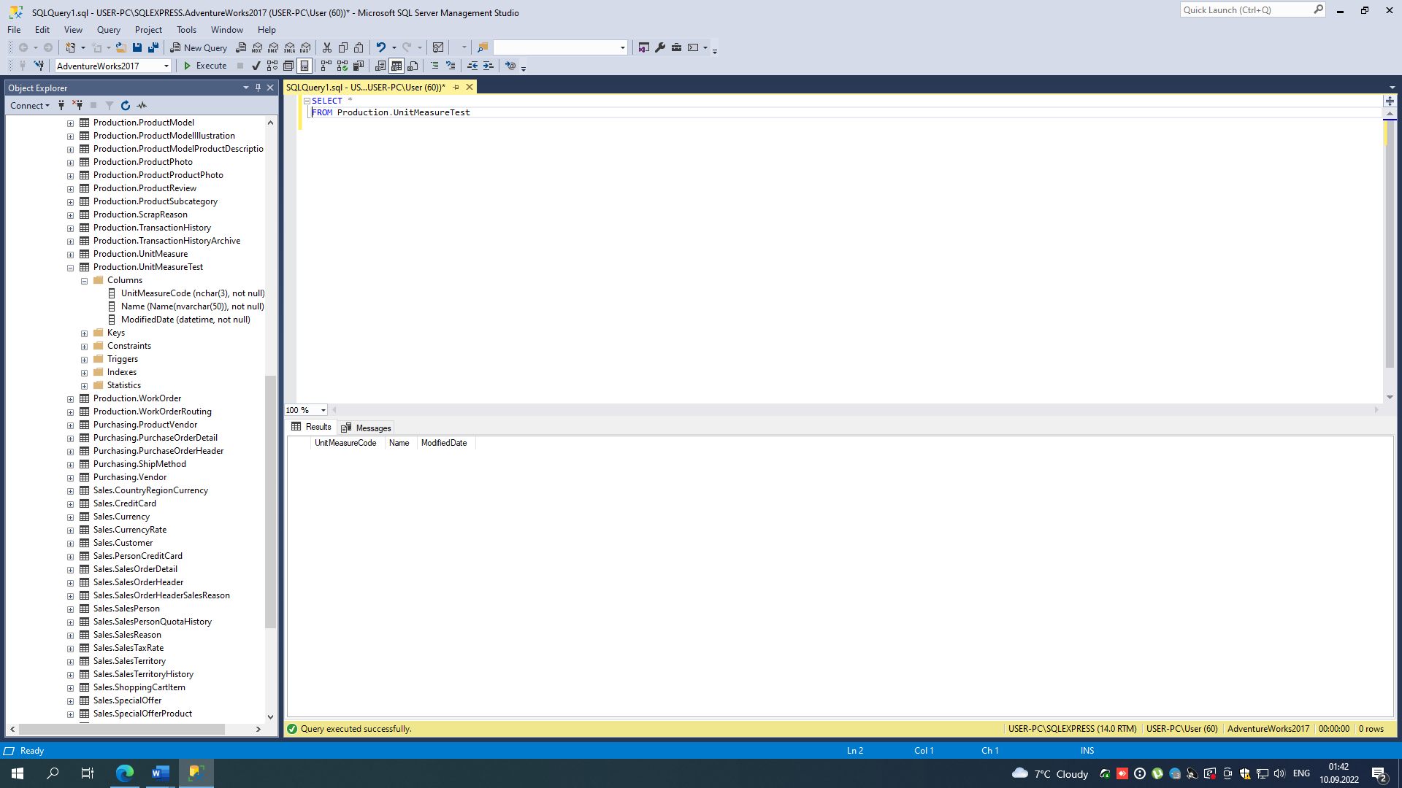

--task4 e)

SELECT DISTINCT SalesOrderID, MAX(LineTotal) OVER(PARTITION BY SalesOrderID) AS max,

MIN(LineTotal) OVER(PARTITION BY SalesOrderID) AS min,

AVG(LineTotal) OVER(PARTITION BY SalesOrderID) AS avg

FROM Sales.SalesOrderDetail

WHERE SalesOrderID = 43659 OR SalesOrderID = 43664

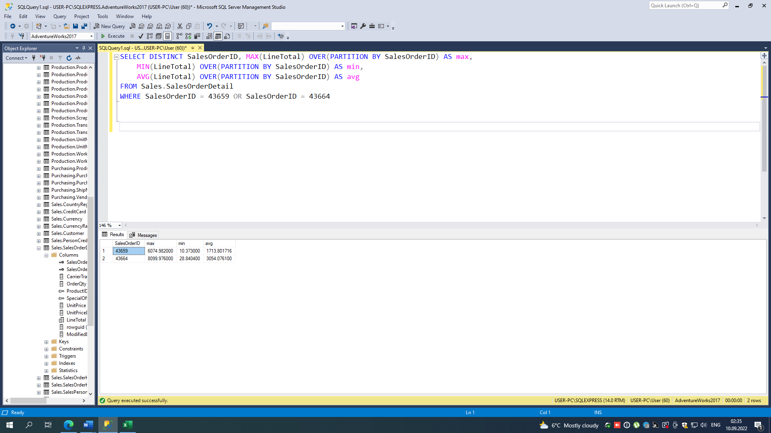

--task4 f)

SELECT FirstName, SalesYTD, SalesLastYear,

CONCAT(UPPER(LEFT(LastName, 3)), 'login', TerritoryGroup) AS login,

DENSE_RANK() OVER(ORDER BY SalesYTD DESC) AS rankYTD,

DENSE_RANK() OVER(ORDER BY SalesLastYear DESC) AS rankLY

From Sales.vSalesPerson

Рейтинг возглавляет Linda:

SELECT TOP 1 FirstName,

CONCAT(UPPER(LEFT(LastName, 3)), 'login', TerritoryGroup) AS login,

DENSE_RANK() OVER(ORDER BY SalesYTD DESC) AS rankYTD

From Sales.vSalesPerson

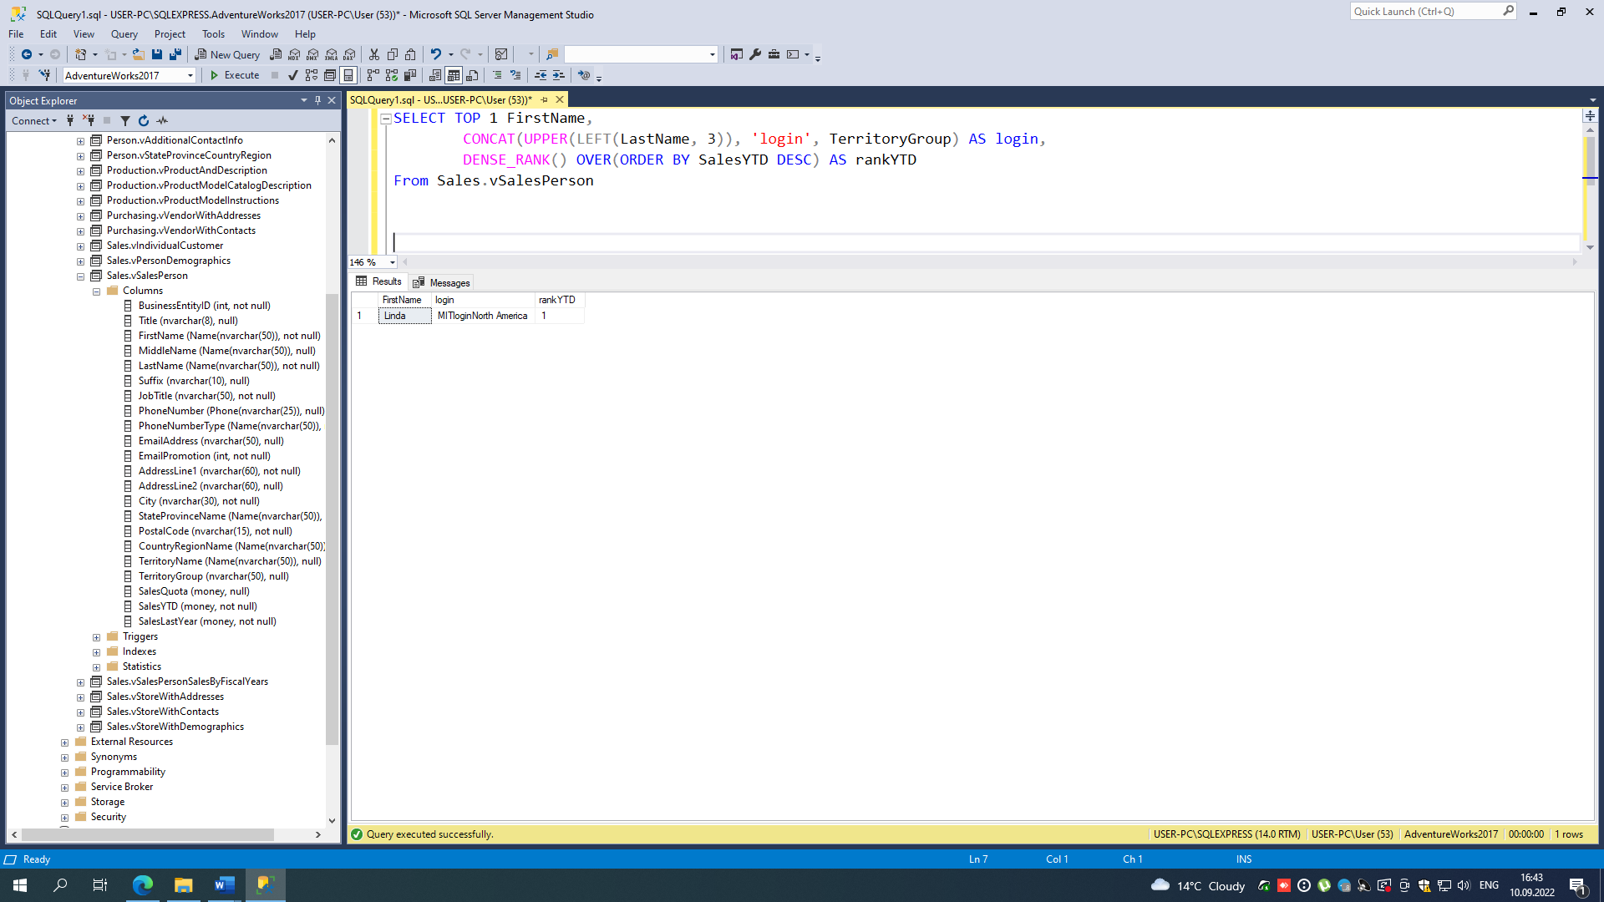

А в прошлом году рейтинг возглавлял Ranjit:

SELECT TOP 1 FirstName,

CONCAT(UPPER(LEFT(LastName, 3)), 'login', TerritoryGroup) AS login,

DENSE_RANK() OVER(ORDER BY SalesLastYear DESC) AS rankLY

From Sales.vSalesPerson

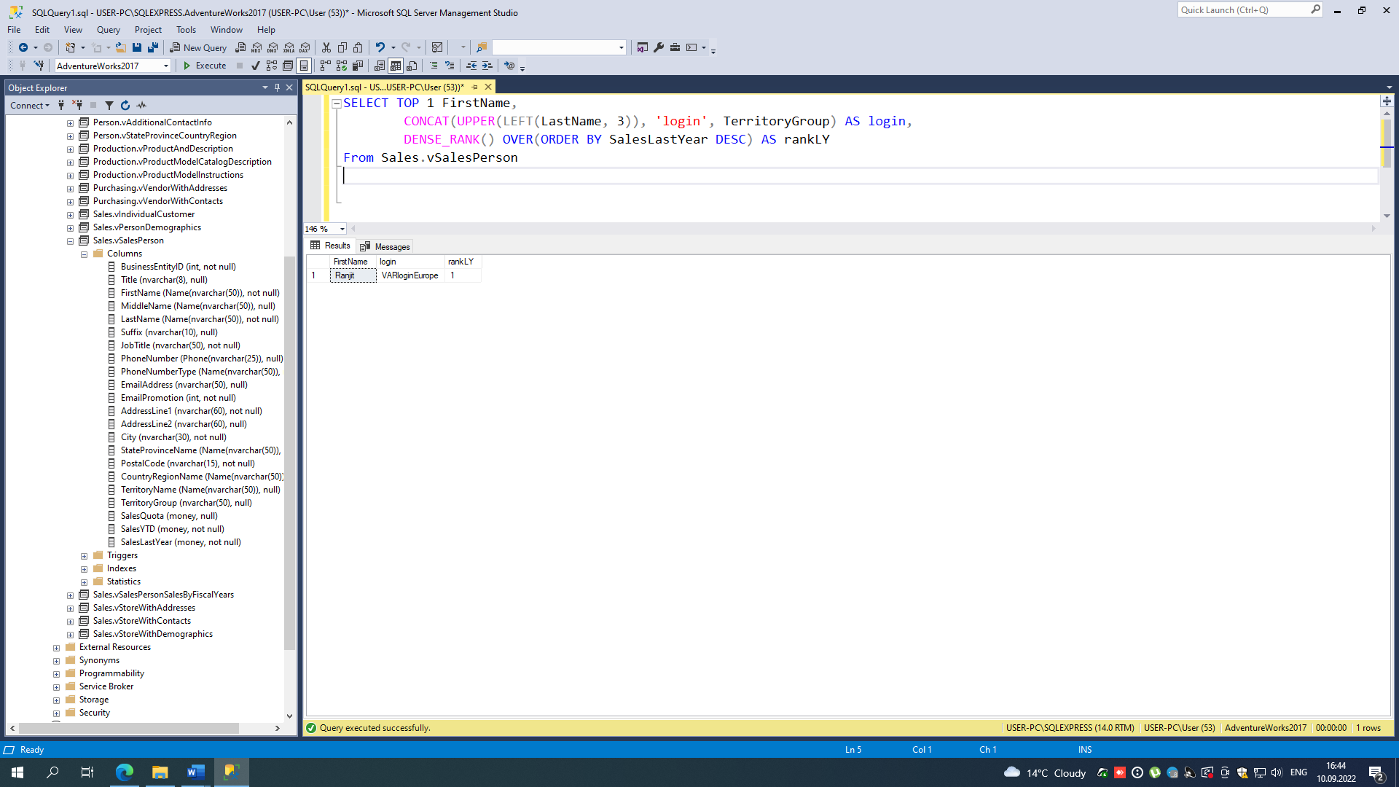

SELECT TOP 1 FirstName,

CONCAT(UPPER(LEFT(LastName, 3)), 'login', TerritoryGroup) AS login,

DENSE_RANK() OVER(ORDER BY SalesYTD DESC) AS rankLY,

'First place this year' AS comment

From Sales.vSalesPerson

UNION

SELECT TOP 1 FirstName,

CONCAT(UPPER(LEFT(LastName, 3)), 'login', TerritoryGroup) AS login,

DENSE_RANK() OVER(ORDER BY SalesLastYear DESC) AS rankLY,

'First place last year' AS comment

From Sales.vSalesPerson

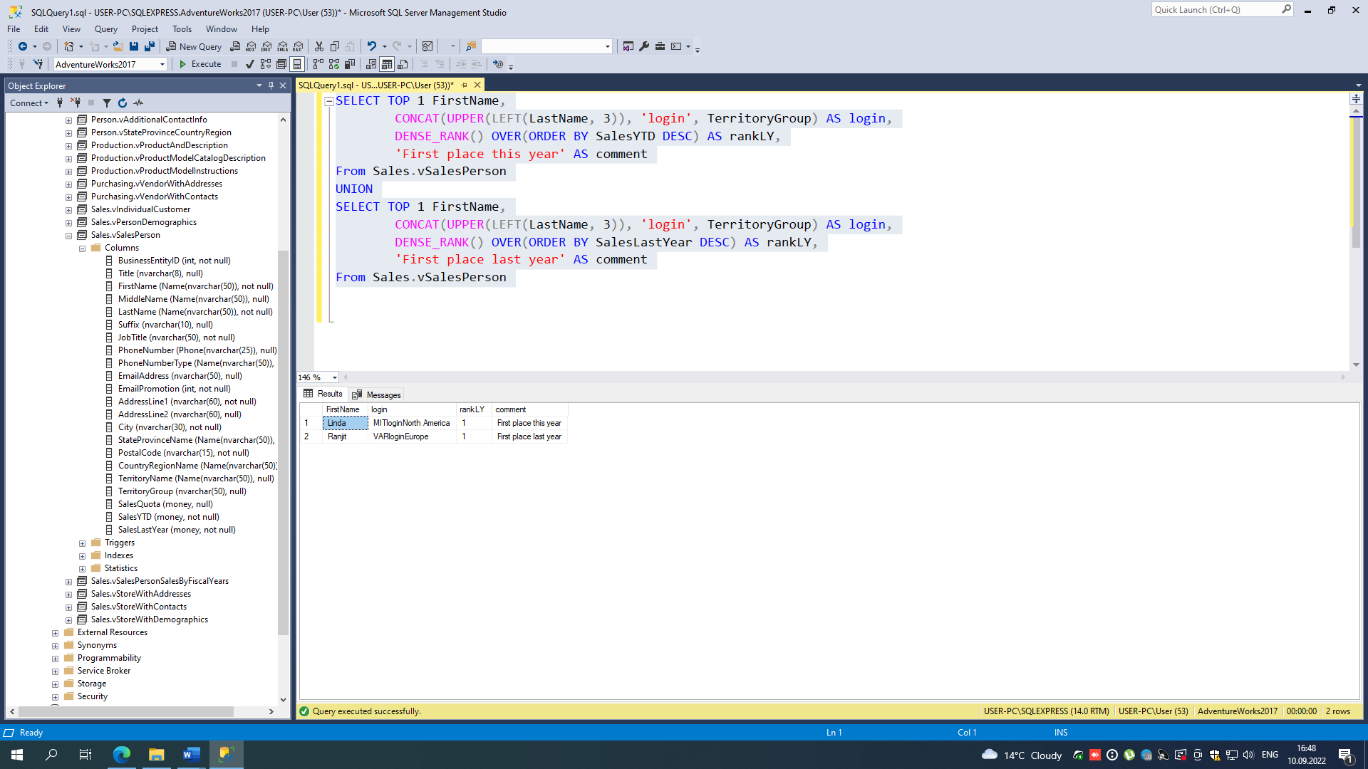

--task4 g)

SELECT

CASE DATENAME(dw, CONCAT(DATEPART(yyyy, GETDATE()), '-', DATEPART(mm, GETDATE()), '-1'))

WHEN 'Saturday' THEN CONCAT('3 ', DATENAME(mm, GETDATE()), '', DATEPART(yyyy, GETDATE()))

WHEN 'Sunday' THEN CONCAT('4 ', DATENAME(mm, GETDATE()), '', DATEPART(yyyy, GETDATE()))

ELSE CONCAT('1 ', DATENAME(mm, GETDATE()), '', DATEPART(yyyy, GETDATE()))

END AS 'First working day'

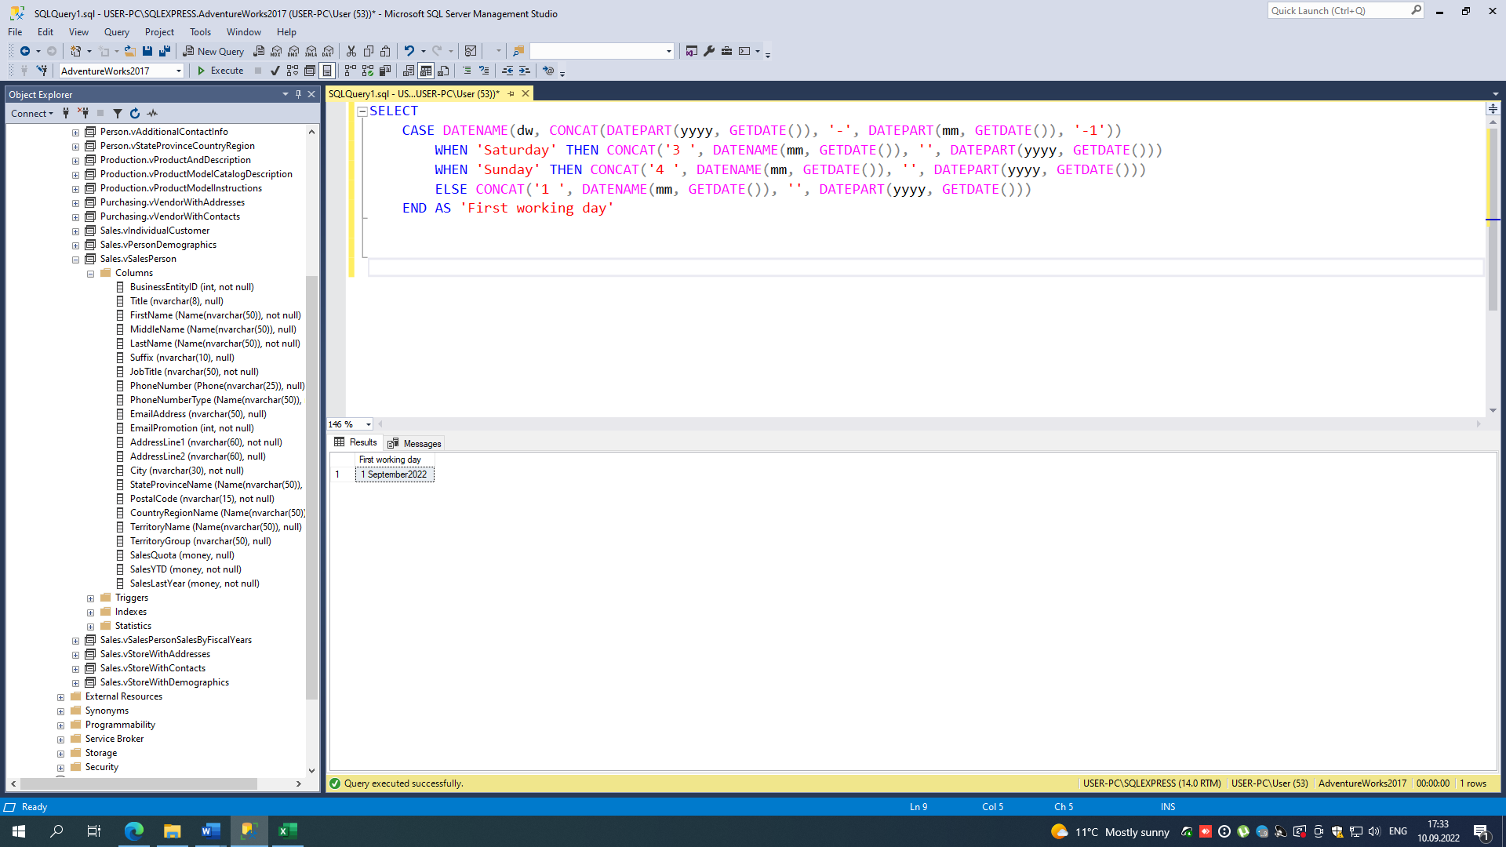

--task5)

count(1) = 4

count(name) = 2

count(id) = 4

count(*) = 4