-- hw5

--task6)

CREATE TABLE Patients

(

ID INT PRIMARY KEY IDENTITY (1,1),

FirstName NVARCHAR(30),

LastName NVARCHAR(30),

SSN CHAR(15),

Email AS CONCAT(UPPER(LEFT(FirstName, 1)), LOWER(LEFT(LastName, 3)), '@mail.com'),

Temp DECIMAL(5,2),

CreateDate DATE

) 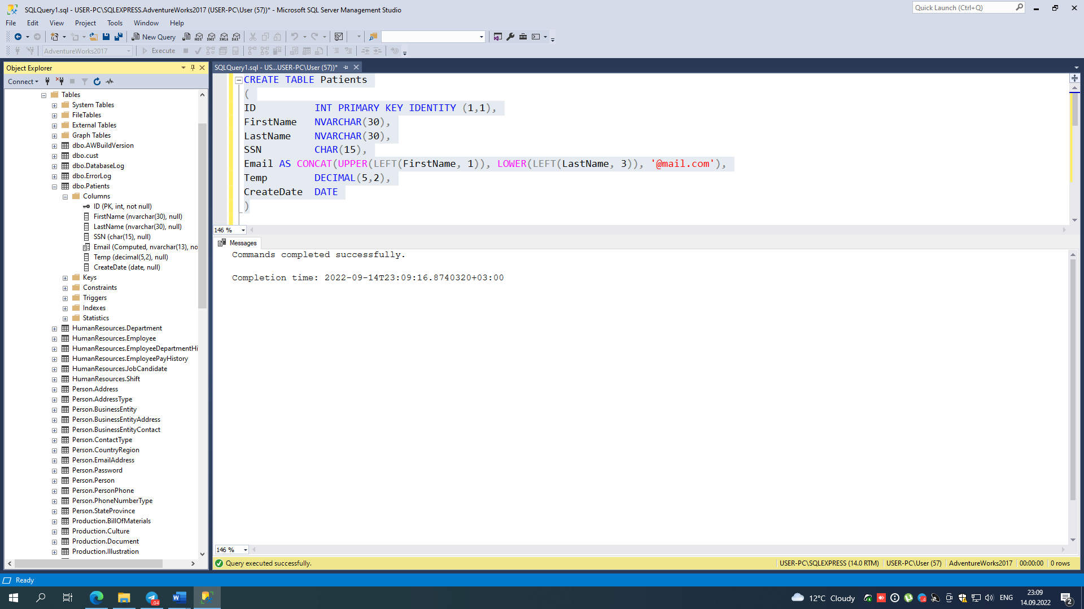

--task7)

INSERT INTO dbo.Patients (FirstName, LastName, SSN, Temp, CreateDate)

VALUES

('Peter', 'Ivanov', 'TDFjsd124854khg', 38.2, CAST('2022-09-07' AS DATE)),

('Peter', 'Ivanov', 'TDFjsd124854khg', 37.5, CAST('2022-09-08' AS DATE)),

('Peter', 'Ivanov', 'TDFjsd124854khg', 37.2, CAST('2022-09-09' AS DATE)),

('Peter', 'Ivanov', 'TDFjsd124854khg', 36.9, CAST('2022-09-10' AS DATE)),

('Vera', 'Sidorova', 'TDFojh851822lku', 36.6, CAST('2022-09-07' AS DATE)),

('Miron', 'Galkin', 'TLOtfd186421ook', 36.8, CAST('2022-09-08' AS DATE)),

('Natasha', 'Kotova', 'LNJudr781234dty', 36.8, CAST('2022-09-07' AS DATE))

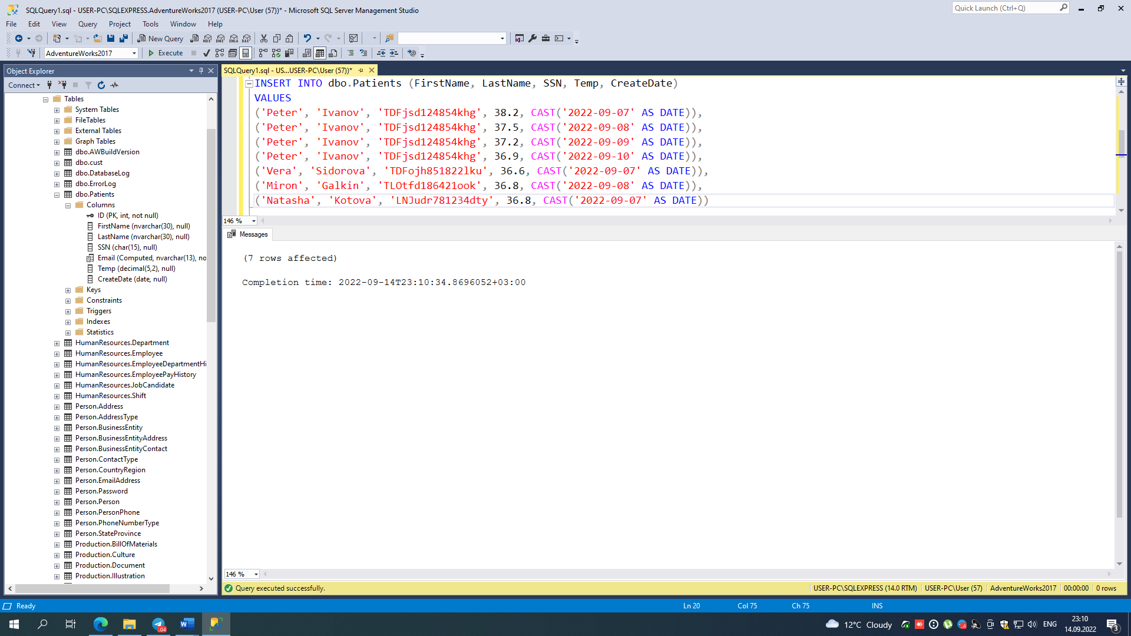

--task8)

ALTER TABLE Patients

ADD TempType AS

CASE

WHEN Temp > 37 THEN '>37°C'

ELSE '<37°C'

END

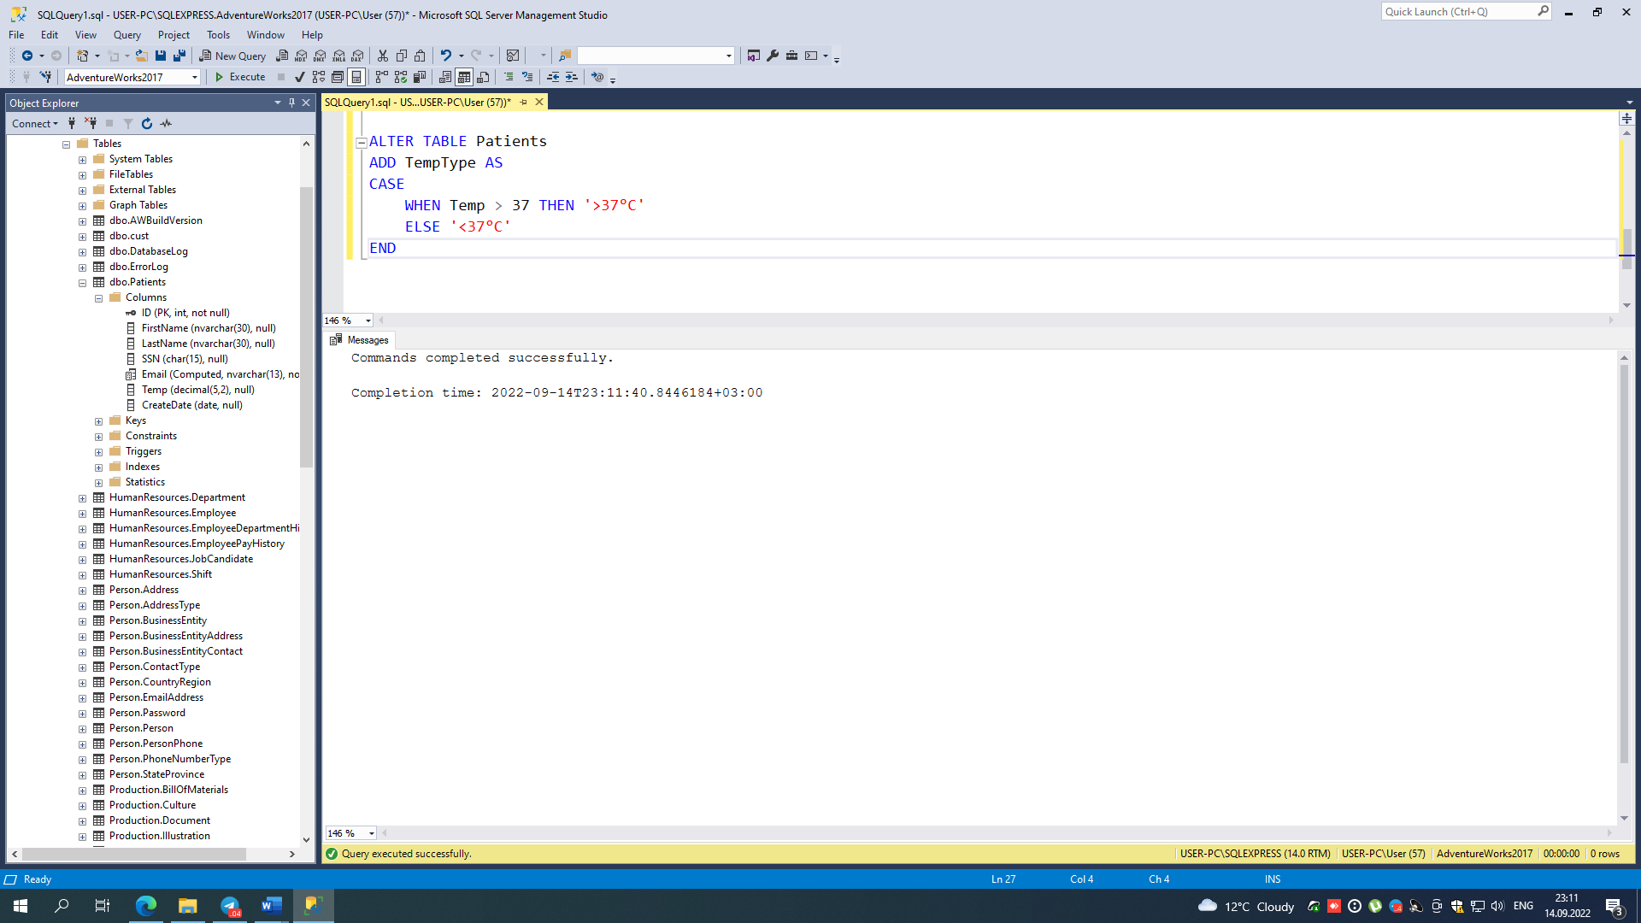

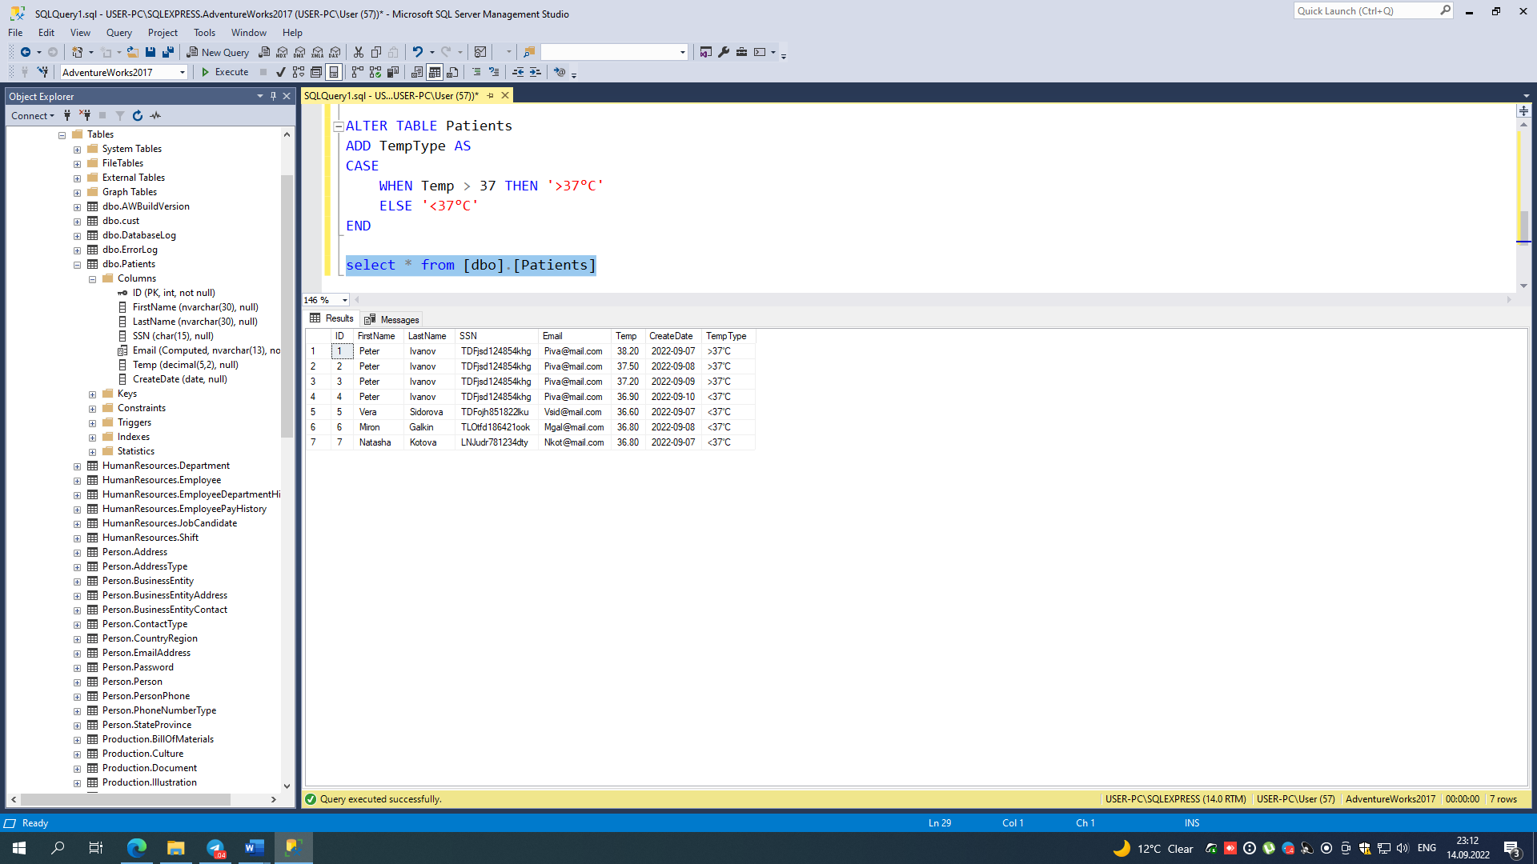

--task9)

CREATE VIEW Patients_v (F)

AS

SELECT Temp * 9 /5 + 32

FROM Patients

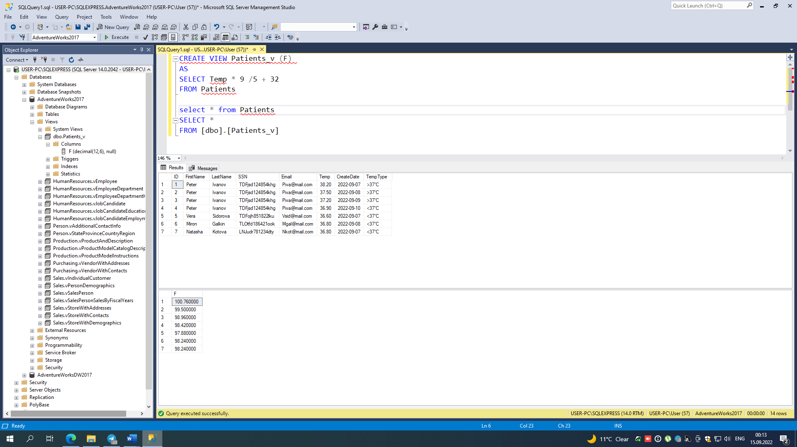

--task10)

CREATE FUNCTION ConvertCelsiusToFahrenheit(@degree DECIMAL(5,2))

RETURNS DECIMAL(7,2)

BEGIN

DECLARE @Fahrenheit DECIMAL(12,6)

SET @Fahrenheit = @degree * 9 / 5 + 32

RETURN @Fahrenheit

END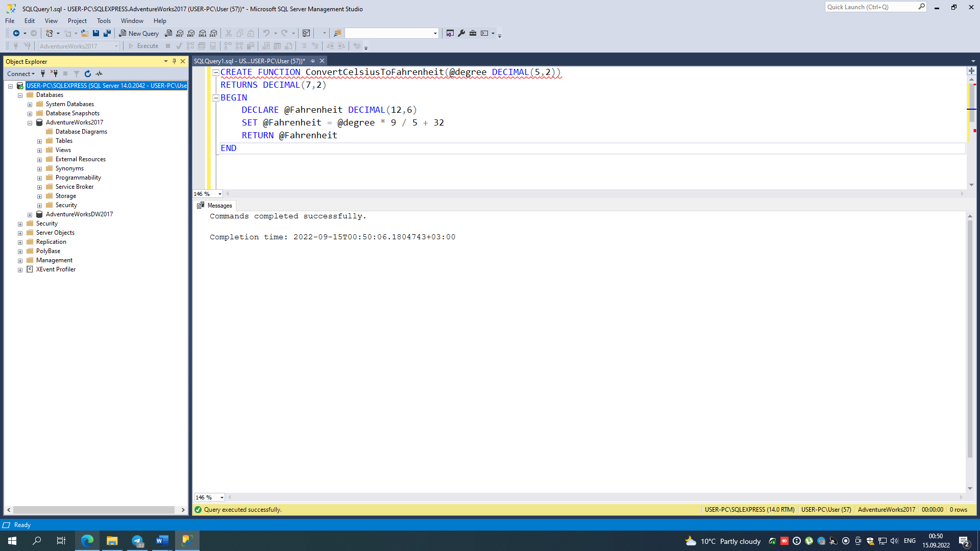

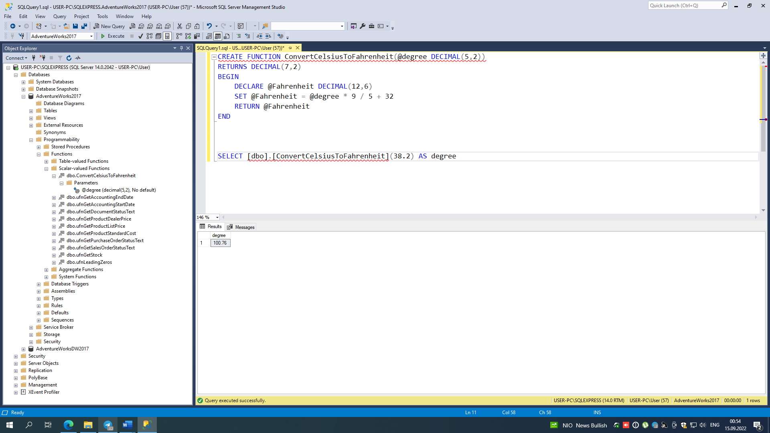

--task11)

DECLARE @FirstDay VARCHAR(20) = CONCAT('1 ', DATENAME(mm, GETDATE()), '', DATEPART(yyyy, GETDATE()))

DECLARE @SecondDay VARCHAR(20) = CONCAT('1 ', DATENAME(mm, GETDATE()), '', DATEPART(yyyy, GETDATE()))

DECLARE @ThirdDay VARCHAR(20) = CONCAT('1 ', DATENAME(mm, GETDATE()), '', DATEPART(yyyy, GETDATE()))

DECLARE @DayWeek VARCHAR(20) = DATENAME(dw, CONCAT(DATEPART(yyyy, GETDATE()), '-', DATEPART(mm, GETDATE()), '-1'))

SELECT

CASE @DayWeek

WHEN 'Saturday' THEN @ThirdDay

WHEN 'Sunday' THEN @SecondDay

ELSE @FirstDay

END AS 'First working day'

