-- hw6

--task2)

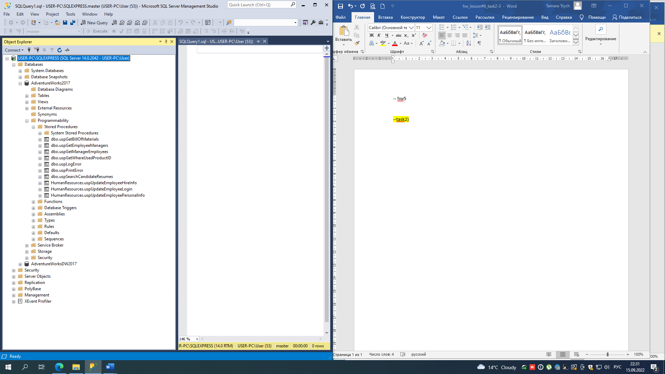

--task3)

CREATE PROCEDURE ps_ChangeBusinessEntityID

@param_BusinessEntityID INT,

@param_NationalIDNumber NVARCHAR(15)

AS

UPDATE HumanResources.Employee

SET NationalIDNumber = @param_NationalIDNumber

WHERE BusinessEntityID = @param_BusinessEntityID

DECLARE @MyBusinessEntityID INT, @NewNationalIDNumber NVARCHAR(15)

SET @MyBusinessEntityID = 15

SET @NewNationalIDNumber = 879341111

EXEC ps_ChangeBusinessEntityID @MyBusinessEntityID, @NewNationalIDNumber

SELECT NationalIDNumber

FROM HumanResources.Employee

WHERE BusinessEntityID = 15

