Exercise 1

А)

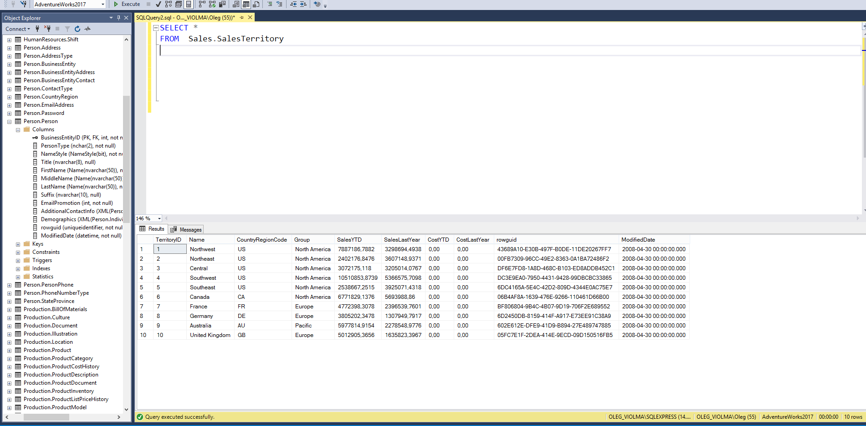

B)

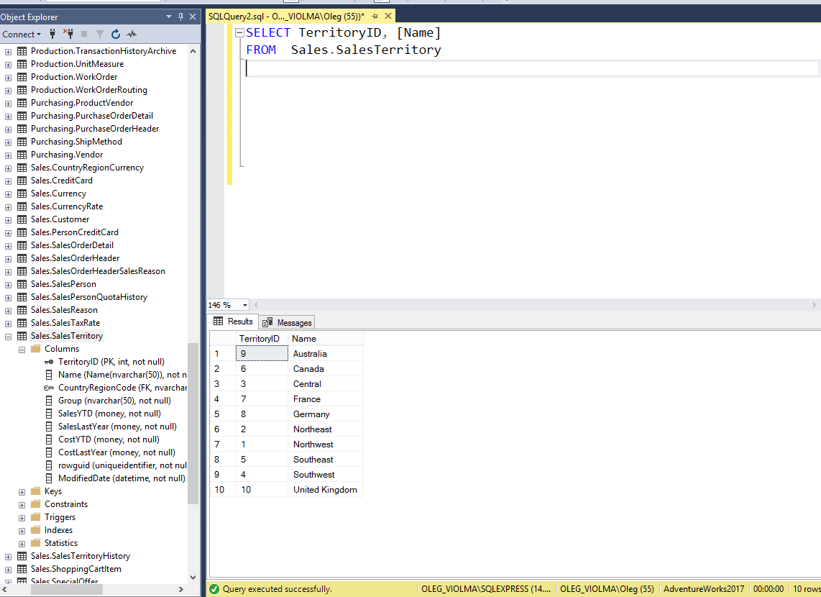

c)

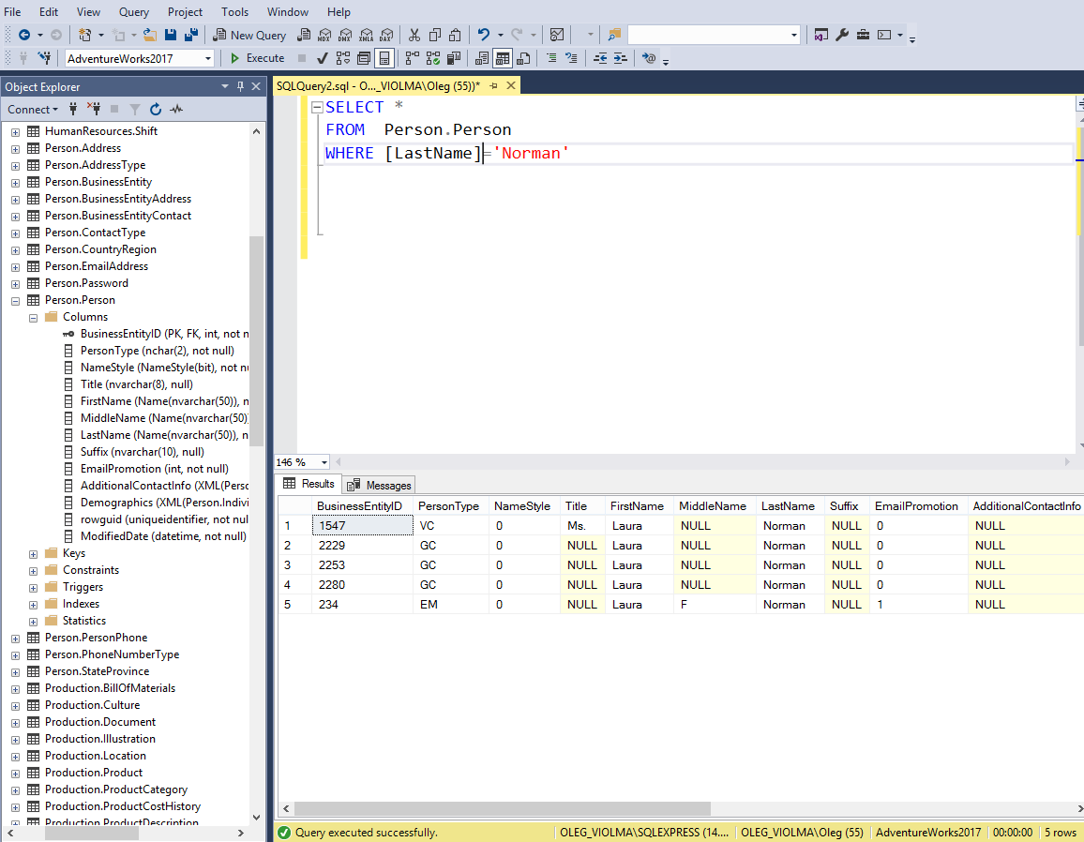

d)

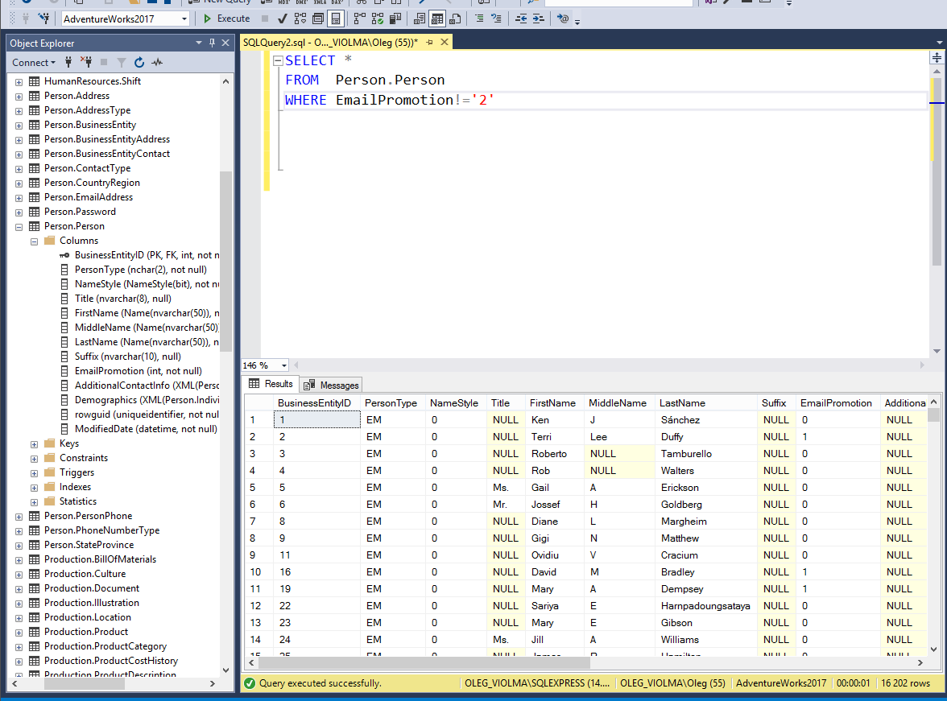

Exercise 3

* Other aggregate functions: [STDEV](https://docs.microsoft.com/ru-ru/sql/t-sql/functions/stdev-transact-sql?view=sql-server-ver15); [VAR](https://docs.microsoft.com/ru-ru/sql/t-sql/functions/var-transact-sql?view=sql-server-ver15); [GROUPING](https://docs.microsoft.com/ru-ru/sql/t-sql/functions/grouping-transact-sql?view=sql-server-ver15).

Exercise 4

a)

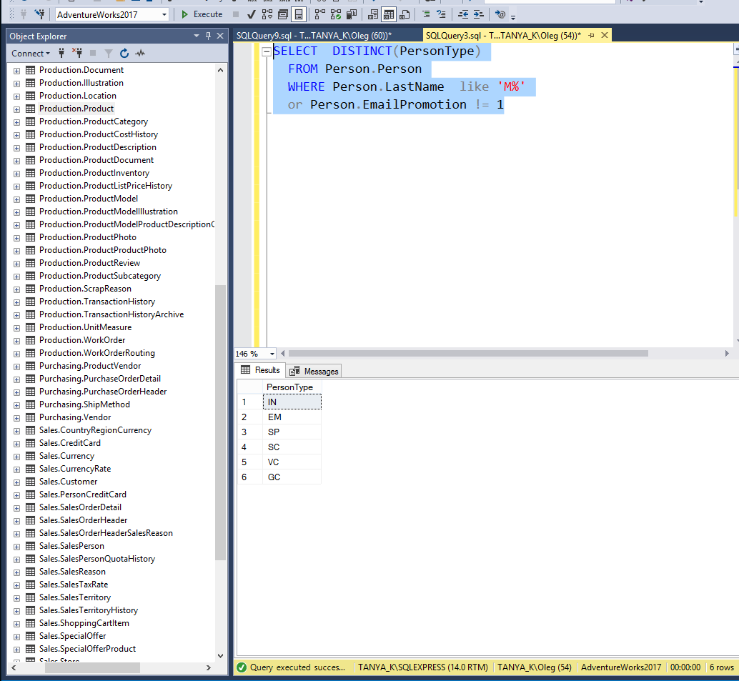

B)

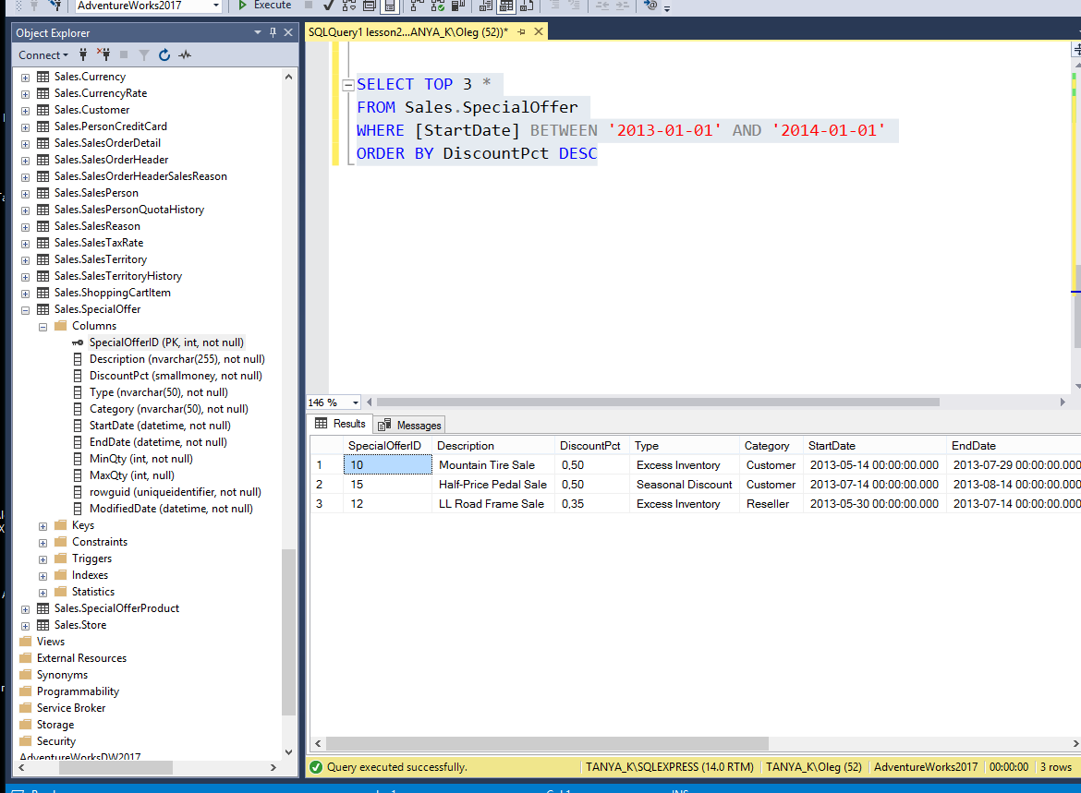

C)

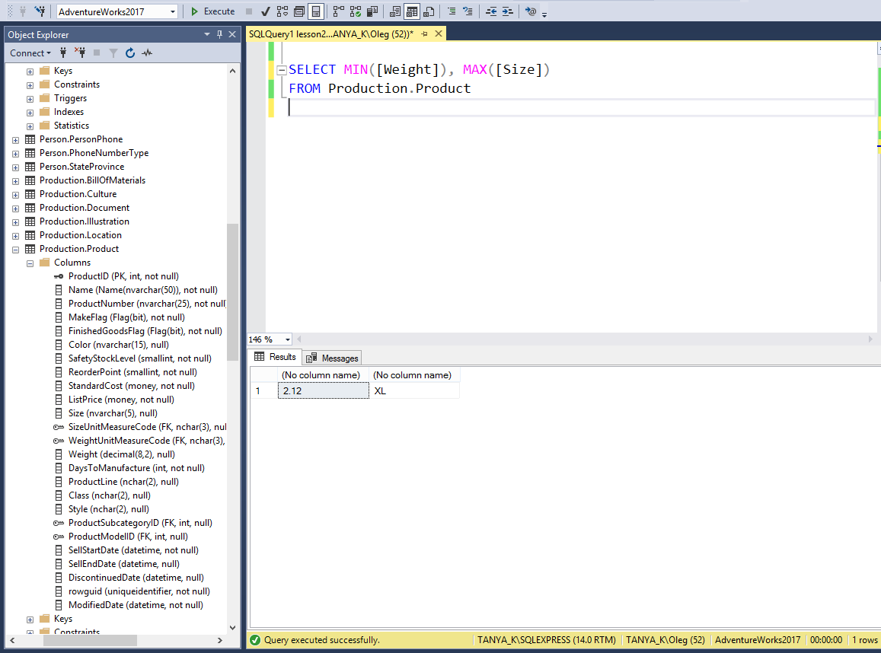

d)

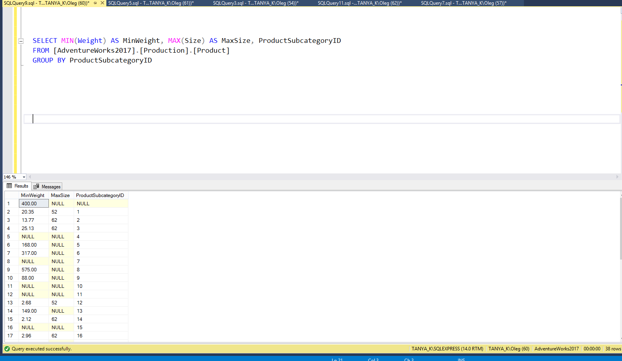

e)

