3) SELECT [Year], [1] as JAN , [2] AS FEBR, [12] AS DECEM

FROM

(SELECT YEAR(DueDate) as [Year], OrderQty, MONTH(DueDate) AS [Month]

FROM [Production].[WorkOrder]) st

PIVOT(

SUM (OrderQty)

FOR [Month] in ([1], [2],[12])

) AS pvt

order by [Year]

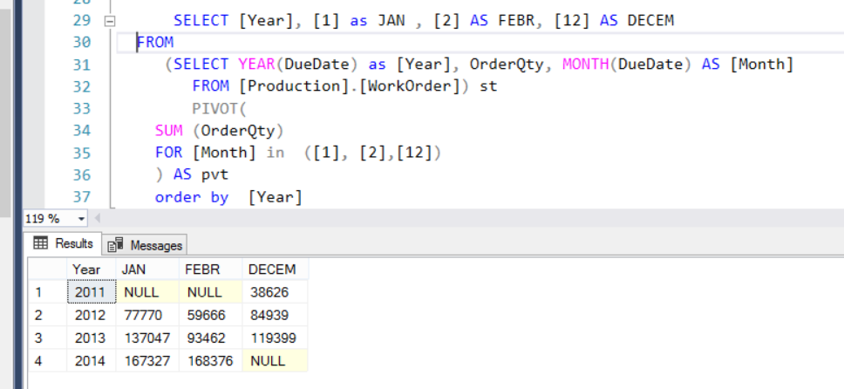

**Самостоятельная работа**

4) Продуктовый магазин

1) Fact Sale (id_sale , id_product, id_ Employees, id_ Depatment, id_ Suppliers, id_ Categories product, id_client, OrderDate)

2) Employees (id_ Employees, First_name, Last_name, Position, Department, Address, Passport_ID, Birthday, Phone)

3) Product (id_Product, Name, Price, Weight, Data of manufacture)

4) Departments ( id_ Departments, name)

5) Suppliers (id_Supplier, Delivery_date, Phone)

6) Categories_product (id_Categorie, name)

7) Client (id_client, Name, Phone)

1 задача

Найти первых 3-х покупателей, совершивших покупку в 2021году.

2 задача

Найти среднюю цену на молочную продукцию (Categories_product).