1. Напишите скрипт для суммы OrderQty для каждого года и зимних месяцев из Production.WorkOrder в виде транспонированной матрицы:

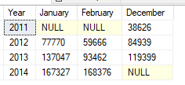

SELECT Year, January, February, December

FROM

(SELECT YEAR (DueDate) AS Year, DATENAME (MONTH, DueDate) AS Month, OrderQty

FROM Production.WorkOrder) AS SourceTable

PIVOT

(SUM (OrderQty) FOR Month IN (January, February, December)) AS PivotTable

ORDER BY Year