1. SELECT TOP 10 fct.id, std.id AS student_id, date_time, les.id AS lesson_id, room, tch.id AS teacher_id

FROM dbo.fct_timetable fct

JOIN dim_students std ON std.id = fct.student_id

JOIN dim_lessons les ON les.id = fct.lesson_id

JOIN dim_teachers tch ON tch.id = fct.teacher_id

2. SELECT id

FROM dim_students

SELECT id

FROM dim_lessons

SELECT id

FROM dim_teachers

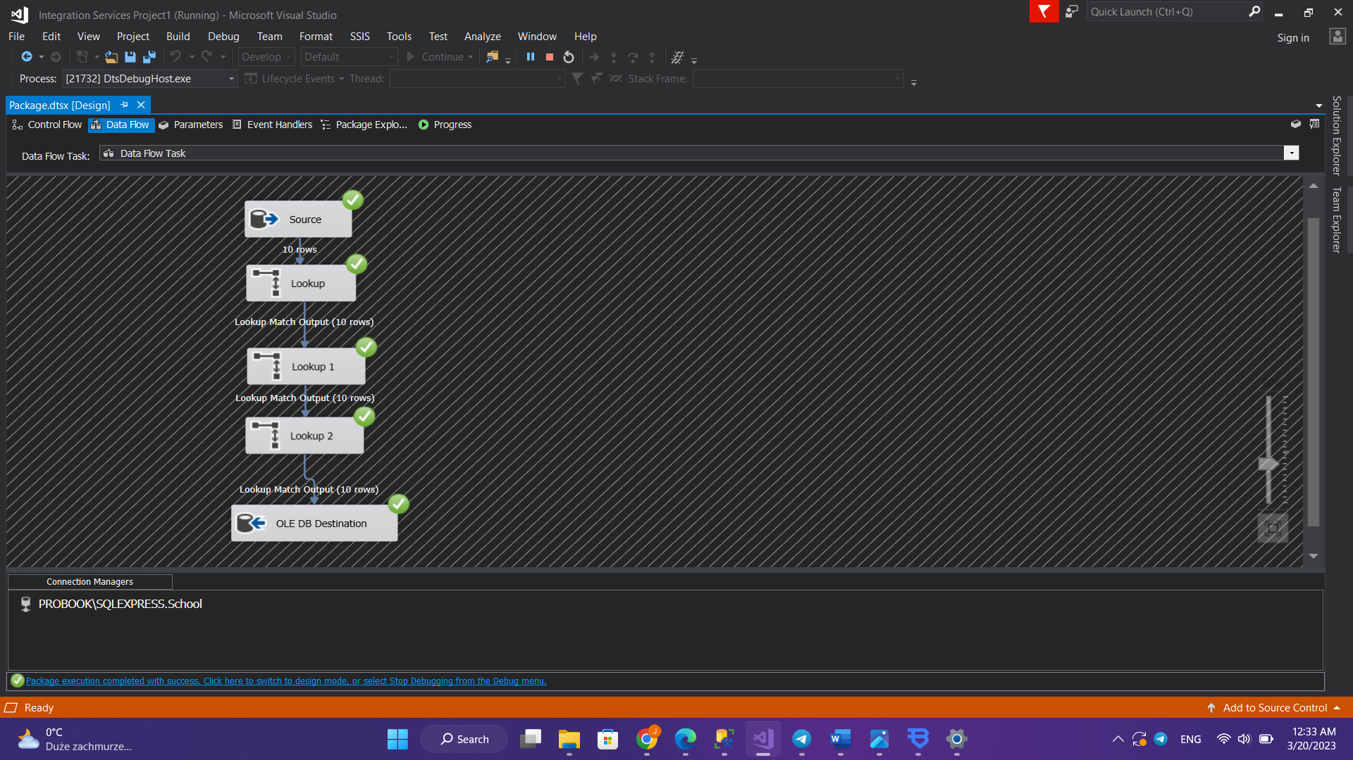3.

