CREATE VIEW TOP50Teachers as

SELECT TOP 50 WITH TIES Name,LastName, SUM(Mark) as SumMark,

DENSE_RANK() OVER (ORDER BY SUM(Mark) DESC) as rnk

FROM

(SELECT [dbo].[dim_teachers].name, [dbo].[dim_teachers].lastname, [dbo].[fct_timetable].date_time,

(CASE WHEN COUNT ([dbo].[fct_timetable].lesson_id )>=10 THEN 3

WHEN COUNT ([dbo].[fct_timetable].lesson_id ) BETWEEN 5 AND 10 THEN 2

WHEN COUNT([dbo].[fct_timetable].lesson_id )<5 THEN 1

END) as Mark

FROM [dbo].[dim_teachers] JOIN [dbo].[fct_timetable] ON [dbo].[dim_teachers].[teacher_id] =[dbo].[fct_timetable].[teacher_id]

GROUP BY [dbo].[dim_teachers].name, [dbo].[dim_teachers].lastname, [dbo].[fct_timetable].date_time ) as r

GROUP BY name,lastname

ORDER BY SumMark DESC

--Результат получился таким, вероятно из-за моих сгенерированных данных, ниже прикрепила скрин, там показала, что запрос работает ☺

--1

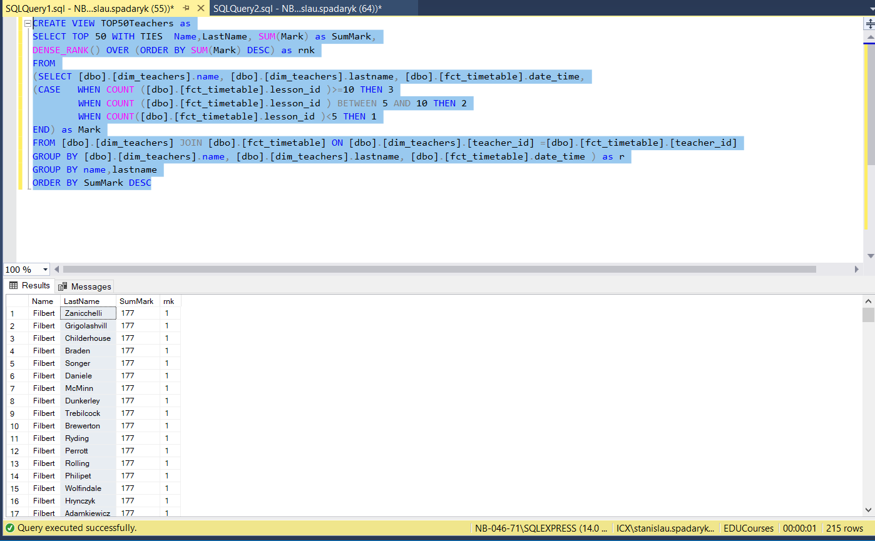

--2

