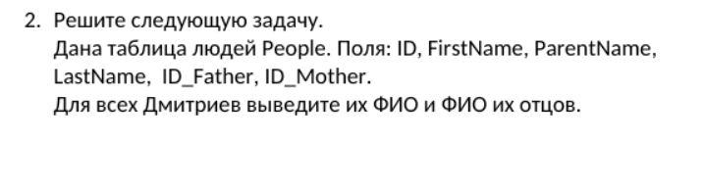

|  |  |  |  |  |  |
| --- | --- | --- | --- | --- | --- |
| ID | FirstName | LastName | ParentName | ID_Father | ID_Mother |
| 1 | Дмитрий | Иванов | Владимир | 3 | 7 |
| 2 | Василий | Зайкин | Светлана | 5 | 4 |
| 3 | Олег | Николаев | Петр | 8 | 9 |

SELECT

CONCAT(LEFT(t1.LastName,1),LEFT(t1.FirstName,1),LEFT(t1.ParentName,1)) AS ChildName, CONCAT(LEFT(t2.LastName,1),LEFT(t2.FirstName,1),LEFT(t2.ParentName,1)) AS FatherName

FROM People2 t1 JOIN People2 t2 ON t1.ID_Father=t2.ID

WHERE t1.FirstName = 'Дмитрий'