1 (а)

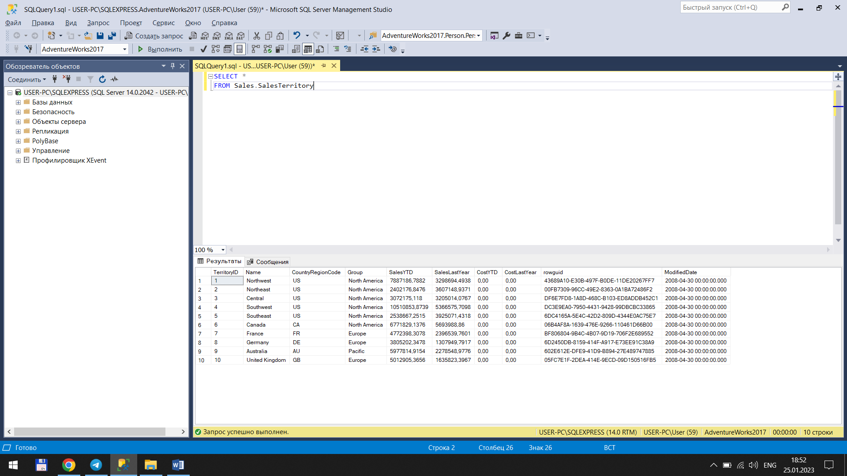

1 (b)

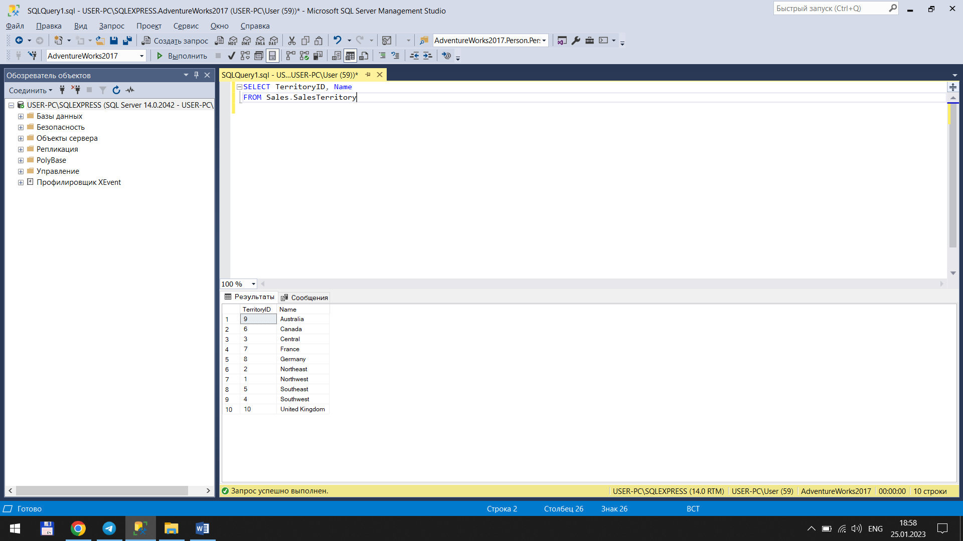

1 (c)

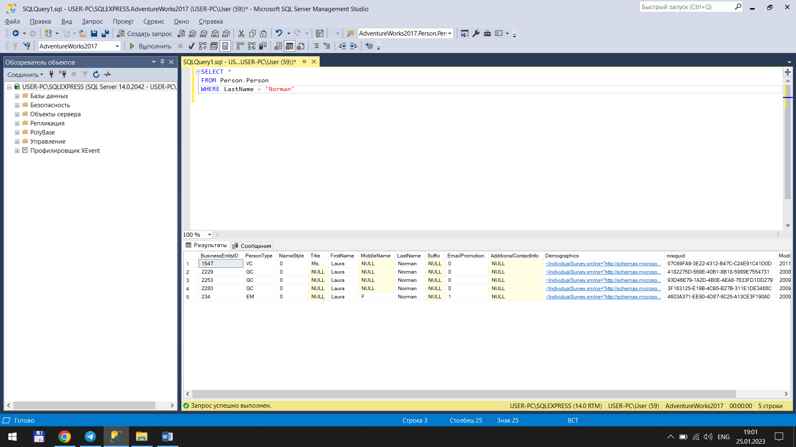

1 (d)

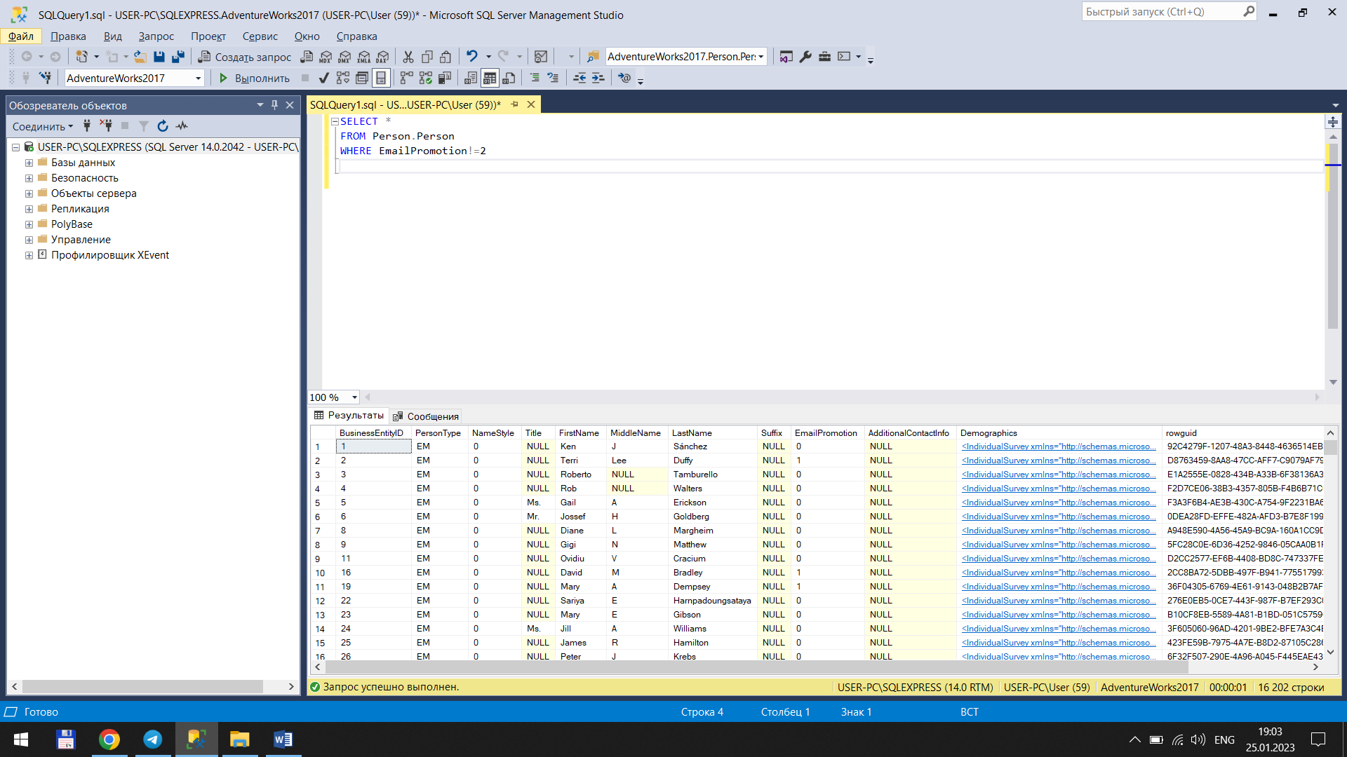

3. Но я пока не готов привести примеры ???

* [CHECKSUM_AGG](https://learn.microsoft.com/ru-ru/sql/t-sql/functions/checksum-agg-transact-sql?view=sql-server-ver16)
* [COUNT](https://learn.microsoft.com/ru-ru/sql/t-sql/functions/count-transact-sql?view=sql-server-ver16)
* [COUNT_BIG](https://learn.microsoft.com/ru-ru/sql/t-sql/functions/count-big-transact-sql?view=sql-server-ver16)
* [GROUPING](https://learn.microsoft.com/ru-ru/sql/t-sql/functions/grouping-transact-sql?view=sql-server-ver16)
* [GROUPING_ID](https://learn.microsoft.com/ru-ru/sql/t-sql/functions/grouping-id-transact-sql?view=sql-server-ver16)

[STDEV](https://learn.microsoft.com/ru-ru/sql/t-sql/functions/stdev-transact-sql?view=sql-server-ver16)

[STDEVP](https://learn.microsoft.com/ru-ru/sql/t-sql/functions/stdevp-transact-sql?view=sql-server-ver16)

[STRING_AGG](https://learn.microsoft.com/ru-ru/sql/t-sql/functions/string-agg-transact-sql?view=sql-server-ver16)

* [VAR](https://learn.microsoft.com/ru-ru/sql/t-sql/functions/var-transact-sql?view=sql-server-ver16)
* [VARP](https://learn.microsoft.com/ru-ru/sql/t-sql/functions/varp-transact-sql?view=sql-server-ver16)

4 (a)

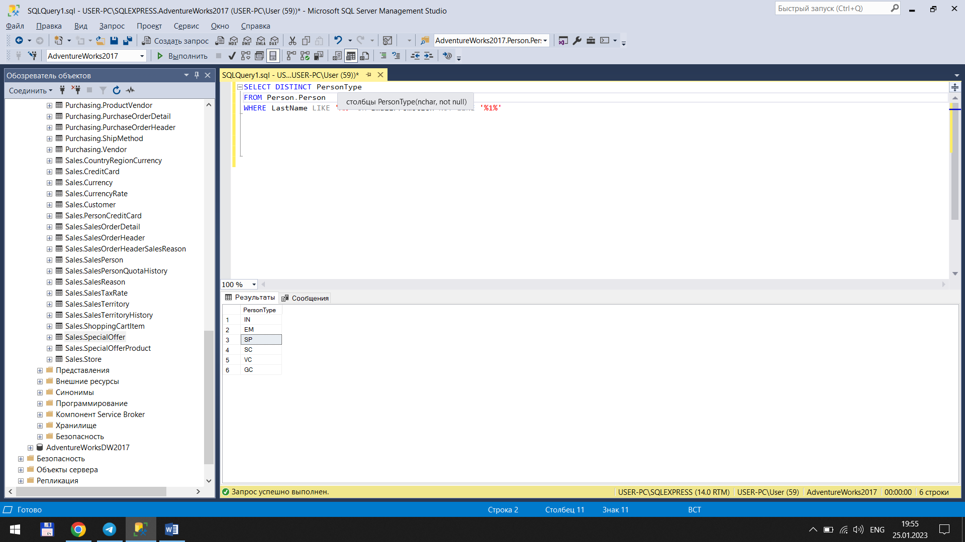

4 (b)

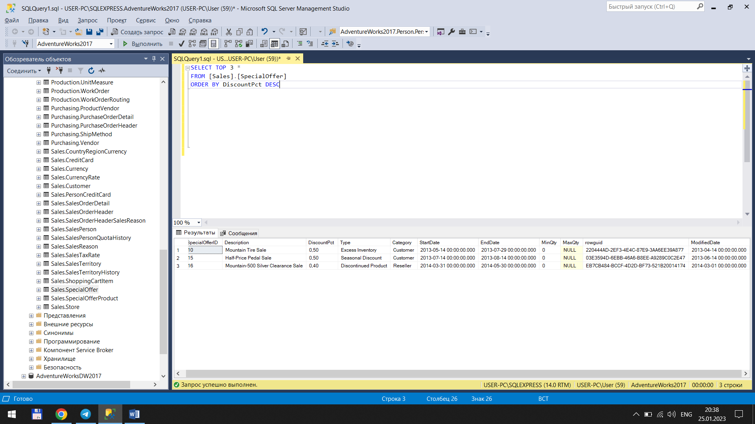

4 (c)

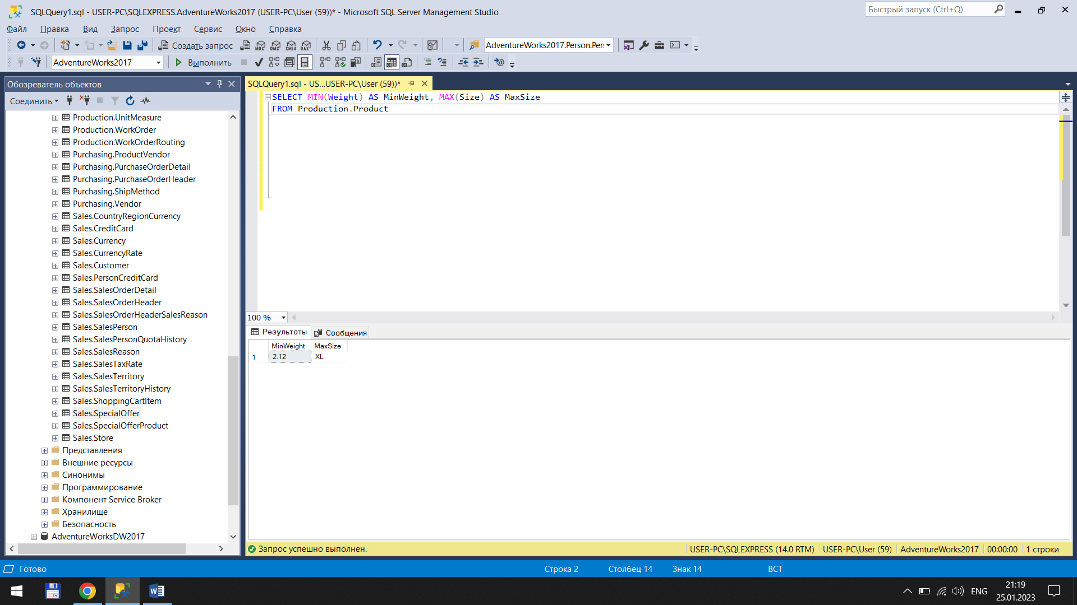

4 (d)

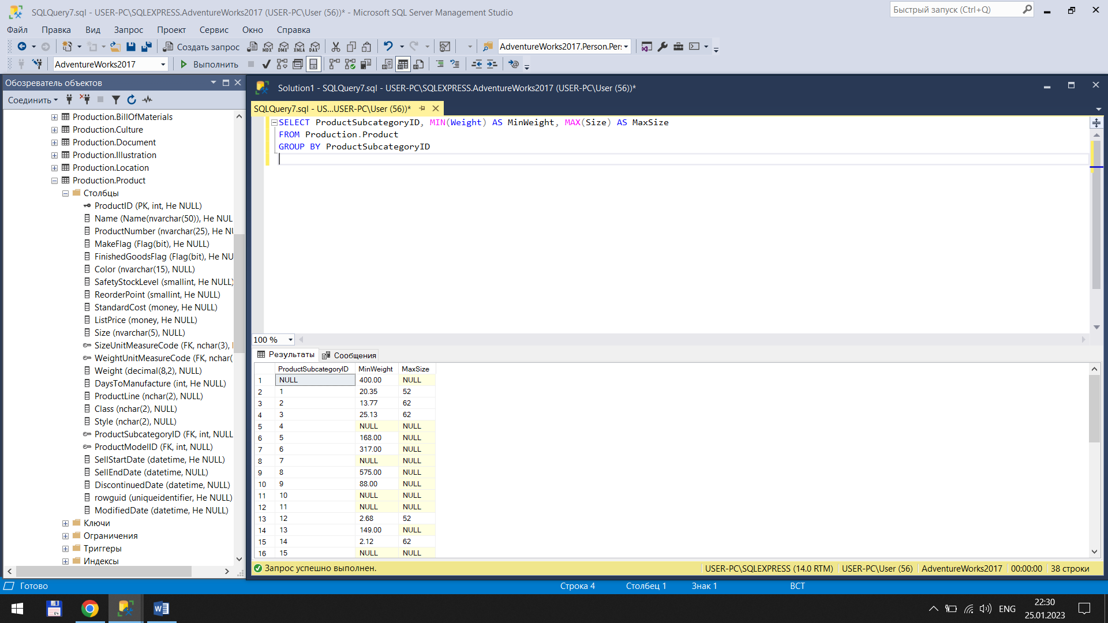

4 (e)

