3) При Row Number, Rank и Dense Rank относящимися к PK

4) a

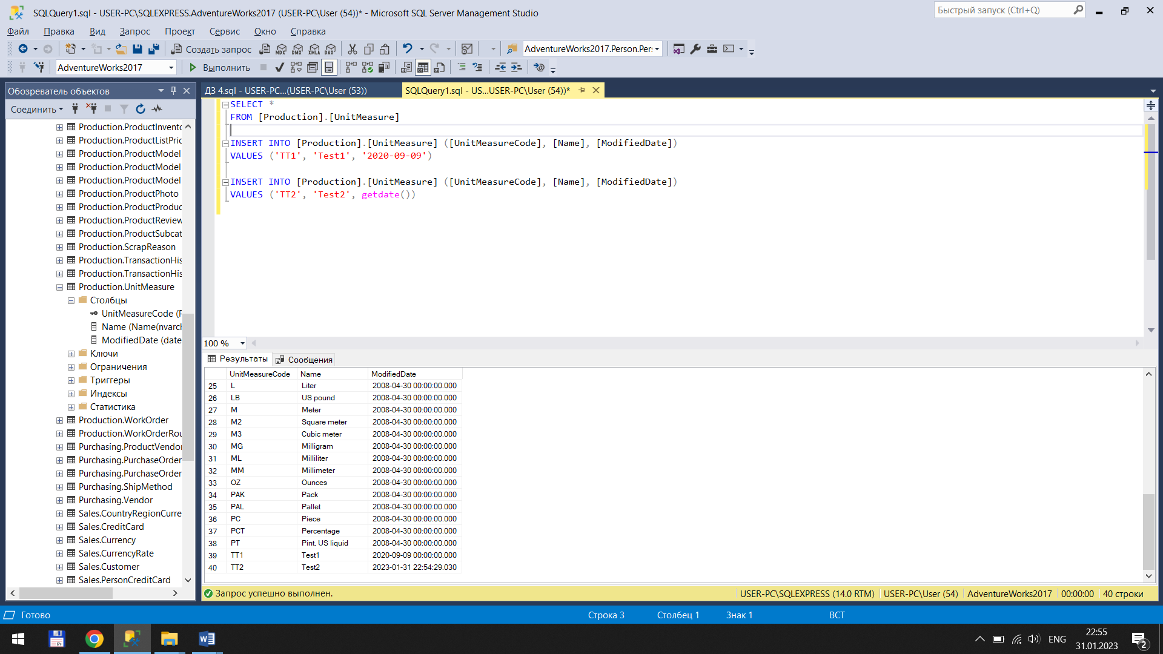

4) b

SELECT \*

FROM [dbo].[Production.UnitMeasureTest]

WHERE [UnitMeasureCode] = ‘CAN’

4) c

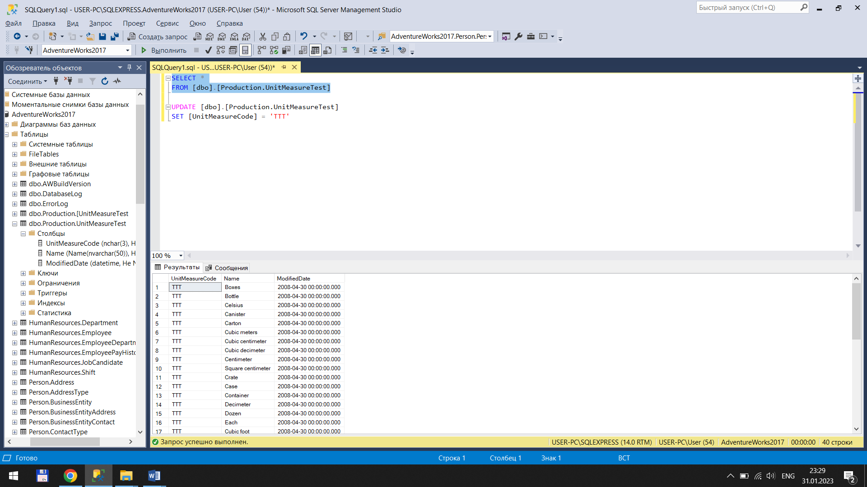

4) d

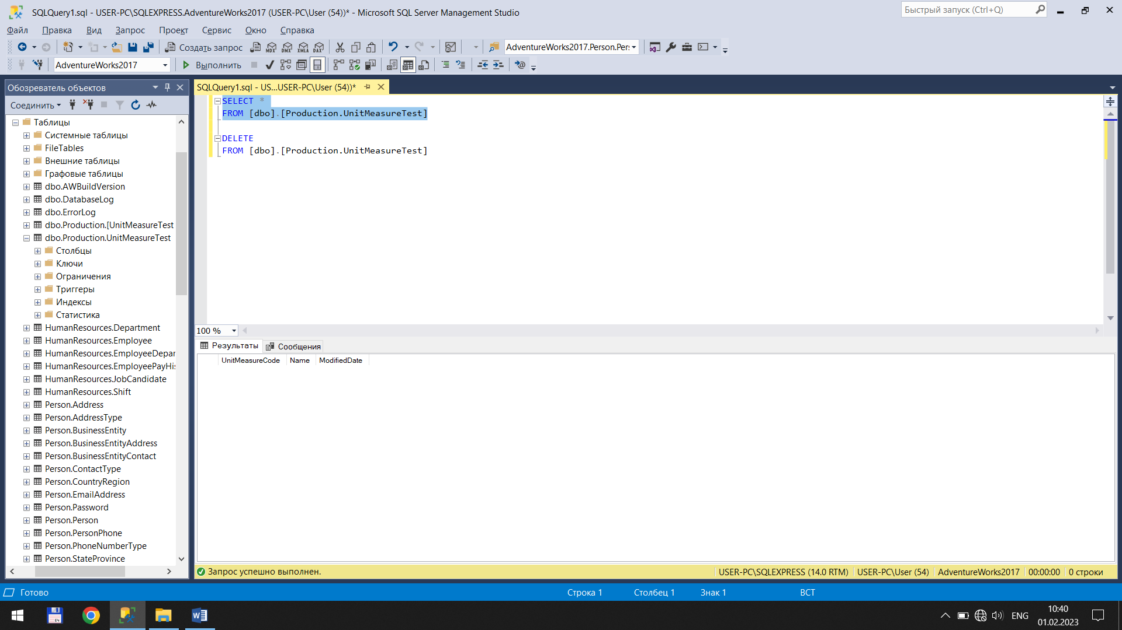

4) e

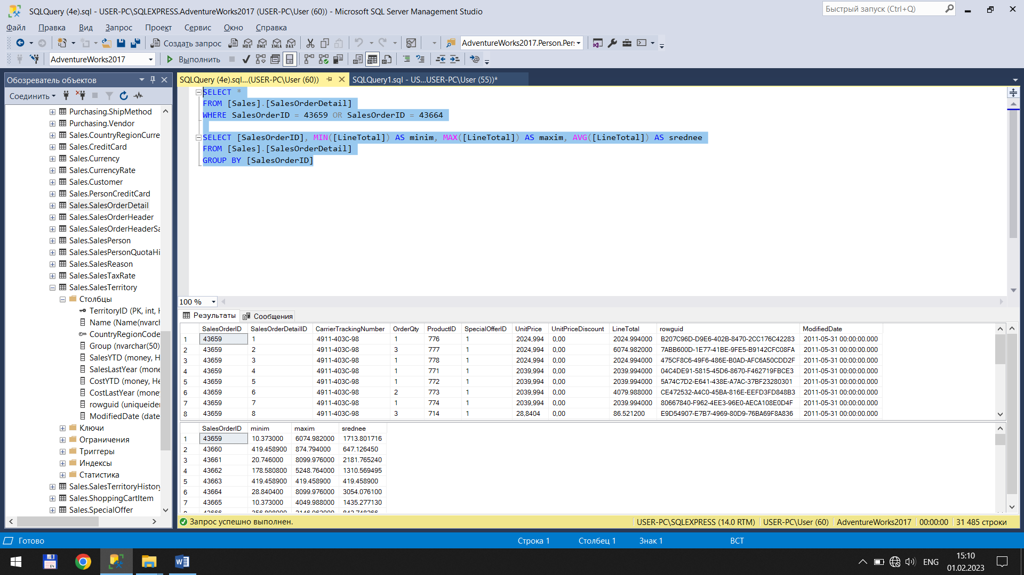

4) f

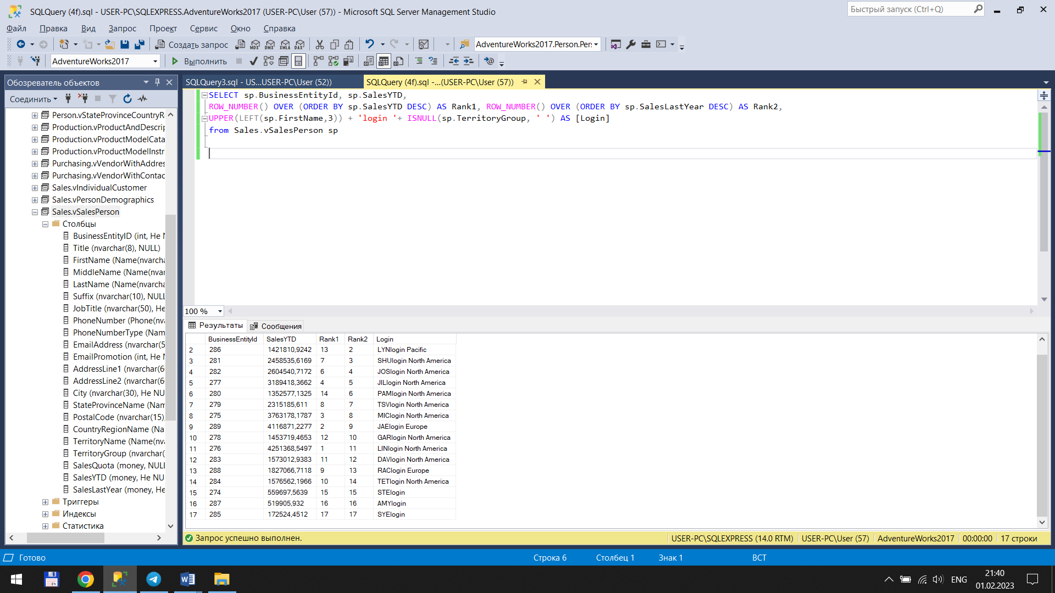

4) f

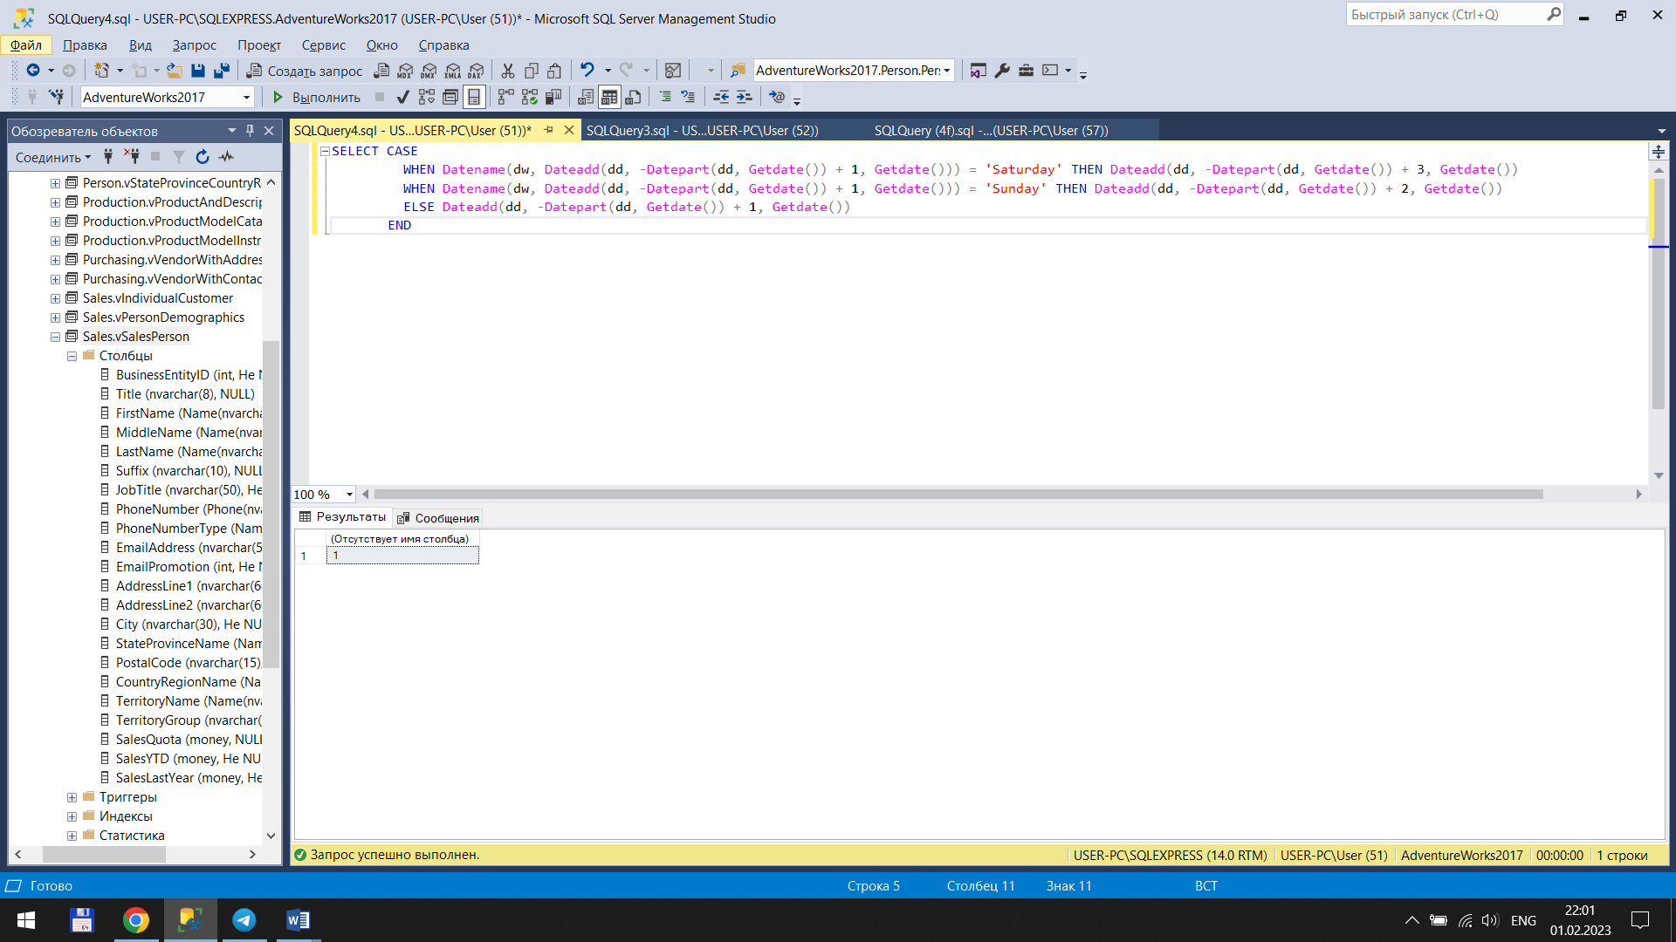

5) count(1) – 1,2,3,4; count(name) – 3,4; count(id) – 1,2,3,4; count(\*) – 1,2,3,4