1)

CREATE DATABASE TouristEquipmentRental

CREATE TABLE fctOrders

(

ID_order INT IDENTITY (1,1),

Inventory_number INT NOT NULL,

Employee_number INT,

Booking_date DATE NOT NULL,

Rent_date DATE,

Plan_return_date DATE,

Fact_return_date DATE,

ID_customer INT,

ID_discount INT,

CONSTRAINT PK_fctOrders_ID_order PRIMARY KEY (ID_order)

);

CREATE TABLE dimEquipments

(

Inventory_number INT IDENTITY (1,1),

Category VARCHAR(50),

Equipment_name NVARCHAR(100) NOT NULL,

Rental_price money,

Security_decosit money,

Vendor_price money NOT NULL,

Vendor_name NVARCHAR(100) NOT NULL

CONSTRAINT PK_dimEquipments_Inventory_number PRIMARY KEY (Inventory_number)

);

CREATE TABLE fctMaintenances

(

Maintenance INT IDENTITY (1,1),

Start_date DATE NOT NULL,

End_date DATE,

Maintenance_cost money,

Inventory_number INT,

Employee_number INT

CONSTRAINT PK_fctMaintenances_Maintenance PRIMARY KEY (Maintenance)

);

CREATE TABLE dimEmployees

(

Employee_number INT IDENTITY (1,1),

Position NVARCHAR(50) NOT NULL,

Full_name NVARCHAR(100),

Fix_salary money NOT NULL,

Employement_date DATE NOT NULL,

Dismissal_date DATE

CONSTRAINT PK_dimEmployees_Employee_number PRIMARY KEY (Employee_number)

);

CREATE TABLE dimCustomers

(

ID_customer INT IDENTITY (1,1),

Category VARCHAR(50),

Customer_name NVARCHAR(50) NOT NULL,

Registration_number CHAR(9) UNIQUE,

Passport_number CHAR(14) UNIQUE,

Phone_number VARCHAR(20),

Email VARCHAR(50)

CONSTRAINT PK_dimCustomers_ID_customer PRIMARY KEY (ID_customer)

);

CREATE TABLE dimDiscounts

(

ID_discount INT IDENTITY (1,1),

Type_discount VARCHAR(50),

Discount_percentage DEC(3,2),

Start_date_discount DATE NOT NULL,

End_date_discount DATE

CONSTRAINT PK_dimDiscounts_ID_discount PRIMARY KEY (ID_discount)

);

ALTER TABLE fctOrders ADD CONSTRAINT FK_fctOrders_Inventory_number FOREIGN KEY (Inventory_number) REFERENCES dimEquipments (Inventory_number)

ALTER TABLE fctOrders ADD CONSTRAINT FK_fctOrders_Employee_number FOREIGN KEY (Employee_number) REFERENCES dimEmployees (Employee_number)

ALTER TABLE fctOrders ADD CONSTRAINT FK_fctOrders_ID_customer FOREIGN KEY (ID_customer) REFERENCES dimCustomers (ID_customer)

ALTER TABLE fctOrders ADD CONSTRAINT FK_fctOrders_ID_discount FOREIGN KEY (ID_discount) REFERENCES dimDiscounts (ID_discount)

ALTER TABLE fctMaintenances ADD CONSTRAINT FK_fctMaintenances_Employee_number FOREIGN KEY (Employee_number) REFERENCES dimEmployees (Employee_number)

ALTER TABLE fctMaintenances ADD CONSTRAINT FK_fctMaintenances_Inventory_number FOREIGN KEY (Inventory_number) REFERENCES dimEquipments (Inventory_number)

2)

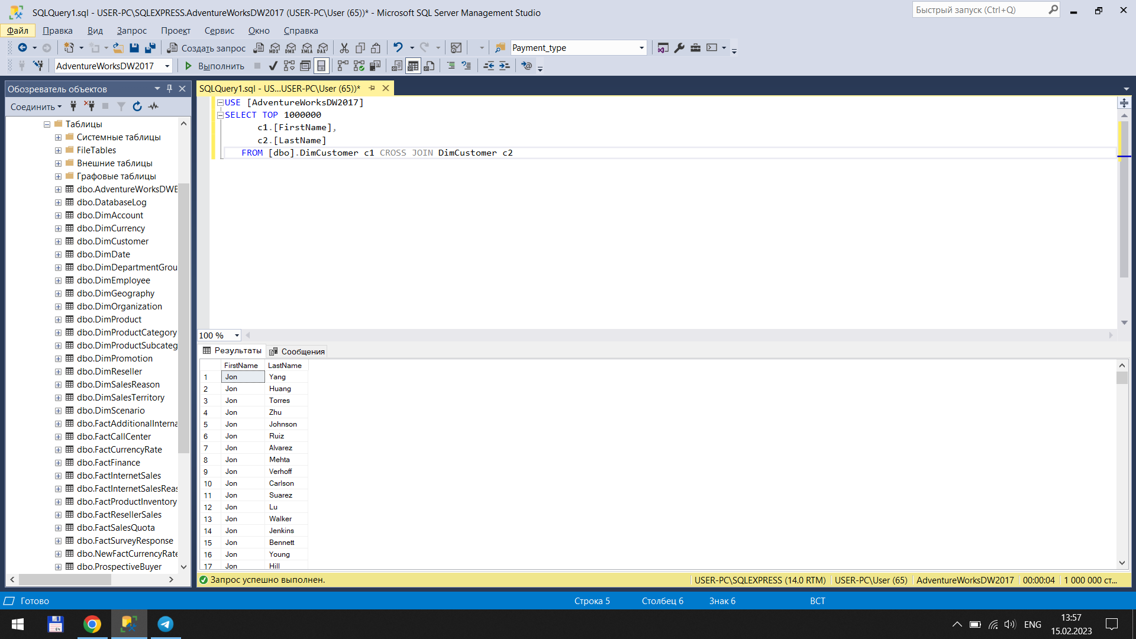

Я ВОСПОЛЬЗОВАЛСЯ GOOGLE!!!!