Lesson 1
Task 3:
Created date 10/27/2017.
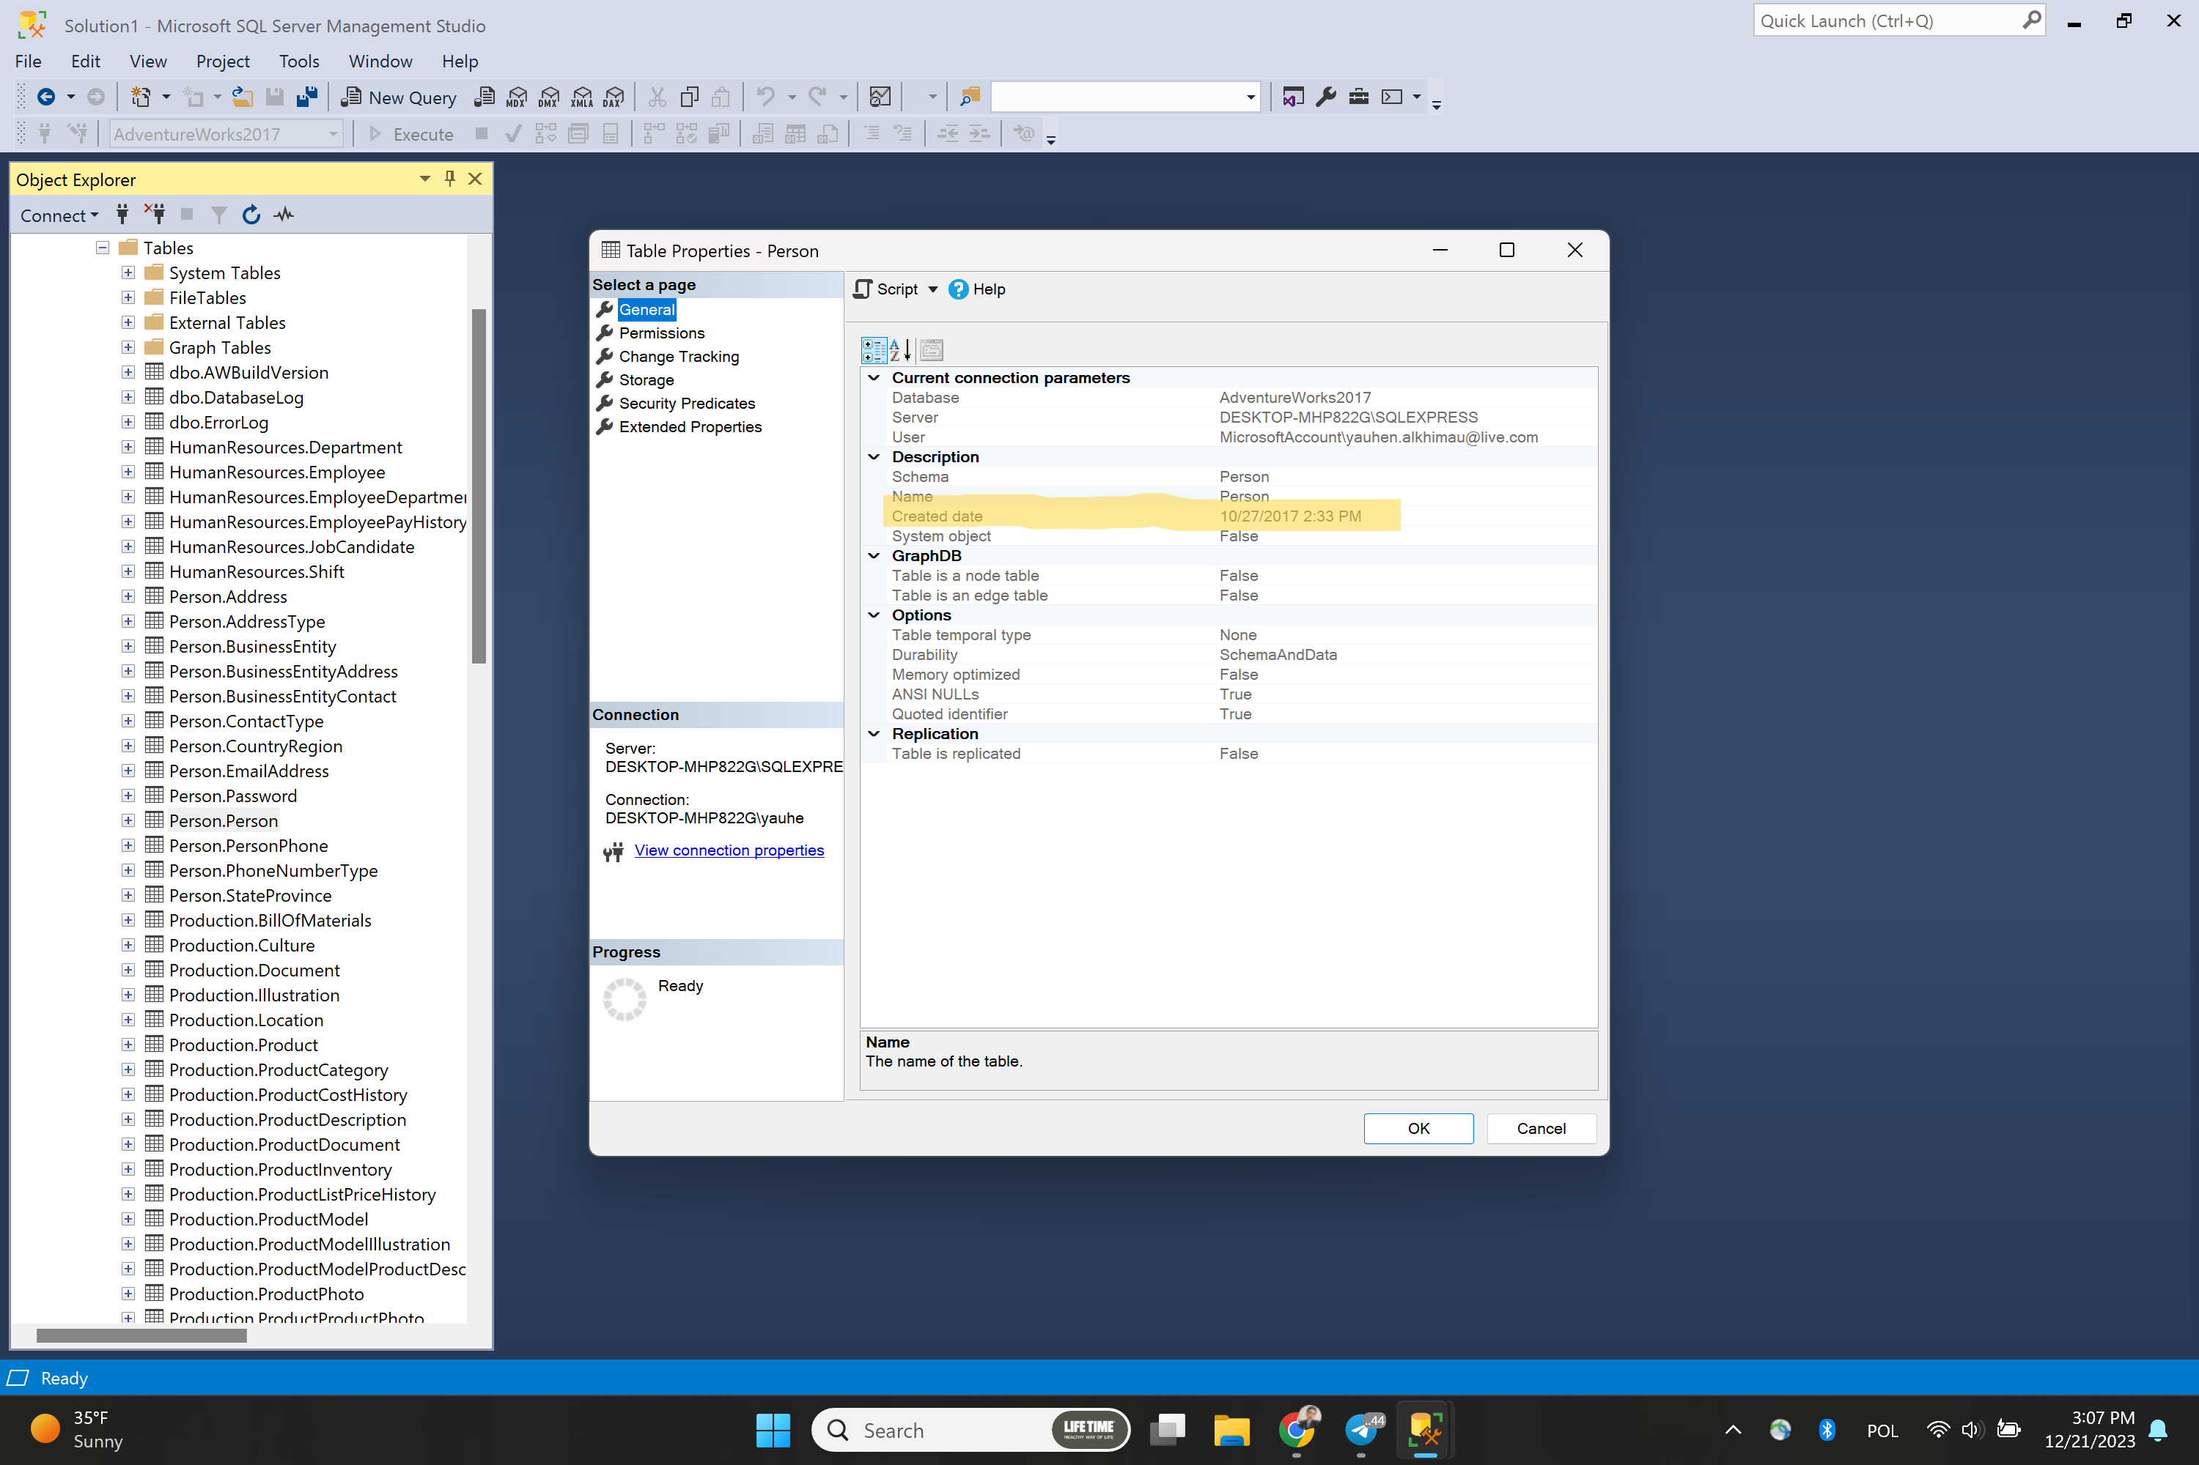
Task 4:
Data space: 0.008 MB
