METHODS

Goal:
Assess whether and how subjects are able to find the answers to a set of questions that typical users might want to answer.

Architecture
Five views of the data are provided:
- Patient view (PAT) (Figure 1)
  - Input: User enters a valid MRN - program warns if invalid entry
  - Output: Table showing an individual patient’s MRN, MD, Location, Month, bug(s) and their sensitivity profile.
- Doctor’s list (DOC) (Figure 2)
  - Input: User enters an MD and a Month via pick-lists. ‘All’ is the default option for each variable.
  - Output: Compact table showing all of the patients for a given doctor/month - with MRN, location, bug(s) and color-coded sensitivity profile (green for sensitive, maroon for resistant, gray for not assessed).
- Floor-Plan View of Patients, Bugs, and Severity (LOC)
  - Input: User enters an MD, a Month, and a Bug via pick lists. ‘All’ is the default option for each variable.
  - Output: A Floor-plan view of the data, filtered according the input criteria. The Floor number is on the vertical axis. The Room and Bed numbers are on the horizontal axis. The cells are color coded based upon the maximal severity of the infection in any given room: red = “bug resistant to all drugs”; orange = “bug resistant to all but one drug”; yellow = “bug resistant to all but two drugs”; white = “bug sensitive to three or more drugs”.
    - Overview (LOC-O) (Figure 3)- shows total numbers of patients and bugs in each room over all months
    - Zoom (LOC-Z) (Figure 4)- shows the hyperlinked MRN of the patient in the room, and the list of bugs they have.
    - Totals - In both LOC-O and LOC-Z, the total numbers of patients and bugs by room and floor are shown in summary columns with light blue background.
- Temporal Trends (TIME) (Figure 5)
  - Input: User enters an MD and a Floor from pick-lists. ‘All’ is the default option for each variable.
  - Output: Two colored line charts; one line per bug.
    - # Infections - shows trends in the number of infections, by bug
    - % Virulence - shows trends in the percentage resistance by bug
- Sensitivity Profile of Bugs (SENS) (Figure 6)
  - Input: User enters an MD, a Month, and a Floor from pick-lists. ‘All’ is the default for each variable.
  - Output: A colored table of Bug vs. Drug showing the number of samples tested and the percentage sensitive. Higher sensitivities are brighter green.

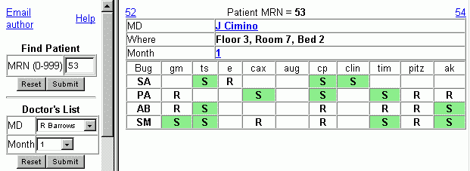
Figure 1: Patient View (PAT)

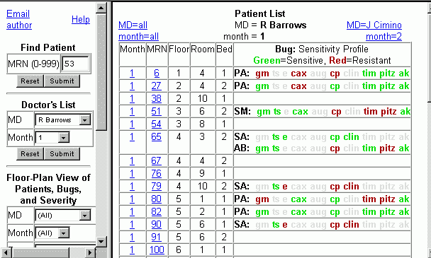
Figure 2: Doctor’s List (DOC)

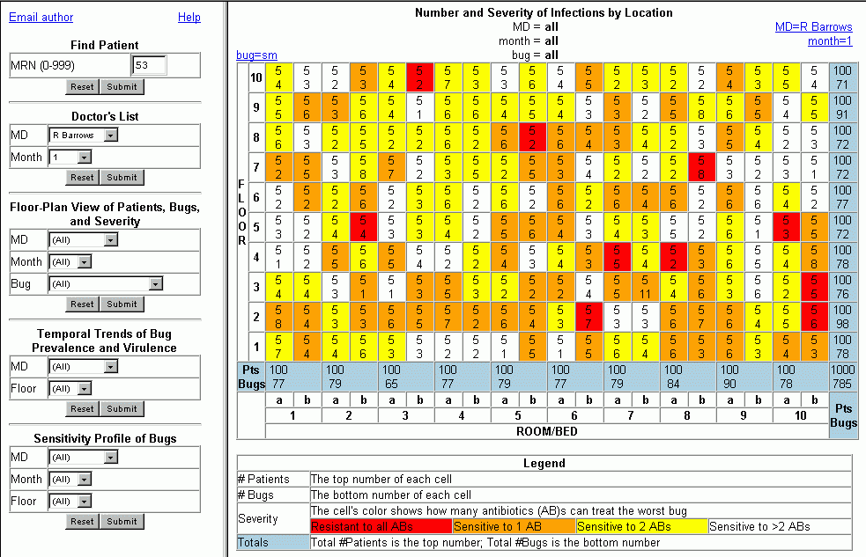
Figure 3: Floor-Plan View - Overview (LOC-O)

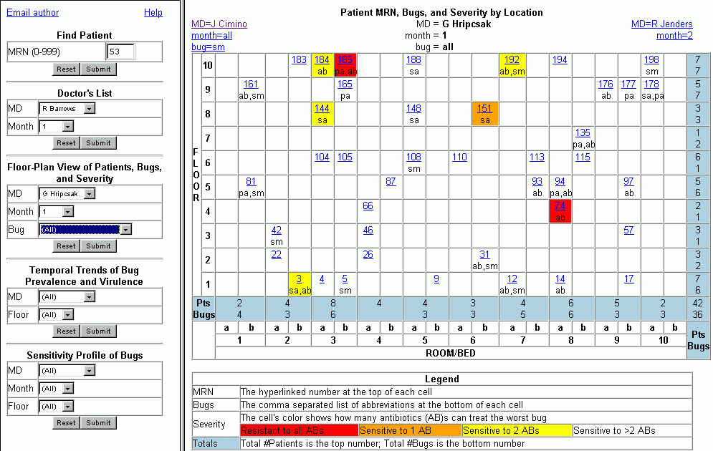
Figure 4: Floor-Plan View - Zoom (LOC-Z)

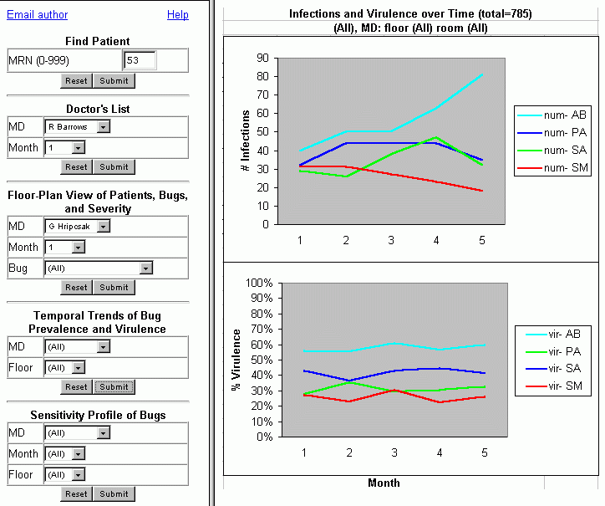
Figure 5: Time View (TIME)

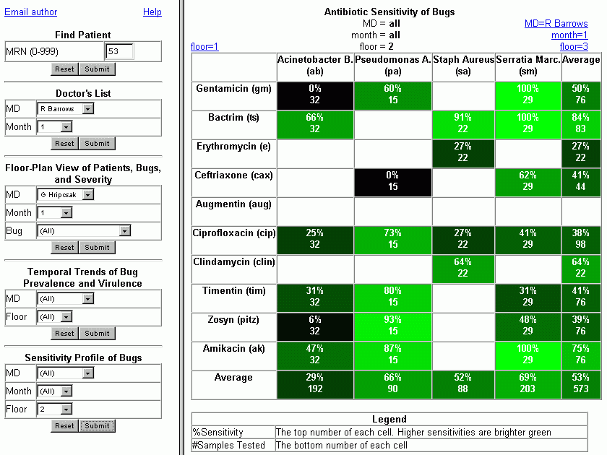
Figure 6: Sensitivity View (SENS)

Environment
The subject’s office, using their own computer and its connection to the web

Instructions to Subject
“Thank you for agreeing to help me evaluate the usability of the Bugs project. The goal of the project is to make it easier for hospital employees to track and manage infectious diseases (bugs) in patients. You will be asked to answer a series of questions using this interface. All of the questions can be answered. However the user interface may make it very difficult to answer some of the questions. Your task is to help us assess how difficult it is to answer the questions using the existing user interface, and to get your suggestions on how it might be improved. Please remember that if you can’t find an answer to a question, the problem is with the program, not you. So, please point your browser to the following URL (http://www.cpmc.columbia.edu/homepages/thw7001/bugs/index.htm), and we will begin. Please feel free to verbalize your thoughts and feelings as you work.”

Length of Observation
30 minutes, up to 24 questions. Each question can be divided into states (see dependent variables). All of these will be timed using the Time Motion Timer as a tool for facilitating the data collection.

Independent Variables
PRE: user name, location (setting), academic degree, academic title, years of medical training,
POST: 1-5 scale of understanding of each question.

Dependent Variables
(1) time to read question
(2) time to input query
(3) time to make a decision on the displayed answer (visit length) - getting answer or detecting dead-end
(4) accuracy and time-to-completion of answers
(5) search path to solution [order of navigation, time in each state, use of short-cuts between pages]
(6) time spent asking for clarification, commenting upon interface/task, or giving advice
(7) time spent distracted from task (e.g. by phone, pager, email)
(8) subset of the QUIS (Questionnaire for User Interaction Satisfaction) survey from U.MD

[Identifiers]
Name,10
Task#,5

[Events]
<process name="navigation">
a,iBtwn
b,iPat
c,iMd
d,iLoc
e,iTime
f,iSens
g,oPat
h,oMd
i,oLocO
j,oLocZ
k,oTime#
l,oTime%
m,oSens
n,back
o,forward
p,help
q,menu
r,linkMd
s,linkMonth
t,linkBug
u,linkFloor
v,linkPt
w,linkDrug
</process>
<process name="talk">
1,read question
2,ask clarification
3,suggestion
4,critique
5,talk
</process>
<process name="answer">
6,correct
7,incorrect
</process>
Figure 7: Configuration File for Time Motion Timer

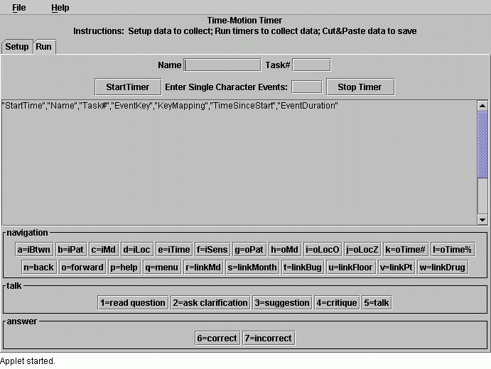
Figure 8: Screenshot of Usability Study Parameters

# | Question | Answer | Ways(s) to Find Answer
1 | Patient 185 was just admitted (month 1). What room was she sent to? | Floor 10, Room 3, Bed 2 | a) PAT - by MRN  b) LOC - by month
2 | Who is patient 185’s doctor? | G Hripcsak | a) PAT - by MRN  b) LOC - by month, then click MRN
3 | Is patient 185 sharing a room with anyone? | yes | a) LOC - click month from PAT  b) LOC - by month
4 | What bugs does patient 185 have? | pa, ab | a) PAT - by MRN  b) LOC - by month
5 | Why is patient 185’s room colored red? | poly-resistance | a) LOC - read legend  b) HELP - read instructions
6 | Which bug is poly-resistant? | ab | a) PAT - by MRN  b) PAT - click MRN from LOC
7 | What bug do patient 185 and her room-mate share? | ab | a) LOC - by MRN
8 | Are these bugs of the same serotype? | no | compare PAT for mrns 184 & 185
9 | How many patients does Hripcsak have in month 1? | 42 | a) LOC-Z - by MD and Month
10 | Assuming that all patients with bugs sensitive to 0 or 1 antibiotic should be isolated, how many of his patients need isolation in month 1? | 3 | a) LOC-Z - by MD and Month - count red and orange cells
11 | How many of his patients in month 1 are infected with Acinetobacter? | 14 | a) LOC-Z - by MD, Month & Bug  b) LOC-Z - click ‘bug=ab’ links from previous question
12 | How many patients did Hripcsak have over all 5 months? | 216 | a) LOC-O - by MD, month=all, bug=all
13 | How many of his patients had Staph aureus over all 5 months? | 34 | a) LOC-O
14 | How many of his patients had MRSA (poly-resistant Staph aureus) over the 5 months | 0 | a) LOC-O - no red cells, so no MRSA
15 | What drug should patient 179 be given? | Bactrim (T/S) | a) PAT - by MRN - bugs are both sensitive to T/S, and nothing else
16 | What drug should patient 94 be given? | Gentamicin (GM) | a) PAT & HELP - bugs are sensitive to GM, CP, and AK, but GM, the leftmost, is the cheapest
17 | Which bug has an increasing prevalence? | AB | a) TIME-I - num-AB increasing over time
18 | Which doctors do not have in increasing prevalence of AB? | Hripcsak, Starren | a) TIME-I - filter by each of the MDs
19 | What drug was never tested throughout the 5 months | Augmentin | a) SENS - default - all cells for aug are empty  b)
20 | A patient floor 2 comes down with a new case of Acinetobacter. Based upon the existing sensitivity profiles in the hospital, what is the best empiric therapy? | Bactrim (t/s) | a) SENS - filter by floor=2 - Bactrim has highest sensitivity
21 | What is the worst empiric therapy for the same patient? | Gentamicin (gm) | a) SENS - filter by floor=2 - Gentamicin has 0% sensitivity
22 | Which doctor has had the most patients on floor 3 over the 5 months? | Cimino (29) | a) LOC-Z - filter by default; then use arrow links to move between MDs
23 | Which patient had the most bugs (4) in month 1? | mrn 53 | a) LOC-Z - filter by month - look for widest column
24 | How many other patients had that many bugs simultaneously? | 1 - mrn 375 | a) LOC-Z - navigate months with arrow links
Table 1: Questions

RESULTS

What Worked
Accuracy
All of the subjects were able to accurately answer each question, although the amount of time required for each question ranged from two seconds to nearly a minute.

Speed of Learning
Since the subjects were not given any introduction to the functionality of this interface, all subjects felt it somewhat challenging to learn the interface. All of them immediately deduced that they should use the Patient View for the first several questions. However, as they moved to more complex questions, they did not know what functionality were provided by the other views; and did not know when to expect that there might be easier ways to solve particular tasks using different views. Had the subjects been shown a splash screen and/or screen-shots highlighting the available functionality; or been encouraged to read the help page which is organized by use cases; they might have more quickly detected the fastest way to answer each question.

Speed of Use
Even though the questions became increasingly challenging, the rate of solving questions uniformly increased as the subjects got further down the list of questions. Once the subjects realized how they needed to filter the data in order to answer a question, it only took a few clicks of the mouse on the pick-lists in order to pull up the correct data; and once the subjects saw a page of data, it seldom took more than a second to answer the question of interest. The subjects did not find the graphs intuitively obvious at first glance; however, after reading the legend provided with each graph, they found the graphs and tables easy to search, remember, and assess.

Ease of Retention
All of the subjects found it easy to remember what functionality each of the views provided. However, the complexity or wording of some of the questions allowed them to get side-tracked. For example, all of the subjects explored the SENS screen when asked question 8, even though the sensitivity profile could be clearly seen from the PAT and DOC views. This was a failure of expectation.

Problems with the Study Design
Data Collection
The Time-Motion-Timer (TMT) did not facilitate the usability assessment. Although the use of the state-based approach, and division into three mutually exclusive categories made conceptual sense, it was not easy to simultaneously observe the user’s actions and record their steps using this approach. Instead, it was more easier to use a short-hand to note which menus they accidentally navigated through, at the expense of losing quantitative timing information.

If the subject had been instructed to read the question themselves, rather than having the observer read the questions aloud, it might have been easier to use the Time-Motion Timer. Part of the challenge with the TMT was in shifting focus from the computer to the page of questions.

Another limitation of the TMT approach was the difficulty in changing the task number mid-stream. This may have reflected the rapidity of events involved in this assessment - for many of the questions, the total time from listening to a question and finding the answer was less than 5 seconds, yet involved more than one event per second.

Confusing Questions
The wording of several questions was confusing. Specifically, “serotype” in question 8 was meant to ask about the patient’s sensitivity profile, but was not recognized as such. “Virulence” and “severity” connote meanings other than the level of resistance of bugs.

Complexity of the Questions
Many of the questions did not have views which allowed the decision statistic to be directly assessed. For example, in order to answer question 22, the subject had to look at the floor summary view for floor 3 for each MD: there was no view which allowed that question to be answered in a single view. This was also true for question 18.

Other questions required open-ended exploration of the data. For example, question 24 required that the subject assess all 1000 patients to determine how many have 4 bugs. It took less than 5 seconds to answer this question using the LOC view, since the number of bugs affects the width. However, the one user who looked through the overall DOC view had a much harder time finding the two patients with 4 bugs.

Thus, although it was possible to answer quite complex questions using the five views provided, one could argue that this was a usability failure since there was not a specific view for each of these challenging questions.

Order Dependence of Questions
The order of the questions was designed to assess whether the subject noticed the availability of expert short-cuts and hyperlinks within the right-panel displays; or continued to use the left-panel pick-lists to navigate among related choices. However, this order dependence caused problems when the subject did not answer preceding questions in the expected manner. For example, it was expected that by question 5, the user would have discovered the Floor-Plan view, and thus would see that the cell was colored red. Since all of the users used the PAT view to look for a room-mate, none had yet seen the LOC view.

Comments about the Interface
General
- Hyperlinks overlooked
  - Navigation - none of the users realized that it was possible to navigate between neighboring data in the same view category (using the hyperlinks at the top left and right of each view)
  - Drill-down - none of the users consistently realized that they could connect different views of the data via hyperlinks within the cells of the tables. For example, from the LOC-Z view, the subject can click on the patient’s MRN to get to the PAT view. Similarly, it is possible to get to the DOC and LOC-Z views from the PAT view.
- Titles
  - Too small: The titles were easily overlooked since they were the same size as the text in the tables
  - Color focus - the directional hyperlinks in blue tended to grab the user’s attention rather than the centrally located titles. Thus, the subjects commonly thought that the titles were the right-most blue hyperlinks
- Speed
  - Eliminate Submit buttons - instead have immediate change in view based upon new value

Left-Panel Menu
- Cluttered
  - Try vertical frame-set - 5 views as hyperlinks on the top; each of which would pull up one of the sets of picks lists in the bottom frame
  - Try showing all 5 pick-list variables in a static frame, but change how they are used by radio buttons for the type of view - that way would not have to re-enter MD or Month in multiple places. Dilemma is that user might be confused by variables that don’t have any effect on views. If there were a way to gray-out the non-applicable variables, this problem could be alleviated.
- Lack of Use-specific directions
  - Although the help menu tells MDs, Nurses and Housekeeping how to answer typical questions, the fact that this information is available in the help was not obvious - no one found it.
  - Allow tailoring of menus to different user categories.
  - One of the users would have liked to see tailored views for the ten most common questions which need to be answered.

PAT View
- Hyperlinks overlooked
  - Link to DOC view
  - Link to LOC view
- Sensitivity profile useful
  - Subjects found it easy to figure out the best drug for a patient using this view
  - Cost - increasing from left to right (although inadvertently not labeled as such), makes it easy to answer question 16 - choosing among completing drugs

DOC View
- Failed Expectation
  - No totals - expected to answer questions 9 and 12 using this view.
  - Color saturation - the green coloration of sensitive drugs was hard to read

LOC-Z View
- Confusing totals
  - It took several seconds to realize that the light blue columns show the total number of patients and bugs. Users said that would have been easier if the word “Total” were used to label the columnns
  - Putting the totals in bold might make it more intuitively obvious that they are totals.
- Excessive coloring
  - Clinicians need to know which drugs are resistant to everything, but not necessarily resistant to one or two drugs. Thus, the yellow and possibly orange colors can be removed. However, if the administration sets a policy that dictates how rooms should be cleaned based upon the “severity” of the infections in the rooms, then it would be valuable to retain this feature.
  - Blue hyperlinks on red background is lousy combination; and black on red is low contrast, and thus fatiguing on the eyes.

LOC-O View
- Changing view based on month=’all’ versus individual month
  - LOC-O view shows total number of patients and bugs in each cell.
  - LOC-Z view shows patient MRN and list of bugs in each cell. Thus, the meaning of each cell changes depending upon whether the overview or zoom views are being used
  - Subjects did not find this change problematic, since the color coding by severity was used consistently.

TIME View
- Labeling
  - Subjects found the “num-“ and “vir-“ prefixes distracting in the legend. It would have been easier had they just shown the abbreviation of the bugs.
- Virulence unclear
  - The meaning of this statistic was not clear, or considered useful
  - Would have been better to show bar graph of counts of numbers of infections, color coded by bug; with the percent that are resistant to all bugs shown as a fraction of the bar height.
- Aesthetics
  - Line plots look odd when there is missing data
- Missing expectations
  - No ability to look at changes in sensitivity of individual drugs over time.

SENS View
- Unclear meaning
  - When asked about the best empiric drug for floor 2, the non-clinicians did not realize that they might want to filter by floor. So, they used the global view which recommends a different antibiotic. An explanation of how to use the data would have been beneficial
- Color saturation
  - one user liked the color saturation approach to showing the decision statistic.
  - Another subject would have preferred bar charts that only showed one bug at a time, rather than a table of all bugs.

Help
- Good features
  - Subjects liked the descriptions grouped by view and use-case.
- Bad featues
  - Using a screen shot of the pull-down menus made some users think that these were interactive menus.

CONCLUSIONS
The subjects found this interface appealing and easy to use, after a variable amount of challenge in learning to use it. Once they were aware of the ability to get detail on demand, they were more interested in exploring. The most consistent complaint, other than cosmetic issues, was the lack of tailoring to the needs of particular groups of users - rather than showing an obvious view of the answer to each question posed, the burden was often on the user to look at multiple charts and graphs to deduce an answer. However, they did appreciate the ability to find answers to potentially uncommon questions using these views.

