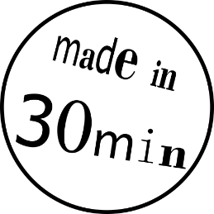3D-PRINT YOUR OWN KEY TAG

These instructions will guide you on your way to 3D-print your personalised key tag!

Overview

|  |  |
| --- | --- |
| The first step is to design your 3D-model in the easy-to-use CAD-program Tinkercad. | The process “slicing” then translates the 3D-model into the language of the 3D-printer, the G-code. |
| The G-code is sent to the 3D-printer, which creates your object by melting and depositing layers of plastic filament. | Finally, you will hold your first 3D-print in your own hands. The print will be yours to take home! |

Let’s go!

1. Open Tinkercad by clicking on the \\tmw.ac.at\hdd\users\fabiewil\Downloads\logo-tinkercad-128.png-icon on the desktop. If you are asked to log in, please call an explainer!
2. If the website is not in English scroll to the bottom of the page, click on the language next to the small world logo  and **select English.**
3. Click on An empty workspace will be opened.
4. Ein Bild, das Text enthält.

   Automatisch generierte BeschreibungGive your design a name. Click on the text in the top left corner above “Change name” and enter your name.
5. 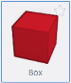On the right side you will find objects of various shapes. **Select the red “Box”**  by clicking once on it.
6. Move the Box into the middle of the workspace and drop it there by left-clicking.
7. Click on the small white square in the middle of the Box to adapt its height. Change the value of the **height** **to 2 mm**.
8. Click on one of the small white squares  at the corners of the Box. **Change the  
   width to 50 mm and the length to 20 mm.** 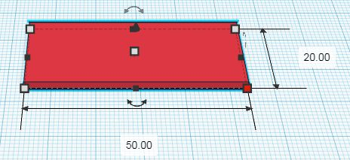
9. A key tag needs a hole! Get a **striped cylinder** and drop it onto the workspace.
10. Click on one of the white boxes of the **cylinder** and set **both values to 5 mm**.
11. Position the cylinder close to the left edge of the box. Moving can be done by using the arrow keys of the keyboard or by mouse.
12. 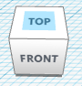It can be useful to change the view of your workspace. At the top left corner of the screen there is a white cube. Click on “TOP” of the cube to change the view to the top view.   
    *Pro-Tip: Try holding the right mouse button while moving the mouse.*
13. Hold down the combination  +  on the keyboard to select all elements, followed by  + to group them. Wait a little and the hole will be cut out!
14. Look for the -object on the right side and drag it onto your box.
15. To fill in your name, click on the textbox that reads “TEXT” on the right side of the screen (it should be next to the striped box). **Replace the “TEXT” with your name**.
16. **Change the** **height** of your name **to 3 mm** (see Step 7). The name only sticks out by 1 mm, because the bottom of the name is flush with the bottom of the box.
17. Adjust the width and the length of your name so that it fits onto the red box.

**YOU ARE DONE! Ask an explainer for the next steps**

* You can also work further on your design! Adding or cutting out shapes, rounding corners, the possibilities are endless! Just keep in mind to keep your design small:   
  an object of doubled size takes 8 times as long to print!
* 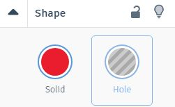Any shape can be a hole! Click on the object and then select the striped circle on the right to turn the object into a hole.
* You might want to change the z-position (level) of an object. To achieve this, hold down  and press the H:\Museumspädagogik\techLAB\easy things to do\_Grafikvorlagen\Keyboard_icons\300dpi\big\cursor-down_big.png or H:\Museumspädagogik\techLAB\easy things to do\_Grafikvorlagen\Keyboard_icons\300dpi\big\cursor-up_big.png -key on the keyboard. Changing the view to a side view is a good idea to make the z-positioning of objects easier.