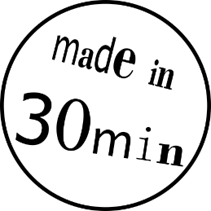**3D-PRINT YOUR OWN KEY TAG**

These instructions will guide you on your way to 3D-print your personalised key tag!

Overview

|  |  |
| --- | --- |
| The first step is to design your 3D-model in the easy-to-use CAD-program Tinkercad. | The process “slicing” then translates the 3D-model into the language of the 3D-printer, the G-code. |
| The G-code is sent to the 3D-printer, which creates your object by melting and depositing layers of plastic filament. | Finally, you will hold your first 3D-print in your own hands. The print will be yours to take home! |

Let’s go!

1. Open Tinkercad by clicking on the \\tmw.ac.at\hdd\users\fabiewil\Downloads\logo-tinkercad-128.png-icon on the desktop
2. If the website is not in English scroll to the bottom of the page, click on the language next to the small world logo  and **select English.**
3. Go back to the top of the page and click on . An empty workspace will be opened.
4. Ein Bild, das Text enthält.

   Automatisch generierte BeschreibungName your design. Click on the text in the top left corner and enter your name.

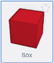

1. On the right side you will find objects of various shapes. **Drag the red “Box”** onto the workspace by keeping the left mouse button, place it by releasing the mouse button.
2. 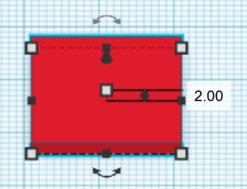Click on the small white square  in the middle of the Box to adapt its height. Change the value of the **height from 20 mm to 2 mm**.
3. Click on one of the small white squares at the corners of the Box. **Change the  
   width to 50 mm and the length to 20 mm.**

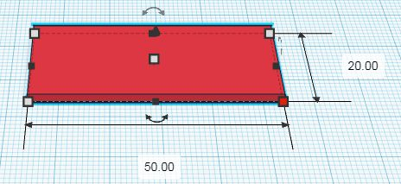

1. A key tag needs a hole! Get a **striped cylinder** and drop it onto the workspace.
2. Click on one of the white boxes of the **cylinder** and set **both values to 5 mm**.
3. 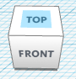It can be useful to change the view of your workspace to place your hole correctly. At the top left corner of the screen there is a white cube. Click on “TOP” of the cube to change the view to the top view.

*Pro-Tip: Try holding the right mouse button while moving the mouse.*

1. Position the cylinder close to the **left edge of the box** by using the arrow keys of the keyboard to **move the cylinder**.
2. Hold down the combination  +  on the keyboard to select all elements, followed by  + to group them. Wait a little and the hole will be cut out!
3. 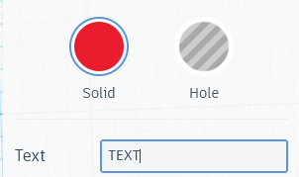Look for the -object on the right side and drag it onto your box.
4. To fill in your name, click on the textbox that reads “TEXT” on the right side of the screen (it should be next to the striped box). **Replace the “TEXT” with your name**.
5. **Change the** **height** of your name **to 3 mm** (see Step 6). The name only sticks out by 1 mm, because the bottom of the name is flush with the bottom of the box.
6. Adjust the width and the length of the text by keeping the left mouse button pressed on one of the white boxes in the corner. Move the mouse into the desired direction.

**YOU ARE DONE! Ask an explainer for the next steps**

* Now you can customize your design further. Adding or cutting out objects, bevelling corners, the possibilities are endless.
* Any shape can be a hole! Click on the object and then select the striped circle on the right to turn the object into a hole.