**3D-PRINT YOUR OWN KEY TAG**

**Overview**These instructions will guide you on your way to 3D-model your personalised key tag!   
Take your finished 3D-model to the techLAB of the “Technisches Museum Wien” to get it printed on one of our 3D-printers. The 3D-print will be yours to take home!

|  |  |
| --- | --- |
| At home you can design your 3D-model with the easy-to-use program Tinkercad. | Later you will be able to 3D-print your design with a 3D-printer in the techLAB! |

**Step-by-step instructions**

1. Open your internet browser and enter [www.tinkercad.com](http://www.tinkercad.com) into the address bar.
2. If the website is not in English scroll to the bottom of the page, click on the language next to the small world logo  and **select English.**
3. Click on the “JOIN NOW”-button in the top right corner.
4. Choose “Create a personal account” and complete the sign-up process.
5. Click on the -icon in the top left corner.
6. Click on . An empty workspace will be opened.
7. 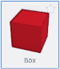Give your design a name. Next to the -icon you will find a weird text. Click on it and enter “Keytag\_Yourfirstname” (without the quotation marks).
8. On the right side you will find objects of various shapes. Select the red “Box” by clicking once on it.
9. Move the Box into the middle of the workspace and drop it there by left-clicking.
10. Click on the small white square in the middle of the Box to adapt its height.  
    Change the value of the **height** **to 2 mm**.
11. Click on one of the small white squares  at the corners of the Box. **Change the  
    width to 50 mm and the length to 20 mm.** 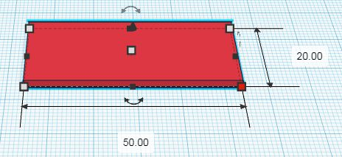
12. A key tag needs a hole! Get a **striped cylinder** and drop it onto the workspace.
13. Click on one of the white squares of the **cylinder** and set **both values to 5 mm**.
14. Position the cylinder close to the left edge of the box. Moving can be done by using the arrow keys of the keyboard or by mouse.
15. 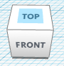It can be useful to change the view of your workspace. At the top left corner of the screen there is a white cube. Click on “TOP” of the cube to change the view to the top view.   
    *Pro-Tip: Try holding the right mouse button while moving the mouse.*
16. Hold down the combination H:\Museumspädagogik\techLAB\easy things to do\_Grafikvorlagen\Keyboard_icons\300dpi\big\ctrl_big.png +  on the keyboard to select all elements, followed by H:\Museumspädagogik\techLAB\easy things to do\_Grafikvorlagen\Keyboard_icons\300dpi\big\ctrl_big.png +  to group them. Wait a little and the hole will be cut out!
17. Look for the H:\Museumspädagogik\techLAB\easy things to do\Lesezeichen 3D-drucken\tinkercad_object_text.jpg object on the right side and drag it onto your box.
18. To fill in your name, click on the textbox that reads “TEXT” on the right side of the screen. It should be next to the striped box. **Replace the “TEXT” with your name**.
19. **Change the height** of your name **to 3 mm** (see Step 10). The name only sticks out by 1 mm, because the bottom of the name is flush with the bottom of the box.
20. Adjust the width and the length of your name so that it fits onto the red box.
21. You can also work further on your design. Adding or cutting out shapes, rounding corners, the possibilities are endless! Just keep in mind to keep your design small:   
    an object of twice the size takes eight times as long to print!
22. When your design is finished, click on  in the top right corner to save your design as an .STL-File on your Computer.
23. If you want to 3D-print your key tag, bring your .STL-File to the techLAB on your next visit. Our explainers will show you how the 3D-printing process works!

You can explore many more exciting new technologies in our **techLAB**! Make sure to come by on your next visit to the “**Technisches Museum Wien**”. Please check the techLABs opening hours[**online**](https://www.technischesmuseum.at/techlab-1)**.**

**We look forward to your visit!**