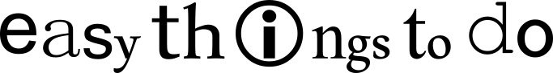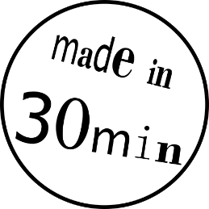LASER-ENGRAVING A KEYCHAIN

In this tutorial you learn to design a keychain with your name on it. Once you are done with the design, we will help you to cut and engrave your keychain from a piece of plywood using a real laser cutter!

Overview

|  |  |
| --- | --- |
| First you draw your keychain in “Inkscape”. | You can decide what shape you want it to be and what you want to have on it. |
| Then we will help you to send the file to the laser cutter. | In the end you get your own laser-engraved keychain that you can take home! |

**Drawing the basic shape:**

1. Open the app “Inkscape“ Quellbild anzeigen  
   It should show you a blank DIN A4 page.
2. Left-click the rectangle tool and use the mouse to draw the outer shape of your keychain. Size doesn’t matter yet.

*Pro-tip: If you want, you can also make your key chain round, star-shaped or any other shape.*

1. 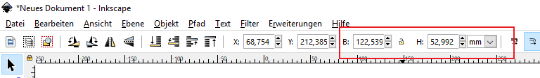Click the arrow tool  and select your shape by left-clicking it once. Now you can use the fields „B“ (width) and „H“ (height) above the drawing to set the size of your keychain, e.g. 20x50 mm. Make sure the right measurement unit is selected (mm or cm)!
2. 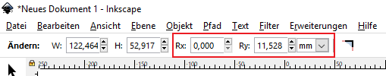If you double-click your shape with the arrow tool  you can use the „Rx“ and „Ry“ fields to round its corners. You can also try entering different values for x and y!
3. 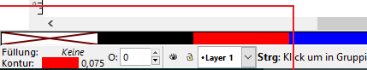The laser cutter is set to cut red lines and engrave anything that’s black. Select red by holding down the -key and clicking red in the bottom-left corner. If your shape is filled with colour, click the red X on white background (“No fill”).
4. If lines are too wide, the laser cutter will not cut them. Set the stroke width by selecting your shape and pressing  +  + . The „Füllung und Kontur“ (Fill and stroke) pane will open on the right-hand side of your screen. In the  
   „Muster der Kontur“ (stroke pattern) tab, change the width to 0.075 mm.   
   Make sure to use a decimal point, not a decimal comma!
5. In the „Farbe der Kontur“(stroke colour) tab you can check whether the colour is set to „RGBA 255, 0, 0, 255“and “Deckkraft” (opacity) is at 100%.
6. If you want to put your tag onto a key ring, it needs a hole. Use the tool to draw a circle. Go back to the arrow tool, select the circle and enter 5 mm in the “B” and “H” fields. Now you can move the circle to the right spot using the arrow keys on your keyboard.
7. The circle needs to be red with 0.075 mm stroke width too (see 5-7).  
   Congratulations! The basic shape is done!

**Engraving:**

1. What do you want to put on your keychain? Use the text toolto write something, e.g. your name. Simply click into your frame and start writing!
2. If you want to change the font or size, press  +  +  to open the text options pane. Always click on “Anwenden” to apply your changes. If you want to change the font size again, you need to re-select the text.  
   Hint: you can always change your text later by double-clicking it!
3. If you have and space left, use the shape tools (rectangle, circle, polygon/star, freehand tool) to draw one or more decorative shapes next to your text.  
   *Hint: always go back to the arrow tool after drawing a shape or writing/editing text or you’ll keep creating new objects!  
   Reminder: red lines are cut through the material, black lines and shapes are engraved (burned) into the surface.*
4. If you want a shape to be cut out, select it and change the colour to red (see 5-7).
5. 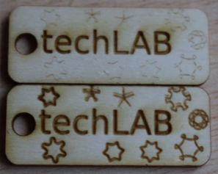If you want to engrave a shape without fill (circle, star, polygon etc.), you need to select it and choose „Kontur in Pfad umwandeln” in the “Pfad” menu, otherwise it will only be engraved as a hairline (top example in the picture).
6. **Changing object size:**   
   If you click an object using the arrow tool, they’re selected. You can use the arrows on the corners to change the object’s size. Press  while dragging to keep the aspect ratio (width to height ratio) fixed.
7. **Moving objects:**  
   Hover over an object with the arrow tool. The pointer changes to crossed arrows. Now you can hold down the left mouse button and drag the object.
8. **Rotating objects:**  
   Click the object again. The shape of the arrow handles changes to round. Now you can rotate the object.
9. If you’re happy with the result, call an explainer. Press  +  to save. Name your file “Keychain_Yourfirstname” and save it to the folder “_PROJEKTE\Lasercutter” on the desktop.