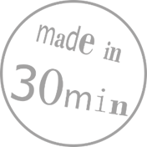**LASERCUTTING A KEY TAG**



In this tutorial you learn how to design a key tag using the program Inkscape .

The Laser Cutter will then cut out your design out of plywood.

|  |  |  |
| --- | --- | --- |
|  |  |  |
|  | First you create a 2D-design using the vector graphics program Inkscape. | Finally, the laser cutter engraves and cuts your design out of plywood. |

1. Create the basic shape of the key tag. Select theRectangle-Tool and draw a rectangle on the white work plane by keeping the left mouse button pressed.
2. The size of your key tag can be adjusted in the toolbar at the top left. Change the values for the width (B) and the height (H) to B = 50 mm und H = 20 mm.
3. You can change the roundness of the rectangle corners with the values Rx and Ry.  
   If you want to have sharp corners, set both values to 0 mm.
4. Press the  -key, to adapt the zoom to your drawing. It’ll be easier to draw like this!
5. The laser cutter **engraves** all **black areas** and cuts red lines. The colour palette underneath the work plane is to change the colour of the fill and the contour of the shape.

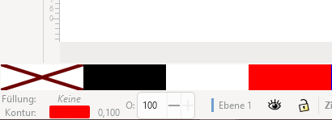

1. Choose „no fill“, by clicking on the -button.
2. Change the stroke colour to red, by clicking on the  -button while pressing the Ein Bild, das Text, Monitor enthält.

   Automatisch generierte Beschreibung -key.
3. The thickness of the line has to be **≤**0,1 mm, to be recognized as a cutting line. Right click onto the number next to the strokecolor and change the thickness to 0,1 mm.

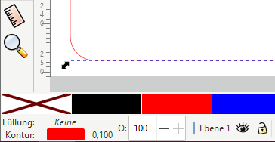

1. Your key tag needs a hole! Use the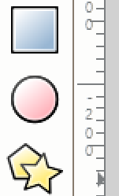 -tool to draw a circle and change the radius-values Rx and Ry (on the top left) to 2.5 mm.

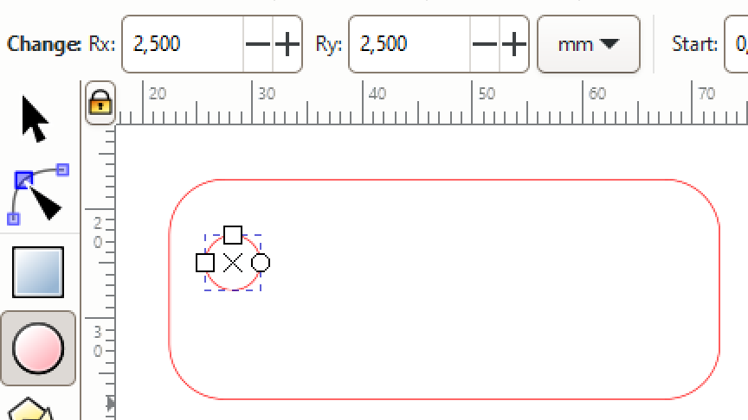

1. Choose the-tool to position your hole. Move the circle with the Ein Bild, das Text, Elektronik, ClipArt enthält.

   Automatisch generierte Beschreibung-keys on the keyboard.
2. Now you can add some text to your key tag – e.g. your name. Choose the tool from the left and click into your key tag. You can just start writing!
3. You can change the font and size in the toolbar at the top left.

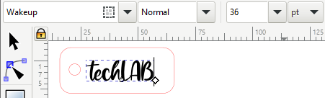

**DONE! Ask for help to cut your key tag 😊**

* You can improve your design: **Engrave shapes** or cut them out, bevel corners, the possibilities are endless!
* You can also choose a different shape for the base e.g., a star or an ellipse.