****Program a micro:bit!

Are you dreaming of programing your own games, or would you simply like to experience what it means to “program” a computer? This tutorial will show you how to write code for a micro:bit minicomputer: Welcome to the world of programming!

What is a micro:bit?

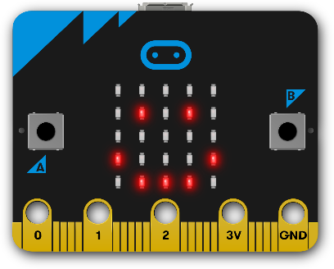 The micro:bit is a minicomputer with a “screen” consisting of 25 LEDs and a keyboard consisting of 2 Buttons (A & B). Additionally, it has built-in sensors for measuring movements and the brightness of lights. You can program a micro:bit on a regular computer and upload the program via USB-cable.

MakeCode Programming-Editor

A Here you can find the blocks used for programming. Every block is an instruction.

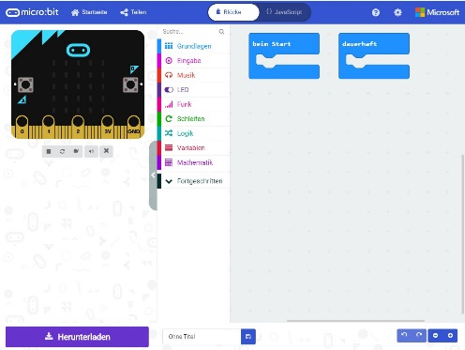

C

A

B

B Move blocks into this area to create your program.

C You can try your program with the “v**irtual micro:bit“**.

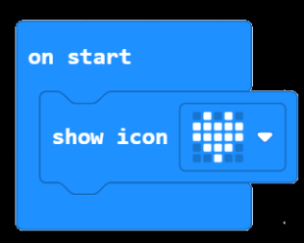

1. In area A: Click onto  and drag a Ein Bild, das Electric Blue (Farbe), Screenshot, Text, Schrift enthält.

   Automatisch generierte Beschreibung-block into area B. Connect it into the block “on start”.
2. Click on , to save your program on the micro:bit. **Now your micro:bit is running your first program!**
3. 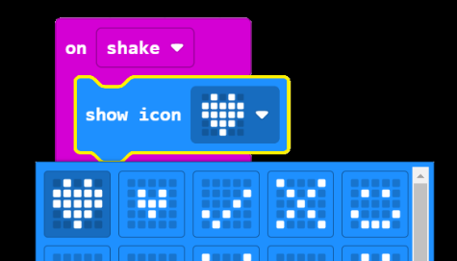Now we can add more code: The micro:bit can react if you shake it. Click on  and drag a 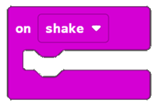 -block into area A.
4. Connect the „show icon“-block into the “on shake“-block. You can also change the icon by clicking onto the heart.
5. Save the finished program onto the micro:bit. If you shake the micro:bit it will show your icon.

**Congratulations!** You now know the basics for programming a micro:bit. You can now try out new blocks or the Bonus-Level below!

[](https://emojipedia.org/google/android-10.0-march-2020-feature-drop/thinking-face/)

Bonus-Level

Program a “virtual” dice! You can useand the -block from . Let the micro:bit show a random number between 1 and 6 on the display, if the micro:bit is shaken. Good Luck!

*Tip: Click onto the* *-Logo on the top left to get back to the main menu. There you can find more instructions to try out!*

i-=-2