**Program a micro:bit!**

Are you dreaming of programing your own games or would you simply like to experience what it means to “program” a computer? This tutorial will show you how to write code for a micro:bit minicomputer: Welcome to the world of programming!

What is a micro:bit?

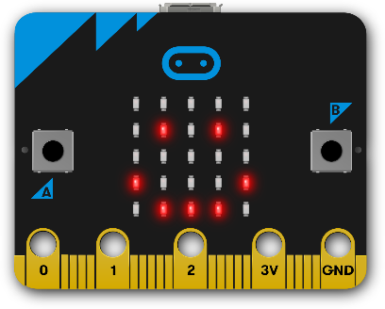The micro:bit is a minicomputer with a “screen” consisting of 25 LEDs, two Buttons (A & B) and some other sensors. You can program a micro:bit on a regular computer and upload the program via USB-cable. You don’t need a real micro:bit to start coding: everything you need is a computer connected to the internet!!

**Let’s go!**

1. 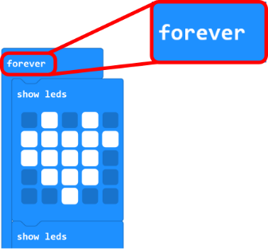Go to the website <https://makecode.microbit.org.>
2. Click on the tutorial „Flashing Heart“ and then on “Blocks”.

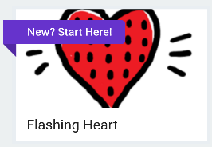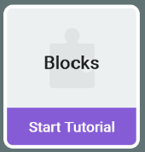

1. Follow the tutorial to program a blinking heart animation!   
   When you are done with a step, click on the   
   orange “Next”-Button.

*TIP: Click on the -icon to get a hint for the current challenge.*

1. Your program is now running on the “virtual micro:bit” in the top left corner! If your micro:bit is not showing a blink heart after step 4 , check if your code is inside the  block, and **not** inside the -block.

*Pro-Tip:**The blocks inside the* *-Block will only be executed ONCE at startup. The Blocks inside the* *-Block will be executed again and again!*

1. Once you are done with the tutorial, click on  .

Buttons A & B

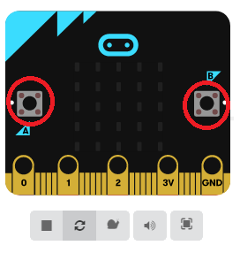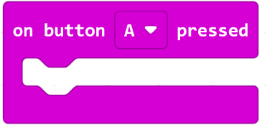You can control your micro:bit using the two buttons “A” and “B”. They work just like the buttons of a gamepad! You can program what happens when you press them, by using the block on the right.  
You can find it by clicking on 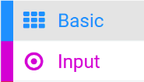 .

1. 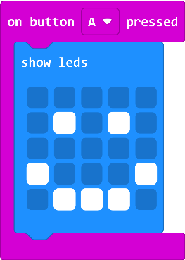Add a „on button A pressed”-block to your program by dragging it into the area on the right.
2. Go back to the blue blocks by clicking on . Take a “show LEDs”-block and dock it inside the “on button A pressed”-block. You can draw any shape by clicking on the pixels inside the block – a smiley for example!
3. Now press the “A” button  on your virtual micro:bit in the upper left corner, and it will show a smiley for a moment and then continue to blink. Congratulations, you programmed your first animation!

[](https://emojipedia.org/google/android-10.0-march-2020-feature-drop/thinking-face/)

Bonus Level:

Program a „virtual“ game of dice! You can use the Ein Bild, das Text enthält.
and the Ein Bild, das Text enthält.
block from  to do so.

Let a random number between 1 and 6 be generated every time you press „A“!

Good luck!

*Pro-Tip: Click on the*  *logo to get back to the main menu. There you will find many other tutorials to continue your programming journey!*

At the techLAB we have real micro:bits that you can use to try out your programs!

If you visit us at the Technical Museum Vienna you can also work with 3D printers, lasercutters, embroidery machines and more. You can find the opening hours online. Entry is free for everybody under 19 years of age!

We’re looking forward to your visit!