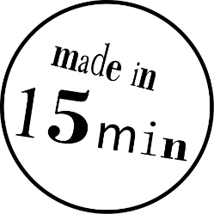Create your own sticker

Here you can design a sticker with a word, for example your first name, and cut it on the vinyl plotter.

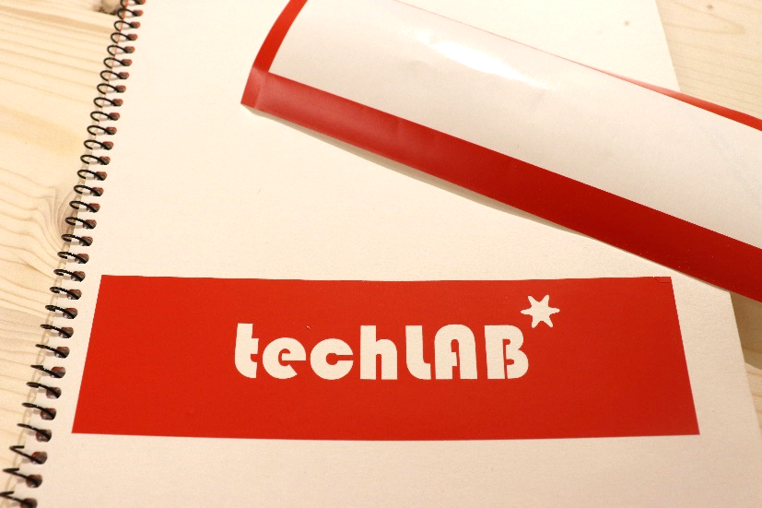

1. Open the template „Vorlage Sticker“ in the folder „Vorlagen“ on the desktop.
2. The app Inkscape is now open and you can see a frame with a sample text “. Click the arrow tool  and double-click the sample text.
3. You now get a text cursor that lets you edit or delete the sample text and write your own.
4. Pro-Tip: You can find more detailed descriptions of the different tools in our Inkscape tutorial.
5. Press H:\Museumspädagogik\techLAB\easy things to do\VC_Sticker\Grafiken\Shortcuts\strg (big).png+ H:\Museumspädagogik\techLAB\easy things to do\VC_Sticker\Grafiken\Shortcuts\shift (DE_big).png+ H:\Museumspädagogik\techLAB\easy things to do\VC_Sticker\Grafiken\Shortcuts\t.png (Ctrl + Shift +T) to open the text options. Here you can change the font and text size. Always click “Anwenden” to apply your changes! Make sure the text doesn’t get larger than the border!
6. Use the drawing tools (rectangle, circle, polygon/star, freehand, line) to draw one or more decorations next to your text. After each object, make sure to go back to the arrow tool or you’ll keep drawing new objects! Make sure the object is a closed shape, i.e. if you follow the outer edge of the object you have to be able to trace it endlessly without taking your finger off. A single line only represents one cut, which is not sufficiently visible on the sticker.
7. If you select objects using the arrow tool, they’re highlighted. Now you can use the corner handles H:\Museumspädagogik\techLAB\easy things to do\_Grafikvorlagen\Software\Inkscape\inkscape_AnfasserGroesse.png to change its size.
8. If you move the mouse pointer onto the border of an object, crossed arrows will appear: H:\Museumspädagogik\techLAB\easy things to do\VC_Sticker\Grafiken\Inkscape_MoveCursor.png. Now you can move objects by holding down the left mouse button.
9. If you click the object once more, the shape of the handles change: 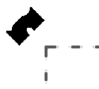. Now you can rotate the object by holding down the left mouse button.
10. You can also change your sticker’s outer shape. The sticker shouldn’t get bigger than the template though. When in doubt, ask an explainer.
11. If you’re happy with your sticker, call an explainer.
12. Once an explainer approves you can save your design by pressing H:\Museumspädagogik\techLAB\easy things to do\VC_Sticker\Grafiken\Shortcuts\strg (big).png+H:\Museumspädagogik\techLAB\easy things to do\VC_Sticker\Grafiken\Shortcuts\s.png. Click on the field “Schnellzugriff” H:\Museumspädagogik\techLAB\easy things to do\VC_Sticker\Grafiken\SchnellzugriffSymbol.png and then on the folder “\_Schneidplotter”. Name it “Sticker\_YourFirstname” in the field “Dateiname”.
13. Now press H:\Museumspädagogik\techLAB\easy things to do\VC_Sticker\Grafiken\Shortcuts\strg (big).png+H:\Museumspädagogik\techLAB\easy things to do\VC_Sticker\Grafiken\Shortcuts\shift (DE_big).png+H:\Museumspädagogik\techLAB\easy things to do\VC_Sticker\Grafiken\Shortcuts\s.png to save the file as a different datatype. Choose the type “PDF” for the field “Dateityp” and save it to the same folder. (Just click “OK” in the following dialogue box.)
14. Pick a colour from the available adhesive films. An explainer will cut the sticker for you.
15. Now you can decide whether your sticker will be the „frame“ with cut-out letters or the individual letter (see the picture below).



1. Once your sticker is cut you need to „weed it“, that means remove all parts you don’t want using a pointy tool.

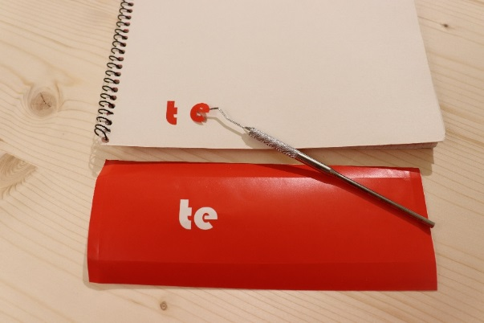

1. What can you do with the sticker? Put it onto your school books, onto a window at home, onto your skateboard etc. The film should peel off of smooth, hard surfaces pretty easily if you no longer want it.