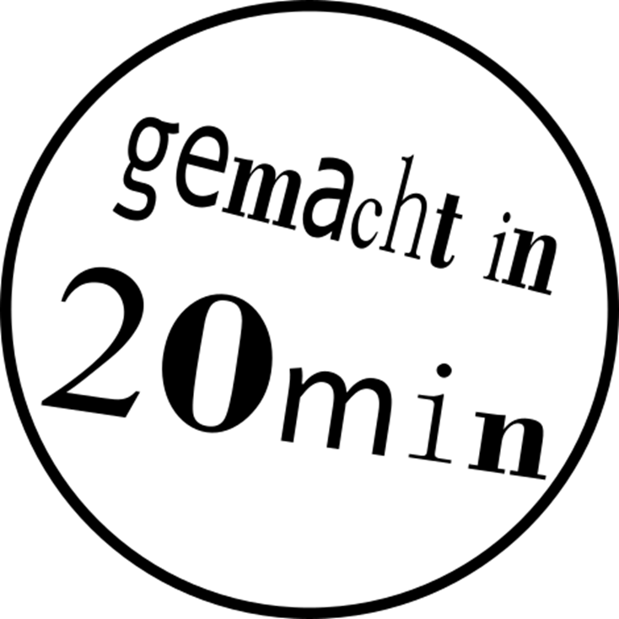**VINYL CUT STICKER 

These instructions will show you how to design a personalised sticker using the program **Inkscape**. You can then cut out your sticker using a vinyl cutter!

|  |  |  |
| --- | --- | --- |
|  |  |  |
|  | First you will design your sticker using the vector graphics program Inkscape. | The vinyl cutter will then cut your design into a vinyl sticker foil. |

1. ****Create the basic shape of your sticker. Select theRectangle-Tool on the left and draw on the white work plane by keeping the left mouse button pressed.

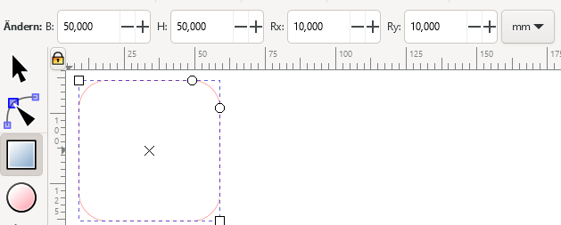

1. The **size** of your sticker can be adjusted in the toolbar at the top left. Change the values for width (B) and height (H), for example to **B = 50 mm and H = 50 mm**.   
   *Note: The maximum size for your sticker is 150 x 100 mm.*
2. You can change the **roundness** of the rectangle’s **corners** with the values **Rx** and **Ry**.   
   If you want sharp corners, set both values to 0 mm.
3. Press the key Ein Bild, das Text, Uhr enthält.

   Automatisch generierte Beschreibung to zoom into your drawing. It’s easier to work that way!
4. You can add some text to your sticker, e.g. your name. Select the text tool on the left, click onto your sticker and start writing.
5. You can change the font und size of the text in the toolbar on the top left.

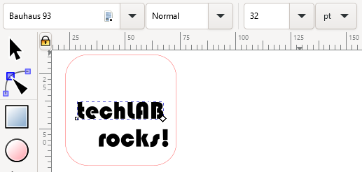

1. Now you can add more shapes to your sticker. The  **Star- and Polygon-Tool** are the best shapes for a sticker**.** You can try out different values for the settings „**Ecken**“ (=corners) und „**Spitzenverhältnis**“ (=Spoke ratio).

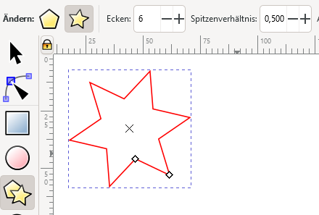

1. If you want to **change the position of the object** or the **size**, choose the  **arrow-tool** first. Move the object with the 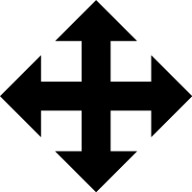 cross or change the size with the  diagonal arrow.

**DONE! Ask for help for cutting out the sticker 😊**

Ein Bild, das Text, Whiteboard enthält.

* circles  stars are also ideal basic shapes for the sticker
* 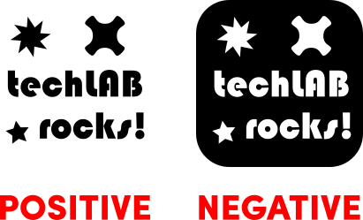You can use the Positive or the Negative of your sticker! à