## **Cryptography Homework**

The main part of this homework assignment is focused around reinforcing the cryptography topics covered in class this week.

We have also included a reminder about Career Services and completing milestones. Make sure to complete your milestone to become employer competitive.

## **Cryptography Homework: Ransomware Riddles**

### **Background**

In this homework assignment, you will play the role of a cybersecurity analyst at Nakatomi Hospital.

* Unfortunately, one of the hospital's doctors opened up an email containing ransomware.
* This ransomware spread throughout the hospital and encrypted all of the Patient Records.
* The ransomware has given you two options to decrypt and retrieve the patient records: Either pay 100 bitcoins or solve six riddles.
* Since you refuse to pay off any ransom, you'll have to solve six cryptographic riddles. Act fast: the doctors need to access the patient records as lives are at stake!

Additionally, a **Career Service Milestone** is located at the end of this file. Complete it to learn how to become more *Employer Ready*.

### **Topics Covered in Your Assignments**

* Encryption
* Decryption
* Caesar Cipher
* Encoding and Decoding
* Binary
* Symmetric and Asymmetric Encryption
* Open SSL
* Key/IV
* Public/Private Keys
* Key Distribution
* Hashing
* Hashing Algorithms
* Hashcat
* Steganography
* Steghide

### **Files Required**

The entire homework assignment can be completed on a publicly available website linked below. If for any reason, the website has issues or is unavailable, an offline copy has also been provided.

* **Website:**<https://sites.google.com/view/cryptobreakout/>
* **Offline Copy:** Crypto_Homework  
  + *If you complete the offline version, you will simply need to submit your answers to the instructor.*

### **Instructions:**

In order to solve each riddle, you will need to apply cryptographic concepts covered in the past three lessons. concepts will need to be applied.

* Once the riddle has been solved, submit your answer on the bottom of each Riddle Page.
* If you are correct, you will receive a **key**. Save this key in your notes.
* Once you have collected all six keys, select the Ransomware Decrypted header on the website and enter all your keys.
* If all the six keys are correct, the ransomware will be removed and the data will be decrypted.
* You will need to **submit a screenshot** as proof that the ransomware has been decrypted.

Good luck and act fast as the Nakatomi Patients are counting on you!

1: 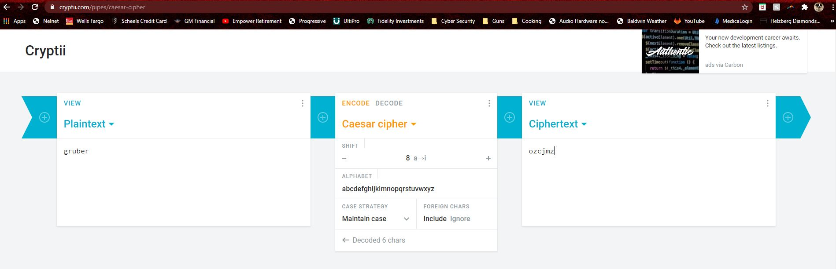

2:

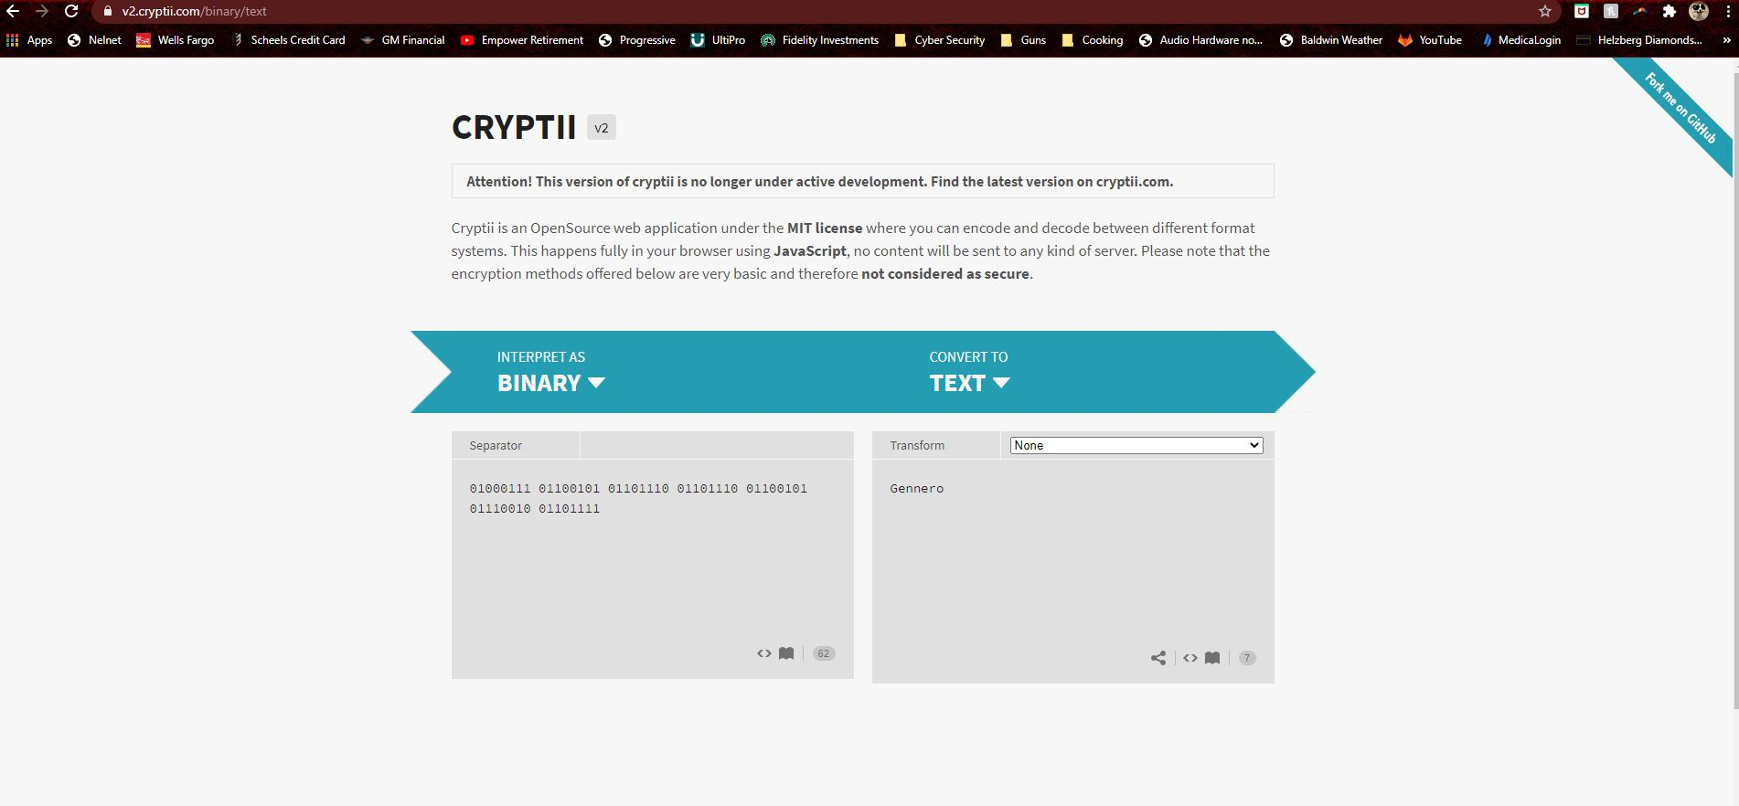

3: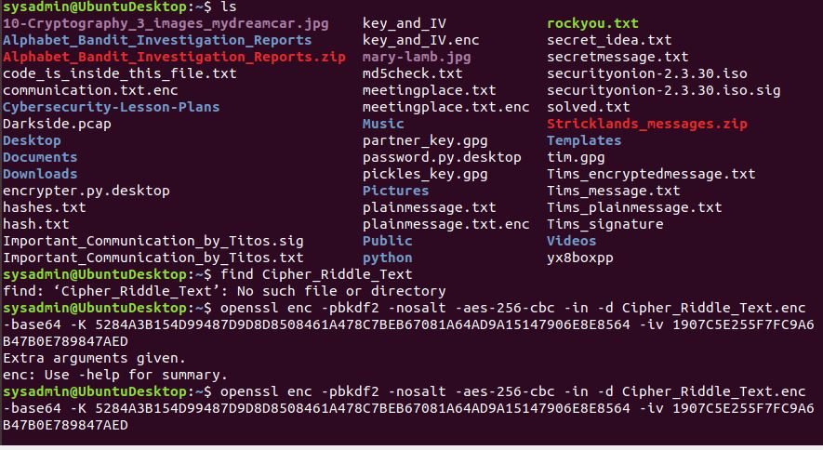

4:

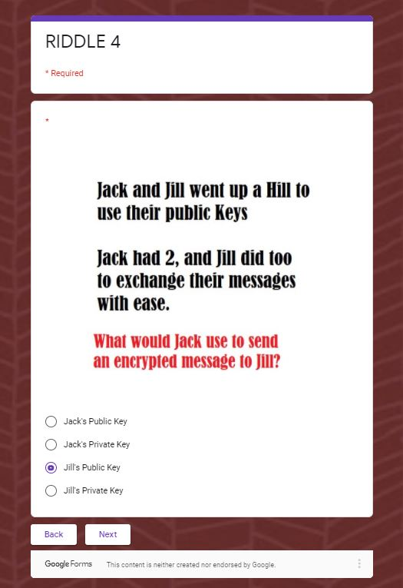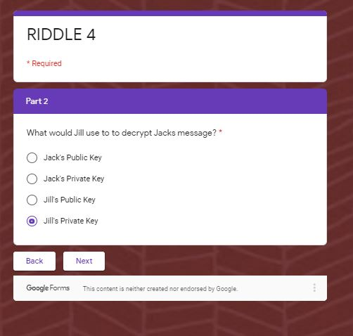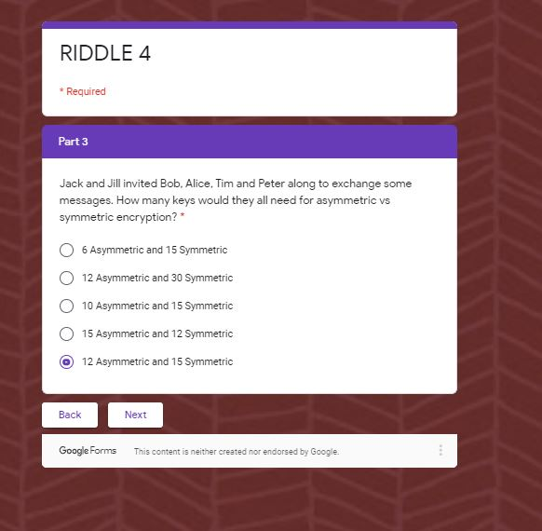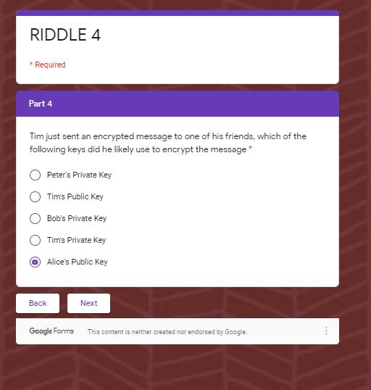

5:

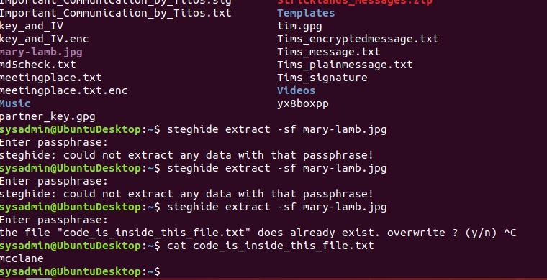

6:

