**IOT Project Document - CODE**

Contents

1. Architecture 1

2. Hardware 1

3. Software 1

4. Install locally (for development purposes) 2

4.1. Backend 2

4.2. Arduino 2

4.3. Esp32 2

4.4. Frontend 4

5. Deploy to the Internet 4

5.1. Backend 4

5.1.1. Update Esp32’s firmware 4

5.1.2. Update frontend 4

5.2. Frontend 4

# Notes

GitHub repository: <https://github.com/thanhlongb/c4s-iot-project/>

Shared to the following email: [manh.nguyentuan@rmit.edu.vn](mailto:manh.nguyentuan@rmit.edu.vn)

# Architecture

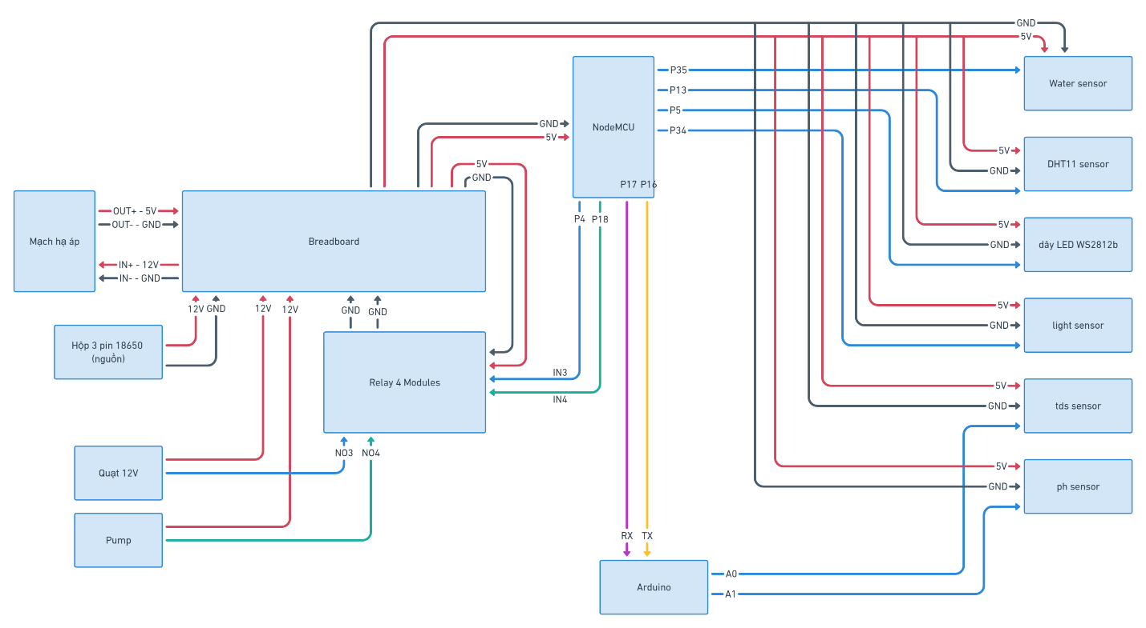

*Figure 1: Circuit diagram*

# Hardware

The system consists of three main hardware components:

1. **A laptop or server**: for running the web-socket server, which acts as the middle-man between the Esp32 and the dashboard.
2. **An Esp32 (NodeMCU-32S,** [**datasheet**](https://docs.ai-thinker.com/_media/esp32/docs/nodemcu-32s_product_specification.pdf)**)**: for collecting data from sensors (water level, moisture and humidity, light exposure) and also receiving commands from web dashboard to control other components, specifically: fan, water pump, LED light.
3. **An Arduino UNO**: for collecting data from analog-output sensors such as the TDS and pH sensors since the analog input from the Esp32 give weird results.

Other components are shown in the Figure 1.

# 3. Software

This project’s repository has four main folders:

1. **/frontend**: contains NextJS-based (a framework built on top of ReactJS) application which serve the web dashboard.
2. **/backend**: contains the Nodejs backend code for running a web-socket server.
3. **/esp32**: firmware for the Esp32.
4. **/arduino**: firmware for the Arduino.

# 4. Install locally (for development purposes)

For the system to work, **all three main components must be in the same Local Area Network**, otherwise, they will not be able to communicate with each other. It is advised to setup the system step by step with the below order from top to bottom:

1. Backend
2. Arduino
3. Esp32
4. Frontend

## 4.1. Backend

The backend is a crucial piece in this system. Without it, there will be no data displayed on the web dashboard. Follow these instructions to run the backend:

1. Go to **/backend** folder.
2. Run **npm i**
3. Run **npm start**
4. Done.

## 4.2. Arduino

*\* This section is only FYI since the Arduino already has the latest firmware uploaded to it, there is no need for further re-upload.*

There is nothing much to talk about this one, just upload the firmware from the **/arduino** folder to the component using Arduino IDE (no additional libraries required). Make sure you select the correct COM port corresponding the Arduino itself.

*Figure 2: Configurations of Arduino MCU in Arduino IDE.*

## 4.3. Esp32

First off, go through [this document](https://randomnerdtutorials.com/installing-the-esp32-board-in-arduino-ide-windows-instructions/) on how to add ESP32 boards to Arduino IDE.

For this component, there are quite a few required libraries, please make sure they are installed (refer to [this tutorial](https://docs.arduino.cc/software/ide-v1/tutorials/installing-libraries) on how to install addition libraries for Arduino IDE) in your Arduino IDE:

* FastLED (<https://github.com/FastLED/FastLED>)
* DHT sensor library for ESPx (<https://desire.giesecke.tk/index.php/2018/01/30/esp32-dht11/>)
* ArduinoWebsockets (<https://github.com/gilmaimon/ArduinoWebsockets>)
* ArduinoJson (<https://arduinojson.org/?utm_source=meta&utm_medium=library.properties>)

After having all these libraries installed, follow these steps:

1. Go to **/esp32** folder.
2. Open **remote.cpp** file.
3. Replace the information inside the double quotation marks at line 10 and 11 with your LAN’s Wifi credentials.
4. Grab the device running the backend, open terminal and type **ipconfig** (or **ifconfig** for Macs) and hit enter.
5. Look for the IP of the device that has the backend code running, for example, the IP in the image is **192.168.1.6**. or the Heroku backendURL

1. Replace the IP into the double quotation mark at line 13.
2. Make sure the configuration for uploading to esp32 is as follow:

*Figure 3: Configurations of ESP32 MCU in Arduino IDE.*

1. Upload the firmware to the MCU.
2. Open Serial monitor (hotkey: Ctrl + Shift + M) to see the debug messages.
3. Done.

## 4.4. Frontend

It’s recommended to run frontend on the same device as the backend for easier setup, or else, you will have to change to URL from at line 92 in **/frontend/pages/index.tsx** to the IP of the backend’s device.

Follow these instructions to run the frontend:

1. Go to **/frontend** folder.
2. Run **npm i**
3. Run **npm run dev**
4. Visit localhost:3000 to see the dashboard.
5. Done.

# 5. Deploy to the Internet

Heroku is the selected platform for deploying the system onto due to its ease-of-use. Please ensure that you have the heroku-cli installed, if not, refer to [this tutorial](https://devcenter.heroku.com/articles/heroku-cli).

It is advised to deploy the system following this order:

1. Backend
2. Frontend

## 5.1. Backend

The backend is simple, follow these steps:

1. Go to the project’s root folder.
2. Create a new Heroku app: **heroku create c4s-iot-backend**
3. Add Heroku git remote: **heroku git:remote -a c4s-iot-backend**
4. Deploy the app: **git subtree push --prefix backend heroku master**
5. (optional) View server’s output log (for debugging): **heroku logs –tail**
6. Done.

After you deployed the server, take note of the server’s URL. It will be necessary for putting into the Esp32’s firmware and frontend’s web-socket URL.

### Update Esp32’s firmware

Update the web-socket URL for Esp32’s firmware **at line 13 in remote.cpp** file.



### Update frontend

Update the web-socket URL for frontend **at line 92 in pages/index.tsx** file.



# 5.2. Frontend

Steps for deploying the frontend are similar to the backend:

1. Go to the project’s root folder.
2. Create a new Heroku app: **heroku create c4s-iot-frontend**
3. Add Heroku git remote: **heroku git:remote -a c4s-iot-frontend**
4. Deploy the app: **git subtree push --prefix frontend heroku master**
5. (optional) View server’s output log (for debugging): **heroku logs –tail**
6. Done.