IERG4320 Data Science in Practice (2025-26)
Assignment 4
Expected time: 6 hours

Learning outcomes:
- To practise data visualization using Python.
- To practise natural language processing using Python.

Instructions:
- Do your own work. You are welcome to discuss the problems with your fellow classmates. Sharing ideas is great, and do write your own explanations.
- If you use help from the AI tools, e.g. ChatGPT, DeepSeek and Gemini, write clearly how much you obtain help from the AI tools. No marks will be taken away for using any AI tools with a clear declaration.
- All work should be submitted onto the blackboard before the due date.
- You are advised to submit the following two items.
  - A .pdf file containing the answers of the written part.
  - A Assignment4_1155xxxxxx.py file storing all your programs for the five problems. (1155xxxxxx refers to your student ID)
- Do type/write your work neatly. If we cannot read your work, we cannot grade your work.
- We will grade your work based on Anaconda Python version 1.13.
- The sample output in the specification is run based on Windows. Your output may be different if you run the programs on Mac or Linux machines.
- If you do not put down your name, student ID in your submission (both .pdf and .py), you will receive a 10% mark penalty out of the assignment 4.
- Due date:
  - Session A: TBC January, 2026 (Thursday) 23:59
  - Session B: TBC April, 2026 (Saturday) 23:59

Short questions (25%)
Answer all questions.

- You are working as a senior data analyst in the Highway Department. You are building and improving the Autotoll Smart Solutions, charging the drivers automatically when driving through the tunnel.

  - In Autotoll Smart Solutions, suggest four different input data. (4%)

Vehicle license plate numbers from cameras, vehicle type from sensors, timestamp of tunnel entry/exit, and traffic speed from radar systems.

  - In recognizing the identity of the car, what is the type of the data analytics? What is the type of the machine learning problem? Explain your answer. (4%)

The type of the data analytics used in recognizing the identity of a car is predictive analytics, since recognizing a car’s identity involves processing real-time data such as image from ANPR cameras or RFID signal to determine which specific vehicle is passing through the toll. The type of the machine learning problem is supervised learning, specifically a classification problem as the system trains on labeled data to classify inputs into specific vehicle identities.

  - Suggest three different machine learning models that can be used to recognize the identity of the car. (3%)

Convolutional Neural Network is the best for ANPR image processing, offering high accuracy for license plate recognition. Support Vector Machine is suitable for RFID or feature-based classification, efficient for smaller datasets. Random Forest is effecient for feature-engineered data, robust to noise, and computationally efficient.

  - In recognizing the identity of the car, suggest two metrics on how you can measure the performance of the model. Explain the calculation briefly. (4%)

Using Accuracy which is accuracy to measure the proportion of correct vehicle identifications, calculated as the number of correct predictions divided by total predictions. And F1-Score to balance precision and recall, calculated as the harmonic mean of the two and it’s ideal for handling potential class imbalances and ensuring both false positives and false negatives are minimized.

  - In recognizing the identity of the car, suggest two types of charts on how you can visualize the performance of the model. Explain the type of the chart and the axes labels briefly. (4%)

We can use Bar Charts to visualize the performance of the model which displays performance metrics with “Metric” on the X-axis and Value (%) on the Y-axis for comparing the metrics or models. Confusion Matrix to visualize the performance of the model which shows actual and predicted classes as a heatmap with “Predicted Class” on the X-axis and “Actual Class” on the Y-axis.

  - The fee depends on the type of the vehicle. Suggest two different ways in determining the types of the vehicle. (2%)

Do the Image-based classification using computer vision which use cameras and deep learning the classify vehicles based on visual features and leveraging exiting ANPR infrastructures. DO the RFID Tag Metadata which relies on RFID tages with embedded vehicle type information to offer a fast and reliable solution.

  - Your junior analyst mentioned that he wishes to perform a 10-fold cross validation for the recognition task. He divides the dataset into 10 folds, trains a model based on 9 folds and calculates the accuracy based on the left-out fold. At the end, the 10-fold cross validation accuracy is the average of the 10 intermediate accuracy. Is he correct? Explain your answer. (4%)

Yes, Since the described process—dividing the dataset into 10 folds, training on 9 folds, testing on the left-out fold, and averaging the 10 accuracies—matches the standard 10-fold cross-validation methodology. It is appropriate for evaluating the car identity recognition model’s performance.

Practical problems (75%)
Work on the following five problems in a single .py file.
If your Python program cannot be run, you will receive no scores for the problem.
Put down your student ID as a comment in your first line of the program.

- Write a function that generates a word cloud based on the text information in the input file. (15%)

- (Provided) Read the text from the input file.
- Convert the text to lower case, remove punctuation and numbers, and convert the text to a dictionary of frequency (keys are words, values are frequencies).
- Remove all words with frequency of word <= threshold, in which the threshold is supplied in the parameter list of the function.
- Create the word cloud based on the frequency dictionary.

This problem covers natural language processing and word cloud.

Code:
# <Your student ID>
import numpy as np
import pandas as pd
import matplotlib.pyplot as plt
import seaborn as sns
from wordcloud import WordCloud
import re
# Problem 2
def problem_2(input_file, output_file="problem2.png", title="Word Cloud for problem 2", threshold=0):
seed_number = 5731 # use this as default seed if neccessary
# step 1: load the text from the file
text = ""
with open(input_file, 'r', encoding='utf-8') as file:
text = file.read()

# write your logic here
# step 2: convert the text to frequency dictionary
# convert all text to lower case, remove punctuations and numbers

# step 3: remove all words with frequency <= threshold

# step 4: create a word cloud based on the frequencies

plt.savefig(output_file, dpi=600, bbox_inches='tight')
# do not call plt.show()

Execution:
> problem_2("problem2.txt", "problem2.png", threshold=3)

problem2.txt:
The People’s Republic of China is a socialist state governed by a
people’s democratic dictatorship that is led by the working class and
based on an alliance of workers and peasants.
The socialist system is the fundamental system of the People’s
Republic of China. Leadership by the Communist Party of China is the
defining feature of socialism with Chinese characteristics. It is prohibited
for any organization or individual to damage the socialist system.
All power in the People’s Republic of China belongs to the people.
The organs through which the people exercise state power are the
National People’s Congress and the local people’s congresses at all levels.
The people shall, in accordance with the provisions of law, manage
state affairs, economic and cultural undertakings, and social affairs
through various channels and in various ways.
The state institutions of the People’s Republic of China shall practice
the principle of democratic centralism.
The National People’s Congress and the local people’s congresses
at all levels shall be created through democratic election and shall be
responsible to the people and subject to their oversight.
All administrative, supervisory, adjudicatory and procuratorial
organs of the state shall be created by the people’s congresses and shall
be responsible to them and subject to their oversight.
The division of functions and powers between the central and local
state institutions shall honor the principle of giving full play to the
initiative and motivation of local authorities under the unified leadership
of the central authorities.
All ethnic groups of the People’s Republic of China are equal. The
state shall protect the lawful rights and interests of all ethnic minorities
and uphold and promote relations of equality, unity, mutual assistance
and harmony among all ethnic groups. Discrimination against and
oppression of any ethnic group are prohibited; any act that undermines
the unity of ethnic groups or creates divisions among them is prohibited.
The state shall, in light of the characteristics and needs of all ethnic
minorities, assist all ethnic minority areas in accelerating their economic
and cultural development.
All areas inhabited by ethnic minorities shall practice regional
autonomy, establish autonomous organs, and exercise the power to selfgovern. All ethnic autonomous areas are inseparable parts of the People’s
Republic of China.
All ethnic groups shall have the freedom to use and develop their
own spoken and written languages and to preserve or reform their own
traditions and customs.
The People’s Republic of China shall practice law-based governance
and build a socialist state under the rule of law.
The state shall safeguard the unity and sanctity of the socialist legal
system.
No law, administrative regulation or local regulation shall be in
conflict with the Constitution.
All state organs and armed forces, all political parties and social
organizations, and all enterprises and public institutions must abide by
the Constitution and the law. Accountability must be enforced for all acts
that violate the Constitution or laws.
No organization or individual shall have any privilege beyond the
Constitution or the law.

problem2.png:
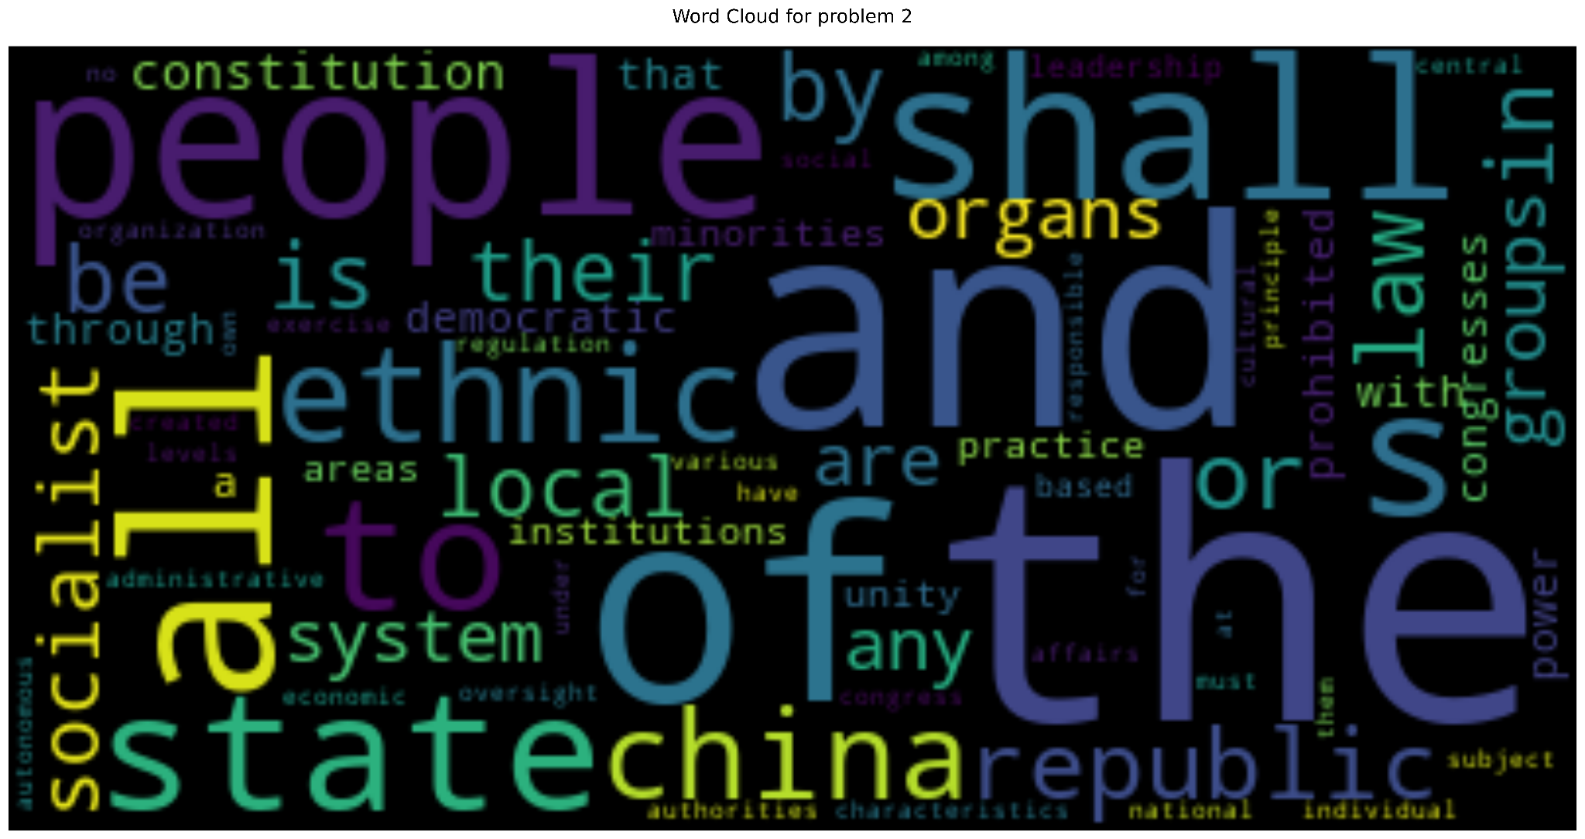

- Write a function that generates a Sankey chart of a paragraph before and after stemming. (15%)

- Download and install the nltk package and resources properly.
- Based on the input text, convert all text to lower case using regular expression, remove punctuations and numbers using regular expression, and remove stop words using nltk library.
- Convert the text to a list of tokens.
- Using nltk library, convert the list of tokens to a list of stems
- Using both lists, create the Sankey chart..

This problem covers natural language processing and Sankey chart.

Code:
# Problem 3
import nltk
from nltk import pos_tag
from nltk.corpus import ort word_tokenize
from nltk.stem import PorterStemmer
nltk.download('stopwords')
nltk.download('punkt_tab')
def problem_3(input_text, output_file="problem3.png", title="Sankey Chart for Problem 3"):
# write your logic here
# step 1: convert all text to lower case,
# remove punctuations and numbers
# remove stop words using nltk library

# step 2: convert tokens to stems

# step 3: create Sankey data

# step 4: create Sankey chart

plt.savefig(output_file)
# do not call plt.show()
stopwords
from nltk.tokenize imp

Execution:
> text = ""
> with open("problem3.txt", 'r', encoding='utf-8') as file:
.. text = file.read()
> problem_3(text, output_file="problem3.png")

problem3.txt:
In the library, books sit quietly, waiting and waiting to be read. Readers come and go, browsing and browsing the shelves filled with stories and adventures. Some find and find treasures hidden within pages, while others search and search for something special. The librarian arranges and rearranges the books, ensuring everything is in order. As the clock ticks and ticks, silence envelops the room, broken only by whispers and whispers of excitement. Each book tells and retells tales of love, loss, and discovery, inviting everyone to explore and explore the worlds within. In this haven, imagination thrives and thrives.

problem3.png:
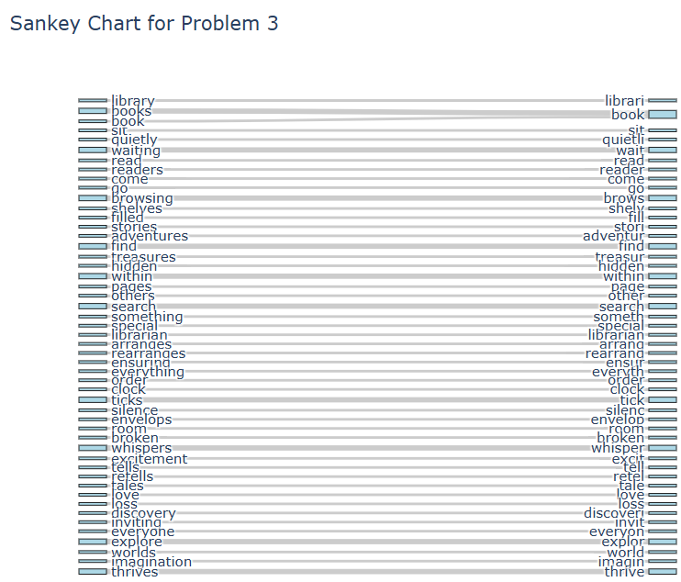

- Write a function that generates the line plots for comparing the stock price with the following properties. (15%)

- Label directly on the lines, around the middle of the line.
- Use text outlines for the labels.
- Do not add the labels on the same date, as one text label may cover another one.

This problem covers advice for data visualization.

Code:
# Problem 4
import yfinance as yf
import matplotlib.patheffects as path_effects
from datetime import datetime, timedelta
def problem_4(tickers, start_date, end_date, output_file="problem4.png", title="Stock Price Comparison for Problem 4"):
# download data
data=yf.download(tickers,start=start_date,end=end_date)['Close']
# write your logic here

plt.savefig(output_file)
# do not call plt.show()

Execution:
> tickers = ["AAPL", "MSFT", "GOOGL", "AMZN"]
> start_date = "2020-01-01"
> end_date = "2025-01-01"
> problem_4(tickers, start_date, end_date)

problem4.png:
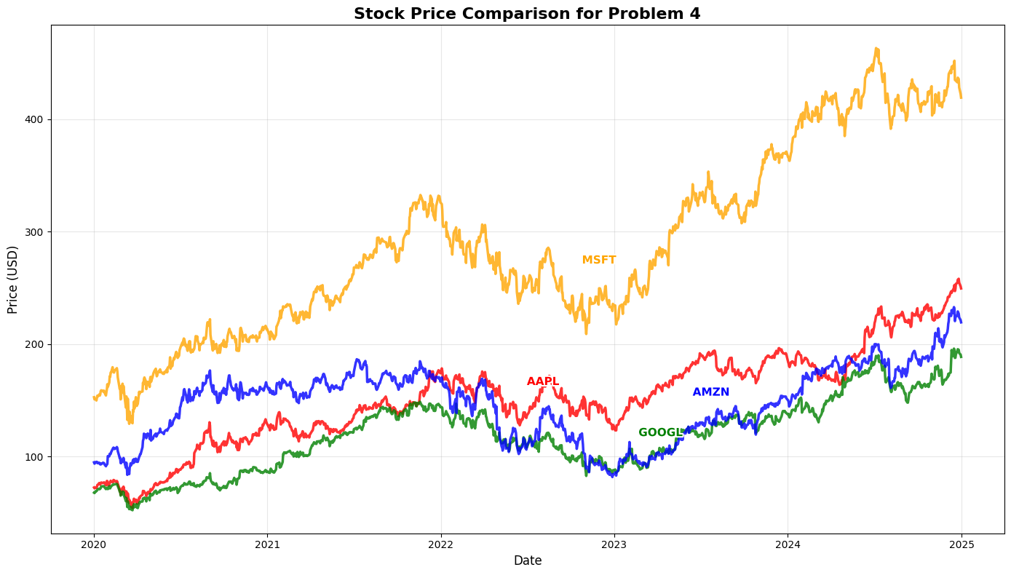
- Write a function that generates two subplots based on the same dataset. (15%)

- The left subplot is a box plot showing the distribution of the data, with title = titles[1].
- The right subplot is a horizontal bar chart showing the average of the data, with title = titles[2].
- The title of the figure is titles[0].

This problem covers matplotlib basics.

Code:
# Problem 5
def problem_5(data, group_names, output_file="problem5.png", titles=["Subplot Exercise for Problem 5", "Box plot", "Mean values"]):
# write your logic here

plt.savefig(output_file)
# do not call plt.show()

Execution:
> np.random.seed(5731)
> data1 = np.random.normal(100, 15, 300) # Group A
> data2 = np.random.normal(110, 12, 200) # Group B
> data3 = np.random.normal(95, 18, 400) # Group C
> data = [data1, data2, data3]
> group_names = ['Group A', 'Group B', 'Group C']
> problem_5(data, group_names) shuffle=False)

problem5.png:
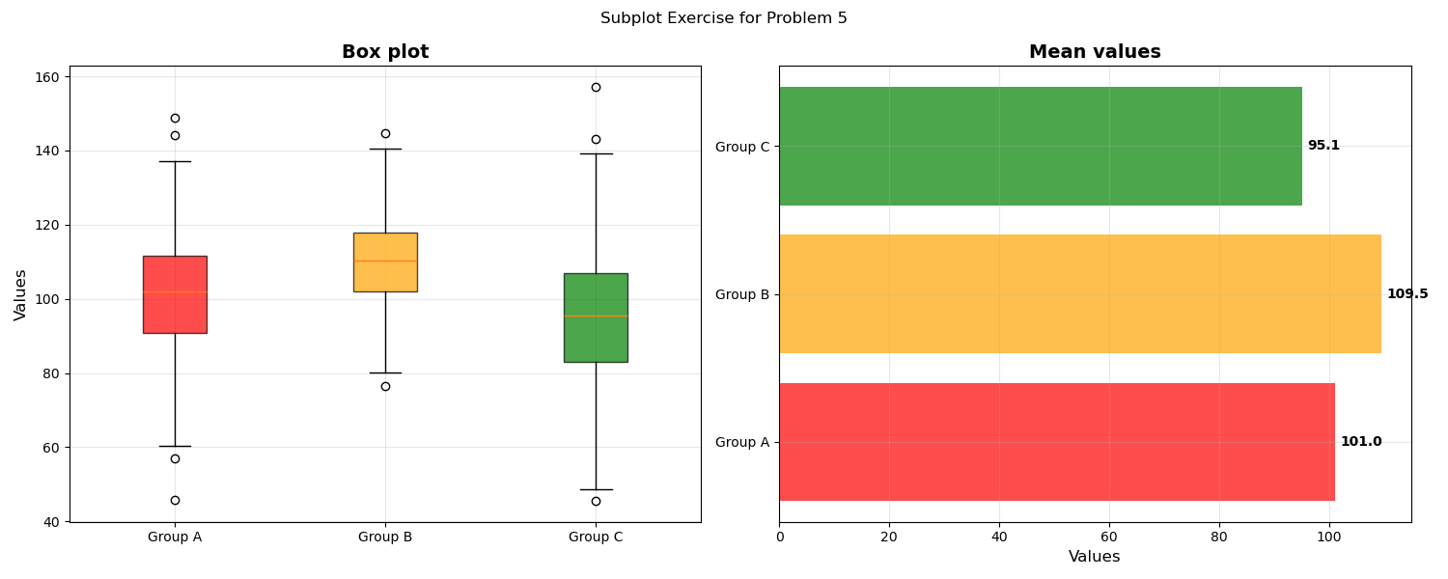

- Write a function that generates the learning curve of a random forest classifier based on the wine dataset. (15%)

- Set training size as [1, 10, 20, 50, 100, 113].
- Generate the learning curve data based on the random forest classifier and training size.
- Plot the learning curve based on the mean of the learning curve data.
- (Optional) Shade the area based on the standard deviation of the learning curve data.
- Add the final performance values at the end of the learning curve.

This problem covers learning curve and random forest classifier.

Code:
# Problem 6
from sklearn.ensemble import RandomForestClassifier
from sklearn.datasets import load_wine
from sklearn.model_selection import learning_curve, train_test_split
from sklearn.metrics import accuracy_score
from sklearn.preprocessing import StandardScaler
def problem_6(X, y, output_file="problem6.png", title="Learning Curve for Problem 6"):
seed_number = 5731
X_train, X_test, y_train, y_test = train_test_split(X, y,
test_size=0.2, random_state=seed_number)
scaler = StandardScaler()
X_train_scaled = scaler.fit_transform(X_train)
X_test_scaled = scaler.transform(X_test)
# write your logic here

plt.savefig(output_file)
# do not call plt.show()

Execution:
> wine = load_wine()
> X, y = wine.data, wine.target
> problem_6(X, y)

problem6.png:
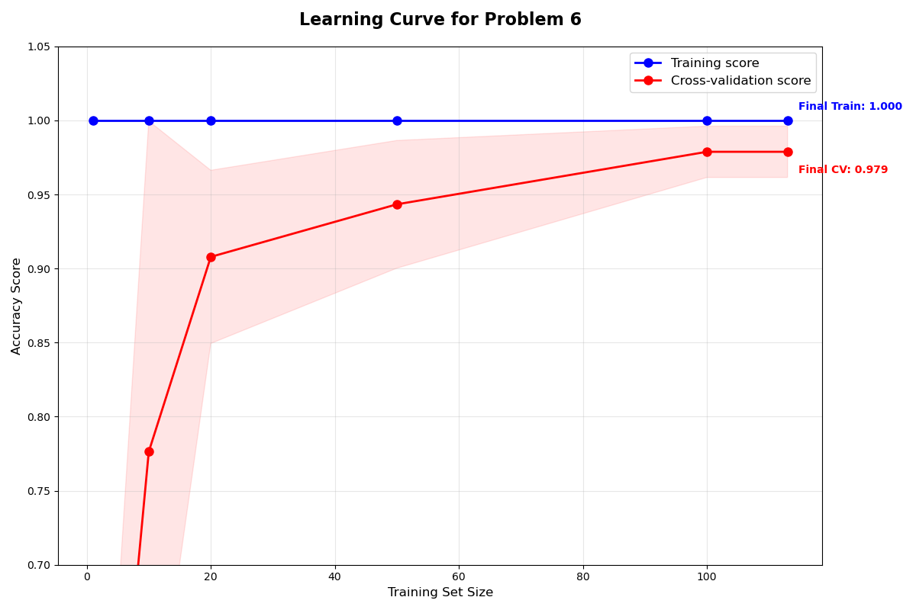

< End of Assignment >

