CCIT4033 Individual Assignment

Student ID: | 20189102
Student Name: | Yeung Man
Class: | CL 06

Part 1
Q1 | Assume that one employee has many dependents.  Assume attribute “MED_BENIF” to know whether the dependents can get the medical benefit or not.  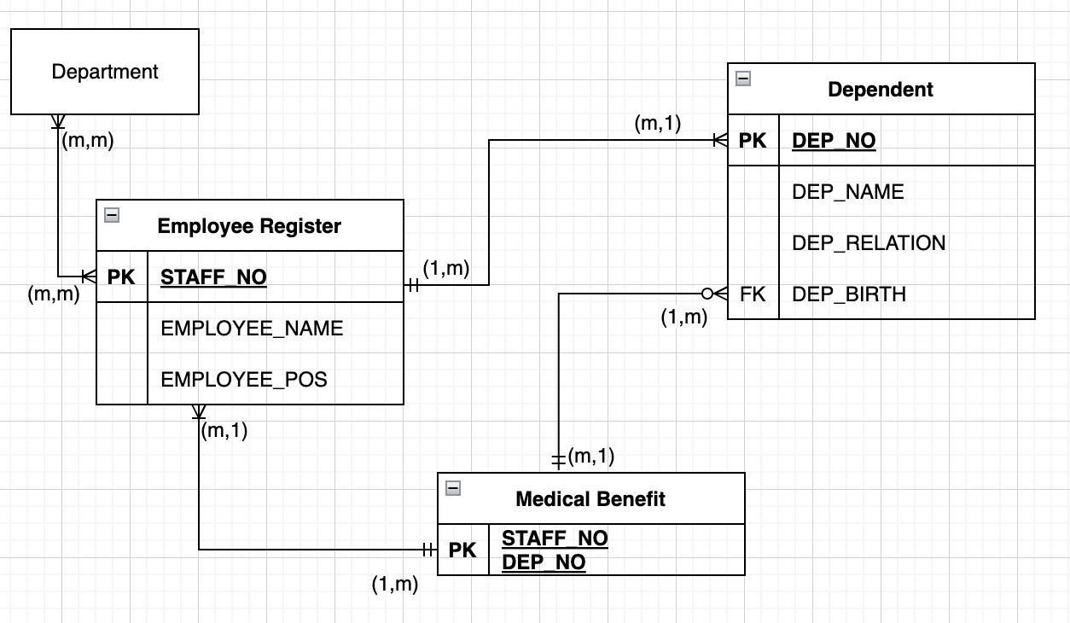
Q2 | The redundant attributes are EMPLOYEE_POS and DEP_RELATION.  Advantage of having redundant attributes in the database design is that it can increase the speed of data retrieval. By duplicating certain data elements across multiple tables, queries that require those elements can be executed more quickly, then data is readily available in multiple locations.  Disadvantage of having redundant attributes is that it can lead to data inconsistency and increase the complexity of data maintenance. If multiple copies of the same data element exist across multiple tables, it can be difficult to ensure that all copies are updated consistently when changes are made. This can lead to data discrepancies and inaccuracies, which can be difficult to detect and correct.
Part 2
Q3 | For insertion anomalies  If I want to insert new bike order, but I entered the wrong bike_no, then the insertion cannot be successful.  For deletion anomalies  If I want to delete one of the “bike_no” in a row of data, the whole data will destroy, since the “bike no” became empty.  For modification anomalies  If I want to update the phone number of a customer, I need to find all the order made by this customer and update it one by one, otherwise the same customer with different phone number cannot be used normally.
Q4 | 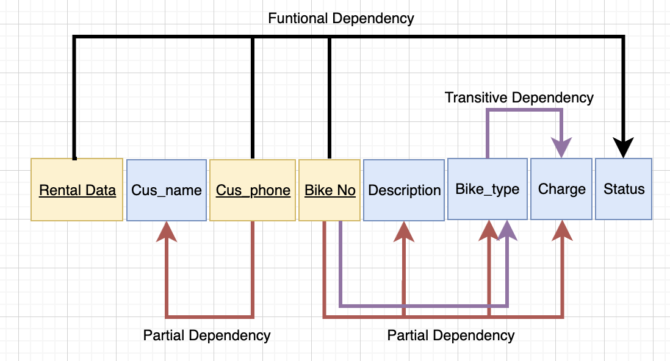
Q5 | This is 1NF diagram:    This is 2NF diagram:  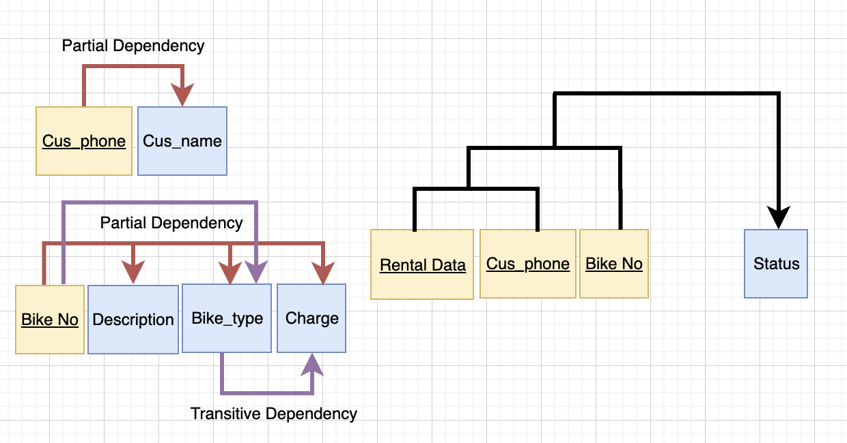  This is 3NF diagram:  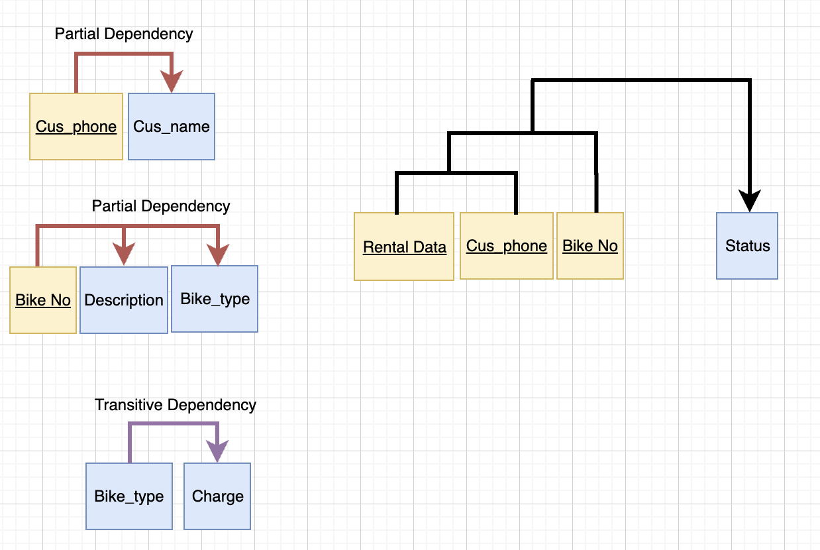
Part 3
Q6 | The BOOKING table do not exhibit referential integrity, because the foreign keys of BOOKING are not using the same name of the primary key of TREATMENT and SPECIALIST.
Q7 | 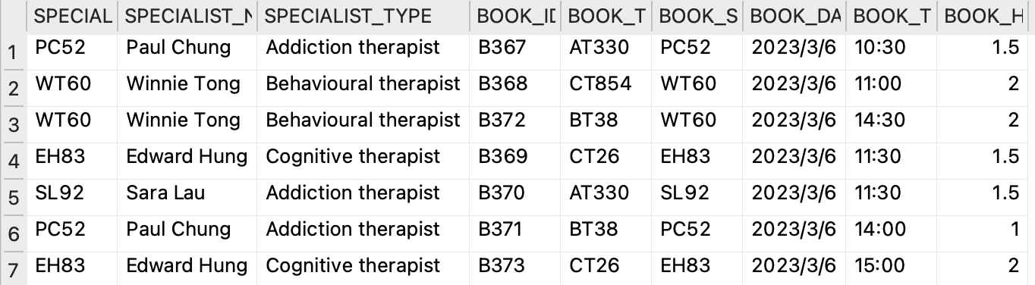
Q8 | SELECT  SPECIALIST_NAME, SUM(BOOK_HRS) AS TOTAL_HOURS  FROM  SPECIALIST, BOOKING  WHERE  SPECIALIST_ID = BOOK_SPECIALIST  GROUP BY  BOOK_SPECIALIST;

Q9 | SELECT  BOOK_ID, TREATMENT_DESC, TREATMENT_TYPE,  SPECIALIST_NAME, SPECIALIST_TYPE, BOOK_DATE,  BOOK_TIME, BOOK_HRS  FROM  BOOKING, SPECIALIST, TREATMENT  WHERE  BOOK_SPECIALIST = SPECIALIST_ID  AND BOOK_TREATMENT = TREATMENT_ID  AND NOT TREATMENT_TYPE = SPECIALIST_TYPE  GROUP BY  BOOK_ID;
Q10 | I would consider changing the data model to prevent it, since highlighting is not the best way to encounter.  I will consider using a foreign key constraint. I will set the SPECIALIST_TYPE as the foreign key of TREATMENT_TYPE. This will ensure that any value inserted or updated in the TREATMENT_TYPE column of the TREATMENT table must already exist in the SPECIALIST_TYPE column of the SPECIALIST table. For example, the user is choosing the expected activity, they need to choose the expected SPECIALIST corresponding to the type.

