Statistical Analysis

In this study we were interested in estimating the probability that a dog will be diagnosed with MUO within 60 days of the last vaccination, this is because from a pathogenetic point of view, if there is a causal relationship between vaccination and MUO this cannot manifest itself in a period of longer time. Therefore the **time from the last vaccination to the diagnosis of MUO** represents the time to event outcome variable of interest. Statistical analysis of these variables is called time to event analysis or survival analysis even though the outcome is not always death.  In survival analysis, we use information on event status and follow up time to estimate a survival function.

The Kaplan-Meier (KM) method is a non-parametric method used to estimate the survival probability from observed survival times (Kaplan and Meier, 1958).

The survival probability at time *ti, S(ti)*  is calculated as follow:

*S(ti) = S(ti-1)(1- di / ni)*

Where,

* *S(ti-1)* = the probability of being alive at ti-1
* nj= the number of patients alive just before ti
* di= the number of events at ti
* t0 = 0
* S(t0) = 1

The estimated probability S(t) is a step function that changes value only at the time of each event.

The KM survival curve, a plot of the KM survival probability against time, provides a useful summary of the data that can be used to estimate measures such as median survival time.

We prefer to generate cumulative incidence curves, as opposed to survival curves which show the cumulative probabilities of experiencing the event of interest ( diagnosis of MUO). Cumulative incidence, or cumulative failure probability, is computed as 1-S(t)

Cumulative incidence curve with 95% Confidence Interval was estimated with survfit function of survival package (T. Therneau 2022) and plotted with ggsurvplot function of ggplot2 package (H. Wickham 2016) on R language (R Core Team 2021).

Results

Median Event Time is 193 days (95%CI : 124-273). It means that the probability of diagnoses MUO after 193 days from last vaccination is 50%.

In table x is reported the Cumulative event table. As it is possible observe the cumulative probability to have a diagnosis in the next 60 days after vaccination is 13% (95%CI: 4% - 21%).

Kaplan-Meyer Cumulative event curve is reported in fig 1.

table x: Kaplan-Meyer Cumulative event table

|  |  |  |  |  |  |  |
| --- | --- | --- | --- | --- | --- | --- |
| **days** | **n. at risk** | **n.event** | **Probability of MUO Diagnosis** | **std.err** | **95% CI (lower limit)** | **95% CI (upper limit)** |
| 3 | 61 | 1 | 0.02 | 0.98 | 0.00 | 0.05 |
| 17 | 60 | 1 | 0.03 | 0.98 | 0.00 | 0.08 |
| 18 | 59 | 1 | 0.05 | 0.97 | 0.00 | 0.10 |
| 32 | 58 | 1 | 0.07 | 0.97 | 0.00 | 0.13 |
| 44 | 57 | 1 | 0.08 | 0.96 | 0.01 | 0.15 |
| 51 | 56 | 1 | 0.10 | 0.96 | 0.02 | 0.17 |
| 56 | 55 | 1 | 0.11 | 0.95 | 0.03 | 0.19 |
| **61** | **54** | **1** | **0.13** | **0.95** | **0.04** | **0.21** |
| 63 | 53 | 1 | 0.15 | 0.95 | 0.05 | 0.23 |
| 80 | 52 | 1 | 0.16 | 0.94 | 0.07 | 0.25 |
| 89 | 51 | 1 | 0.18 | 0.94 | 0.08 | 0.27 |
| 90 | 50 | 2 | 0.21 | 0.93 | 0.10 | 0.31 |
| 93 | 48 | 1 | 0.23 | 0.93 | 0.12 | 0.33 |
| 98 | 47 | 1 | 0.25 | 0.93 | 0.13 | 0.35 |
| 104 | 46 | 1 | 0.26 | 0.92 | 0.14 | 0.36 |
| 109 | 45 | 1 | 0.28 | 0.92 | 0.16 | 0.38 |
| 110 | 44 | 1 | 0.30 | 0.92 | 0.17 | 0.40 |
| 112 | 43 | 2 | 0.33 | 0.91 | 0.20 | 0.44 |
| 114 | 41 | 1 | 0.34 | 0.91 | 0.21 | 0.45 |
| 119 | 40 | 1 | 0.36 | 0.90 | 0.23 | 0.47 |
| 121 | 39 | 1 | 0.38 | 0.90 | 0.24 | 0.49 |
| 124 | 38 | 1 | 0.39 | 0.90 | 0.26 | 0.50 |
| 129 | 37 | 1 | 0.41 | 0.89 | 0.27 | 0.52 |
| 142 | 36 | 1 | 0.43 | 0.89 | 0.29 | 0.54 |
| 148 | 35 | 1 | 0.44 | 0.89 | 0.30 | 0.55 |
| 166 | 34 | 1 | 0.46 | 0.88 | 0.32 | 0.57 |
| 176 | 33 | 1 | 0.48 | 0.88 | 0.33 | 0.59 |
| 186 | 32 | 1 | 0.49 | 0.87 | 0.35 | 0.60 |
| 193 | 31 | 1 | **0.51** | 0.87 | 0.37 | 0.62 |
| 203 | 30 | 1 | 0.52 | 0.87 | 0.38 | 0.63 |
| 204 | 29 | 1 | 0.54 | 0.86 | 0.40 | 0.65 |
| 222 | 28 | 1 | 0.56 | 0.86 | 0.41 | 0.67 |
| 245 | 27 | 1 | 0.57 | 0.85 | 0.43 | 0.68 |
| 257 | 26 | 2 | 0.61 | 0.84 | 0.46 | 0.71 |
| 269 | 24 | 1 | 0.62 | 0.84 | 0.48 | 0.73 |
| 271 | 23 | 1 | 0.64 | 0.83 | 0.50 | 0.74 |
| 273 | 22 | 1 | 0.66 | 0.82 | 0.51 | 0.76 |
| 274 | 21 | 1 | 0.67 | 0.82 | 0.53 | 0.77 |
| 288 | 20 | 1 | 0.69 | 0.81 | 0.55 | 0.79 |
| 294 | 19 | 1 | 0.70 | 0.80 | 0.57 | 0.80 |
| 336 | 18 | 1 | 0.72 | 0.79 | 0.58 | 0.81 |
| 374 | 17 | 1 | 0.74 | 0.79 | 0.60 | 0.83 |
| 386 | 16 | 1 | 0.75 | 0.78 | 0.62 | 0.84 |
| 452 | 15 | 1 | 0.77 | 0.77 | 0.64 | 0.86 |
| 513 | 14 | 1 | 0.79 | 0.75 | 0.65 | 0.87 |
| 514 | 13 | 1 | 0.80 | 0.74 | 0.67 | 0.88 |
| 608 | 12 | 1 | 0.82 | 0.73 | 0.69 | 0.89 |
| 629 | 11 | 1 | 0.84 | 0.71 | 0.71 | 0.91 |
| 636 | 10 | 1 | 0.85 | 0.69 | 0.73 | 0.92 |
| 688 | 9 | 1 | 0.87 | 0.67 | 0.75 | 0.93 |
| 698 | 8 | 1 | 0.89 | 0.64 | 0.77 | 0.94 |
| 973 | 7 | 1 | 0.90 | 0.61 | 0.79 | 0.95 |
| 1480 | 6 | 1 | 0.92 | 0.57 | 0.81 | 0.96 |
| 1739 | 5 | 1 | 0.93 | 0.52 | 0.83 | 0.97 |
| 2047 | 4 | 1 | 0.95 | 0.44 | 0.85 | 0.98 |
| 2084 | 3 | 1 | 0.97 | 0.30 | 0.87 | 0.99 |
| 2751 | 2 | 1 | 0.98 | 0.01 | 0.89 | 1.00 |
| 3436 | 1 | 1 | 1.00 | -Inf | NA | NA |

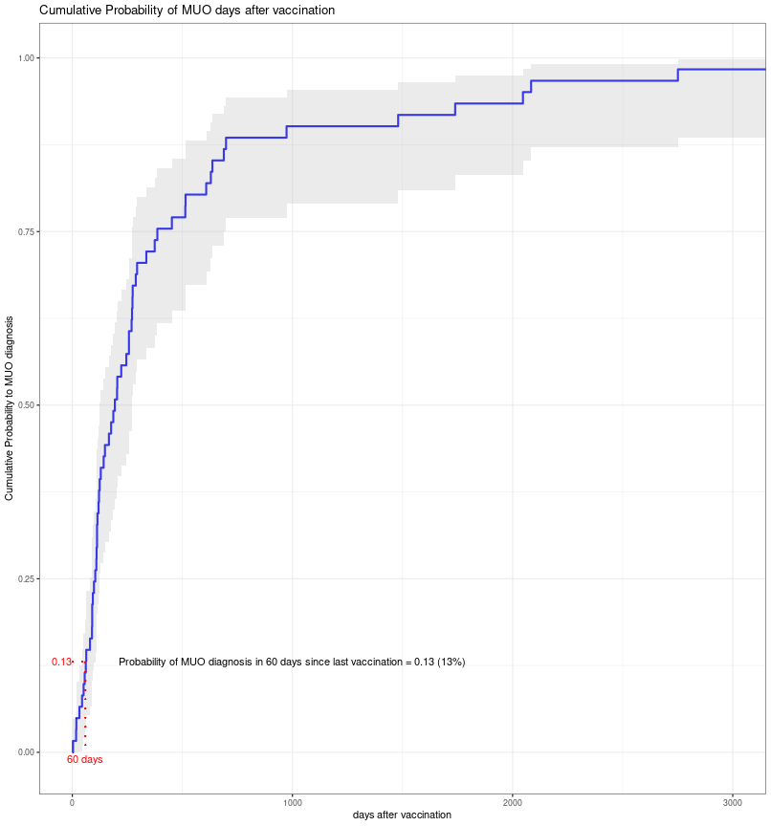

Bibliografia

R Core Team (2021). R: A language and environment for statistical computing. R Foundation for Statistical Computing, Vienna, Austria. URL <https://www.R-project.org/>.

Therneau T (2021). A Package for Survival Analysis in R. <https://CRAN.R-project.org/package=survival>

H. Wickham. ggplot2: Elegant Graphics for Data Analysis. Springer-Verlag New York, 2016.

Kaplan EL, Meier P (1958) Nonparametric estimation from incomplete observations. J Am Stat Assoc 53: 457–481.