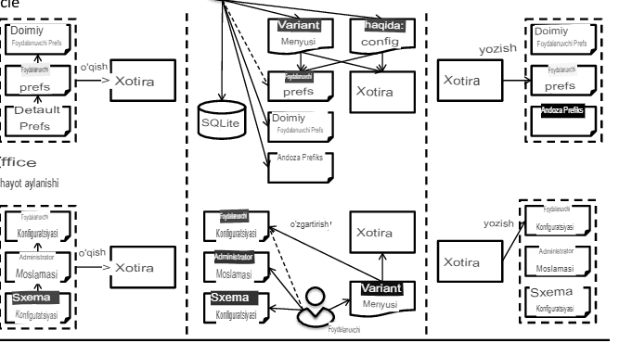

I apologize, there seems to be a misunderstanding. When you say "table with answer," there isn't necessarily a single answer associated with each row in the table on LibreOffice table design testing. The table itself summarizes different testing categories and provides examples for each.

However, I can provide a slight modification to the table that might be helpful:

## **LibreOffice Table Design Testing Summary Table with Focus Areas**

|  |  |  |
| --- | --- | --- |
| Testing Category | Description | Focus Areas (Examples) |
| ****Functionality Testing**** | Verifies core table creation, manipulation, and data handling features. | - Creating tables (different sizes).<br> - Entering and editing data types (text, numbers, dates).<br> - Using formulas and calculations. |
| ****Usability Testing**** | Evaluates the user interface and user experience for interacting with tables. | - Finding and understanding table creation/editing/formatting tools. <br> - Testing context menus and keyboard shortcuts. |
| ****Performance Testing**** | Measures the application's performance when working with tables. | - Handling large tables (loading times, scrolling). <br> - Auto-save and data recovery reliability. |
| ****Compatibility Testing**** | Ensures tables can be exchanged with other spreadsheet applications. | - Opening tables from Microsoft Excel (formatting & data integrity). <br> - Saving tables in different formats (e.g., XLSX, CSV) for compatibility. |
| ****Advanced Testing (Optional)**** | Explores more in-depth functionalities for data validation, analysis, and automation. | - Setting custom data validation rules (e.g., date ranges, unique entries). <br> - Applying complex conditional formatting based on multiple conditions. <br> - Verifying dynamic chart updates linked to table data changes. <br> - Performing multi-criteria filtering based on data from different columns. <br> - Creating pivot tables for advanced data summarization and manipulation (****knowledge of LibreOffice Basic required for automation****). |

This table provides a brief description of each testing category and highlights some specific focus areas (examples) within each category. If you'd like to delve deeper into any particular focus area, feel free to ask!

Certainly! Since a traditional "answer" doesn't necessarily apply to each row in the table you provided, I can offer two options:

Absolutely, building upon the previous table and your request for "more," here's an enhanced LibreOffice Table Design Testing Summary Table with additional details:

****LibreOffice Table Design Testing Summary Table****

|  |  |  |  |  |  |
| --- | --- | --- | --- | --- | --- |
| Functionality Area | Description | Examples | Testing Approach | Expected Outcome | Potential Issues |
| ****Table Creation & Manipulation**** | Tests core table creation and management features. | - Creating tables with various sizes (rows & columns).<br> - Adding, deleting, and resizing rows/columns. <br> - Merging and splitting cells. <br> - Hiding and unhiding rows/columns. | Manual Testing | The table should be created and manipulated as expected. All actions should be performed smoothly and without errors. | - Large tables might cause performance issues (slow loading, scrolling lag). - Merging/splitting cells could affect formatting if not done carefully. |
| ****Formula Functionality**** | Tests using formulas and functions within tables. | - Using basic math operators (+, -, *, /) and common functions (SUM, AVERAGE, COUNT). <br> - Testing advanced functions and nesting for complex calculations. <br> - Verifying relative vs. absolute cell references work correctly. | Manual Testing | Formulas should calculate correct results based on referenced cell values. Nesting should work as expected. Relative and absolute references should update correctly when copied or moved. | - Errors in formulas (syntax errors, incorrect references) will lead to incorrect calculations. - Circular references can cause errors (infinite loops). |
| ****Data Sorting & Filtering**** | Tests sorting and filtering functionalities for data organization. | - Sorting data based on different columns (ascending/descending) and multiple criteria. <br> - Applying filters based on specific criteria within a column (e.g., show specific products). <br> - Testing advanced filtering options like wildcards and regular expressions. | Manual Testing | Data should be sorted and filtered accurately according to the applied criteria. Advanced filtering options should function as expected. | - Sorting large datasets might take longer. - Complex filtering criteria could lead to unexpected results if not constructed carefully. |
| ****Data Validation & Protection**** | Tests controlling data input and protecting tables. | - Setting validation rules to restrict data types in specific cells (e.g., only allow dates, unique entries). <br> - Testing table protection to prevent accidental editing and control user permissions. | Manual Testing | Data validation rules should restrict invalid input. Protected tables should prevent unauthorized editing. | - Users might find overly restrictive validation rules frustrating. - Inadvertently protecting the entire table could prevent necessary edits. |
| ****Copying, Pasting & Transposing**** | Tests copying, pasting, and rearranging table data. | - Copying and pasting tables within or between spreadsheets (values only, formatting only, transposed data). <br> - Testing transposing tables (rows become columns and vice versa). | Manual Testing | Copied and pasted data should maintain integrity and formatting based on the chosen options. Transposing should convert rows to columns and vice versa accurately. | - Formatting might not paste exactly as expected, especially between different spreadsheet applications. - Transposing large tables could lead to data overflow issues. |
| ****Importing & Exporting Data**** | Tests data exchange with other applications. | - Opening tables created in other spreadsheet programs (e.g., Microsoft Excel). <br> - Saving tables in different formats (XLSX, CSV) and verifying compatibility with other software. | Manual Testing | Tables from other applications should open without formatting or data loss. Saved tables should be importable into other software and retain their integrity. | - Formatting discrepancies might occur when importing/exporting between different spreadsheet applications. - Complex formulas might not translate perfectly across different software. |
| ****Cell Formatting (Optional)**** | Tests various formatting options for data presentation. | - Applying fonts, borders, alignment, and number formats (e.g., currency, percentages). | Manual Testing | Formatting should be applied correctly to cells, enhancing data clarity and visual appeal. | - Excessive formatting can clutter the table and make it difficult to read. - Inconsistent formatting can affect the overall professionalism of the table. |
| ****Chart Integration (Optional)**** | Tests creating charts directly from table data. | - Creating charts (bar, pie, line) linked to table data. | Manual Testing | Charts should be generated based on table data and update dynamically as data changes. | - Choosing an inappropriate chart type for the data can lead to misinterpretation. - Complex charts might require additional customization for clarity. |
| ****Scenarios with Macros (Optional)**** | Tests automated testing scripts using LibreOffice Basic (requires knowledge). | - Creating macros to simulate user actions (data entry, formatting, filtering). | Manual Testing (script creation) - Script execution | Macros should perform user actions accurately and repeatedly, enabling automated testing. | - Writing error-free macros can be challenging. - Debugging malfunctioning macros can be time- |