SMART MICROGRID ENERGY MANAGEMENT SYSTEM SIMULATION USING PYTHON

NAME : Chun Jian Yee
COUNTRY : Malaysia
QUALIFICATION : Cambridge International Examination A-Level
INTENDED PROGRAMME : Electrical and Electronic Engineering
DATE OF COMPLETION : 15th July 2026

1.0 Abstract
This report investigates a simplified model of a smart microgrid Energy Management System (EMS). The aim of this project is to simulate the operation of a smart microgrid EMS in a rapid software prototype. This project involves the definition of a simulated environmental profile, integration of multiple systems with respective roles, and operation of the systems with decision-making logic to control the energy flow in a 24-hour period under varying circumstances. As a result of this experiment, this project successfully demonstrates how EMS coordinates power sources with battery storage, runs automated load shedding, controls the State-Of-Charge (SOC) of the battery and executes priority-based load management. With these control strategies, the project demonstrates how EMS improves microgrid reliability and operational efficiency.

2.0 Introduction
The growing demand for electricity is a key challenge for today’s energy sector. Regardless of the scale, from small household electricity consumption to power supply to large facilities like hospitals and factories, this increasing need for power supply creates engineering challenges. A modern power generation system integrates renewable energy sources like photovoltaic (PV) systems into conventional power generation methods like diesel generators. As the demand for electricity grows, more electricity must be generated. Non-renewable sources are being consumed while renewable sources produce fluctuating power output. To cope with these issues, an Energy Management System (EMS) plays a crucial role in achieving better resource coordination and in improving system operation, which contributes to energy efficiency and sustainability.

A microgrid is a coordinated system including various loads and generation units that can run independently from the main grid, functioning as a controllable entity within clearly defined electrical limits (Saeed et al., 2021). A microgrid consists of Distributed Energy Resources (DERs) (e.g., PV, diesel), a Battery Energy Storage System (BESS), electrical loads, power electronic converters, and control systems. DERs provide energy supply, BESS allows excess generation to be stored, power electronic converters regulate electrical voltage, and control systems coordinate each component. Microgrids are introduced to improve reliability and resilience of local power systems by combining DERs and enabling islanded operation when required.

An Energy Management System (EMS) is a decision-making system that operates controllable DERs and electrical loads to generate an adaptive operating schedule for achieving predefined system objectives (Zahraoui et al., 2021). In a microgrid, the operation of multiple DERs, BESS, and electrical loads varies over time, therefore EMS provides coordination and stability. EMS monitors energy supply and demand, then analyses operating conditions according to system requirements. Consequently, decisions are made to address issues such as power imbalance and control actions are executed. In this way, EMS ensures resilience, operational efficiency, and reliability in modern microgrids. To investigate and demonstrate EMS functionality, a software prototype is developed in this project.

This project introduces a simple software prototype of a smart microgrid EMS in a simulated environment using Python in Visual Studio Code. It simulates a 24-hour operation of a microgrid with changing electricity demand, varying solar power output, and battery behavior management. The main features incorporated in this project include a demand profile, a solar profile, a grid balance analysis, an automated load shedding function which is priority based, and a BESS managing function. This prototype demonstrates how EMS coordinates microgrid components under varying operating conditions to achieve a resilient system.

3.0 System Architecture
3.1 Overview
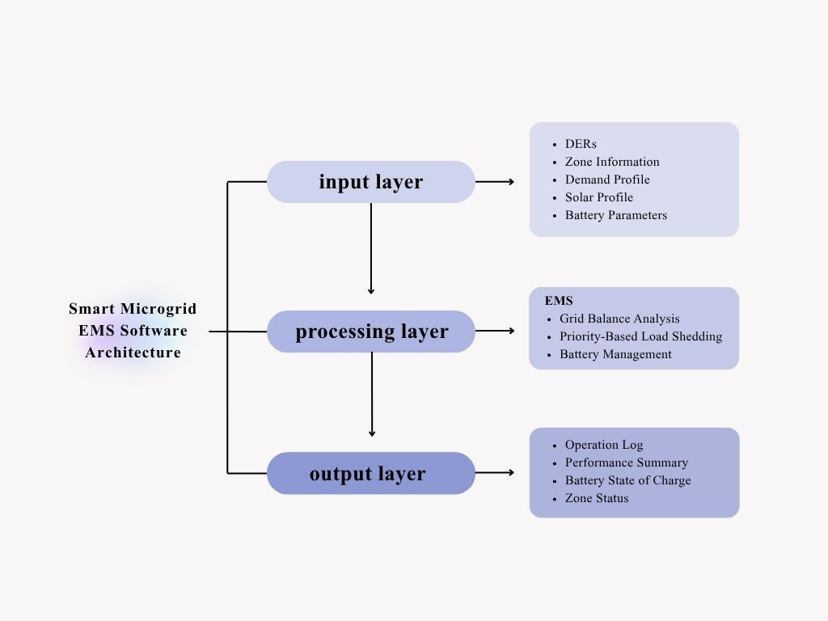
This project models a supervisory EMS of a simplified microgrid environment consists of three major sections, input layer, processing layer, and output layer. Lower-level hardware controllers and electrical converters are abstracted to simplify the model and emphasize energy management and decision making.

3.2 Input Layer
The input layer consists of five components, power sources, zone information, demand profile, solar profile, and battery parameters. Power sources consist of a renewable energy source and a non-renewable energy source, which are solar energy sources and diesel combustion generators. A hospital, a residential area, and a factory are energy consuming zones for this microgrid project. The zone information includes two vital metrics, priority number and status for each zone. A demand profile is created for each zone with their respective characteristic energy consumption patterns for 24 hours. A similar solar profile is also created according to the sunlight intensity in a day to make the renewable energy output more realistic. Finally, battery parameters are defined for the BESS including battery capacity, battery SOC, charge efficiency, and discharge efficiency. These input components provide the information required by the processing layer to implement operation analysis and make energy management decisions.

3.3 Processing Layer
A processing layer is introduced to monitor input conditions, analyze energy supply and demand, and coordinate DERs and BESS to maximize energy efficiency. The processing layer is the Energy Management System, which consists of three main components, a grid balance calculator, a priority-based load shedding system, and a battery management system. These processing components work collectively to improve microgrid reliability and operational efficiency as the results shown in the output layer.

3.4 Output Layer
The output layer shows results processed by its previous layer, the processing layer. The output layer outlines the operation log hour by hour, which includes the battery SOC, the zone status, the power balance, and occurring events by the BESS. A performance summary interface is designed for operators to monitor and assess conditions in the output layer.

4.0 Mathematical Models
4.1 Overview
Mathematical models are used in engineering design to simplify and analyse physical systems by representing them with computational mathematical relationships. Various models are used in this smart microgrid EMS to describe relationships between variables and to quantify system behaviour. This section explores and explains every mathematical model applied in this microgrid EMS project.

4.2 Mathematical models
4.2.1 Solar Generation
Sunlight intensity varies throughout a day, which results in a changing PV output. A solar profile containing multipliers is introduced to represent the dynamic solar intensity in a day. The modelled solar generation power output is obtained using the equation below:

 | $$P_{solar}= P_{capacity} ×M_{solar}$$ | (4.1)

Symbol | Description | Unit
$$P_{solar}$$ | Solar power output | MW
$$P_{capacity}$$ | Rated PV capacity | MW
$$M_{solar}$$ | Solar multiplier | -

When $M_{solar}=0$ , there is zero solar power output. When $M_{solar}=1$ , the solar output equals the rated PV capacity. The $M_{solar}$ is always between 0 and 1 to determine the range for the solar power output, which satisfies that the model assumes the PV system cannot exceed its rated capacity.

4.2.2 Load Demand
Power demand for residential area, hospital, and factory is defined using a demand profile containing electrical power consumption characteristics for each zone. For example, hospital has a fixed power usage profile while factory has increasing power consumption during working hours. The total power demand is computed to obtain electrical power required by the microgrid based on active loads during each hour, which allow further analysis and decision-making. Total power demand depends on the sum of the active power demand, which is the total power demand for the zones whose status are “ONLINE”.

 | $$P_{demand}=\sum{P_{active}}= P_{res}+ P_{hos}+ P_{fac}$$ | (4.2)

Symbol | Description | Unit
$$P_{demand}$$ | Total power demand | MW
$$\sum{P_{active}}$$ | Sum of active power demand | MW
$$P_{res}$$ | Residential power demand | MW
$$P_{hos}$$ | Hospital power demand | MW
$$P_{fac}$$ | Factory power demand | MW

4.2.3 Power Balance
Power balance is the difference between the power generated and the power consumed. This model helps to identify whether there is sufficient power generation to satisfy the active loads.

 | $$P_{balance}= P_{supply}-P_{demand}$$ | (4.3)

Symbol | Description | Unit
$$P_{balance}$$ | Power balance | MW
$$P_{supply}$$ | Total power generated | MW
$$P_{demand}$$ | Total power demand | MW

A positive $P_{balance}$ indicates a surplus generation while a negative $P_{balance}$ shows that there is a power deficit. When $P_{balance}$ equals zero, $P_{supply}= P_{demand}$ .

4.2.4 Battery Energy Storage System (BESS)
This project applies a simple BESS with basic features, including battery capacity, battery State-of-Charge (SOC), a charging efficiency and a discharging efficiency. Energy is transferred when a battery is charged or discharged. When electrical energy is transferred to and from a battery, there will be energy loss due to several factors, such as resistive loss which is caused by battery internal resistance, power electronics conversion losses, and battery electrochemical losses. This model assumes constant charging and discharging efficiencies to account for energy losses during battery operations.
Charging:
 | $$E_{stored}= E_{grid} × η_{c}$$ | (4.4)

Symbol | Description | Unit
$$E_{stored}$$ | Energy stored into battery | MWh
$$E_{grid}$$ | Microgrid surplus energy | MWh
$$η_{c}$$ | Charging coefficient | -

Discharging:
 | $$E_{discharge}= E_{depleted} × η_{d}$$ | (4.5)

Symbol | Description | Unit
$$E_{discharge}$$ | Energy discharged | MWh
$$E_{depleted}$$ | Battery energy depleted | MWh
$$η_{d}$$ | Discharging coefficient | -

Efficiencies are always between less than 1 as there is no perfect conversion from one form of energy to another.
4.2.5 Energy Curtailment
Energy curtailment accounts for excess energy generation after battery is fully charged. It happens after demand is fulfilled and battery cannot store the excess energy. The main purpose of modelling energy curtailment is to quantify unused surplus energy. This helps in decision making such as decreasing non-renewable energy to improve system stability or revise system structure if the curtailment is consistently high.

 | $$E_{curtail}=\left(P_{balance} ×t\right)- E_{available}$$ | (4.6)

where the available storage capacity is calculated as:
 | $$E_{available}= E_{capacity}- E_{battery}$$ | (4.7)

This equation is only valid when:
- $P_{balance} >0$
- $P_{balance} ×t>E_{available}$

Symbol | Description | Unit
$$E_{curtail}$$ | Curtailed energy | MWh
$$P_{balance}$$ | Power balance | MW
$$t$$ | Time | h
$$E_{available}$$ | Available storage capacity | MWh
$$E_{capacity}$$ | Battery capacity | MWh
$$E_{battery}$$ | Battery Energy | MWh

5. Control Algorithm
5.1 Overview
A control system monitors outputs of a process, assesses these results with a reference, and makes adjustments to minimize the difference between real and desired performance (Institute of Electrical and Electronics Engineers [IEEE], n.d.). In this microgrid project, the control algorithm functions within the Energy Management System (EMS). The algorithm receives information from the input layer to perform calculations, then based on the results to make operational decisions. For instance, battery charging and discharging, load shedding and curtailment.

5.2 Operational Logic
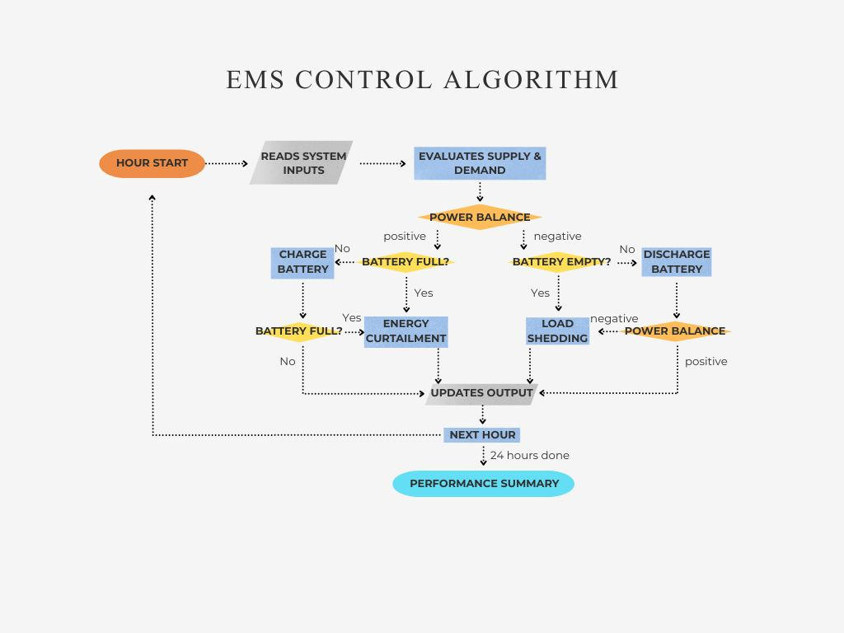
The control algorithm is initiated by the simulation starting a new hourly cycle. In each hour, the EMS reads the system inputs according to current simulation hour. For instance, the system reads the first multiplier in the solar profile and the first demands for each zone in the demand profile arrays in the first hour. This information will be evaluated through calculating supply and demand using Equation (4.1) and Equation (4.2) in the previous section. After this, a power balance can be computed using Equation (4.3). Once the power balance has been determined, the EMS decides the suitable operating strategy based on the value of the power balance, which indicates whether the energy generation is in surplus or deficit.

After a series of decision-making processes which will be detailed in the next section, the EMS updates the system state and stores the results for the hour cycle, which include energy and power statistics, and events that occurred. Finally, a performance summary will be generated after 24 simulation hours for operators to monitor and implement further improvements.

5.3 Decision Rules
The decision-making processes follow a series of predefined rules. Firstly, power balance is evaluated, then according to evaluation result the algorithm splits into two different branches. Algorithm operation in these branches shares the same objective, which is to ensure system stability and resilience.

The first branch represents a surplus operating condition, applies when there is a positive balance. EMS evaluates battery’s available storage capacity. If the battery is fully charged, the surplus is curtailed. If the battery is not fully charged, the battery is charged using the surplus. After charging, EMS re-evaluates the battery status and updates the system state. To conclude, this positive branch utilises surplus energy by charging the battery before curtailment.

The second branch represents a deficit operating condition, follows when there is a negative balance. EMS determines if the battery is depleted. If yes, automated load shedding occurs and the zones will be turned off in the next hour cycle. If the battery is not depleted, the battery discharges and the power balance is computed again with a new total supply. If the power balance computed is still negative, a load shedding event occurs, and these events will be updated into the system state. To sum up, this negative branch maintains supply by discharging the battery before executing load shedding.
6. Simulation Results
6.1 Hourly Operation Overview
Time | Operating events | Battery SOC | Online zones
00:00 – 04:00 | Battery Discharging | 24% – 9% | All zones
05:00 – 06:00 | Battery Depletion,  Load Shedding,  Battery Charging | 22% | Hospital only
07:00 – 08:00 | Battery Depletion,  Load Shedding,  Battery Charging | 9% – 40% | Hospital and Residential
09:00 – 11:00 | Battery Charging | 45% – 74% | All zones
12:00 – 16:00 | Energy Curtailment | 99% – 100% | All zones
17:00 – 19:00 | Battery Discharging | 86% – 18% | All zones
20:00 – 21:00 | Battery Depletion,  Load Shedding,  Battery Charging | 22% | Hospital only
22:00 | Battery Discharging | 5% | All zones
23:00 | Battery Depletion,  Load Shedding,  Battery Charging | 2% | Hospital and Residential

The table above presents the summary for the main operating events occurred during the 24-hour simulation period. It shows the battery SOC and the online zones across operating periods. Battery discharging occurred mainly during the midnight time where solar generation is low, while battery charging and energy curtailment occurred during the midday time where the solar generation is at peak. Load shedding events were recorded when the battery could not fully cater the need for the power deficit.

6.2 Graph
Figure 6.1
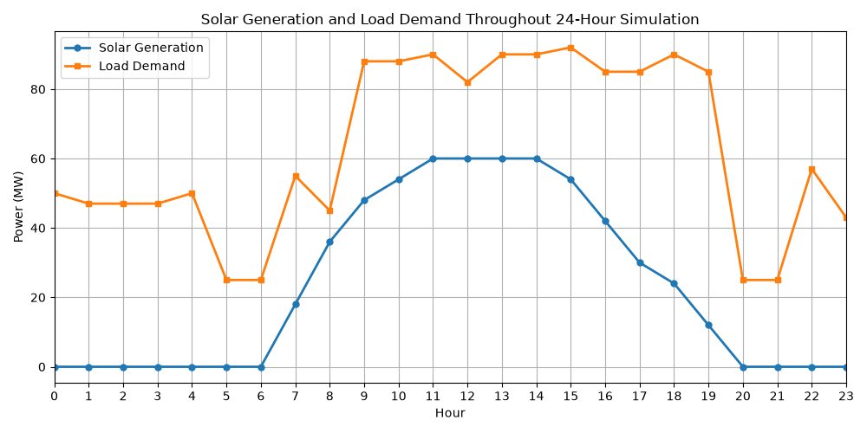
Figure 6.2
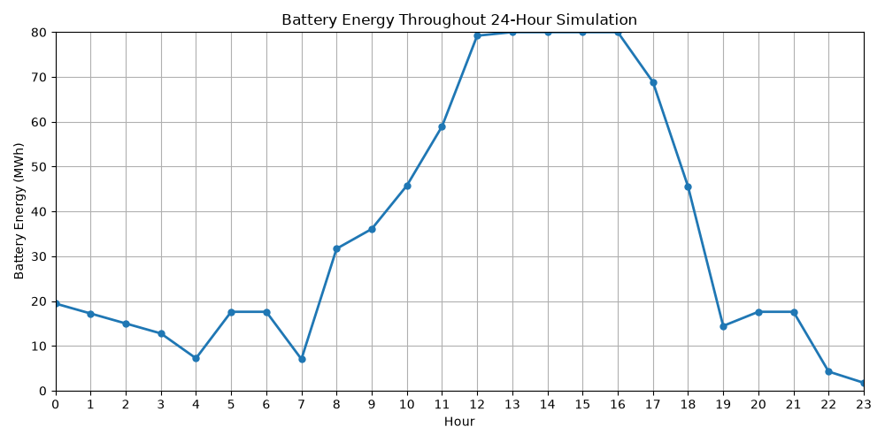
Solar generation curve in figure 6.1 shows a similar trend with battery energy curve in figure 6.2, as increased solar generation supplies surplus energy for battery charging, while reduced solar generation results in battery discharging to support load demand.

Figure 6.3
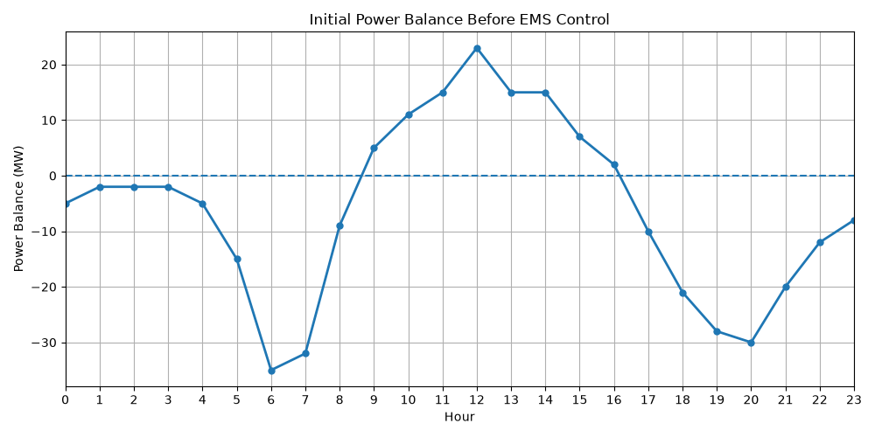
Figure 6.4
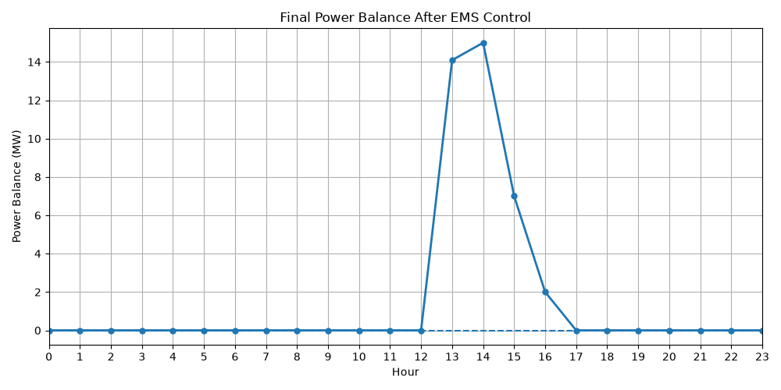
Figure 6.3 shows power deficits during morning and evening periods, while Figure 6.4 demonstrates a near-zero positive balance throughout a simulation cycle.

6.3 Performance Summary
Total Solar Generation | 558.0 MWh
Total Diesel Generation | 1080.0 MWh
Renewable Penetration | 34.1%
Battery Throughput | 341.6 MWh
Curtailed Energy | 38.1 MWh
Total Load Shed | 275.0 MWh
Hospital Uptime | 100.0%
Residential Uptime | 83.3%
Factory Uptime | 70.8%

The simulation produced 558.0 MWh of solar energy and 1080.0 MWh of diesel energy over the 24-hour period. The total solar generation is approximately half the total diesel generation. The renewable penetration shows the ratio of the total renewable energy generation to the total energy generation. A penetration of 34.1% shows that renewable energy generation is approximately a third of the total energy generation.

The battery throughput represents total amount of energy a battery charges and discharges. 341.6 MWh of energy flows in and out of the battery during the simulation period. A total of 38.1 MWh of energy was curtailed during the simulation.

The hospital maintained a full uptime, while the other loads experienced a lower availability throughout the simulation.
7.0 Performance Evaluation
7.1 Power Balance
The final power balance greatly improved compared to the initial power balance, demonstrating that EMS successfully coordinated battery storage and load shedding to reduce power imbalance. The power balance remained close to zero throughout most of the simulation periods except the midday hours, where a significant amount of positive balance was observed. The surplus was stored in the battery, and deficit was compensated by discharging the battery. As a result, the EMS effectively coordinates energy flow to minimize power imbalance.

7.2 Battery Energy Storage System (BESS)
The Battery Energy Storage System (BESS) provided an added benefit to the microgrid EMS as a buffer, ensuring that power imbalances, either surplus or deficits, could be minimized to ensure system stability. During the midnight period, energy in the battery was discharged to compensate for insufficient power generation. During the midday hours, the energy surplus due to large solar generation was stored in the battery. The recorded battery throughput of 341.6 MWh represents that BESS actively operates throughout the simulation. Although the battery was fully depleted during a long period of power deficit, it was recharged during high solar generation, demonstrating its ability to support the system operation under changing conditions. These results demonstrate that the BESS is a crucial part in the microgrid, sustaining system resilience and supporting operational reliability.

7.3 Load Shedding
The total load shed of 275.0 MWh suggests that the EMS frequently reduces system load, indicating the microgrid system experienced energy shortages rather than excess. The load shedding only occurred during prolonged periods of low solar generation, and battery is fully depleted and could no longer compensate for the power deficit. This resulted in lower-priority loads being disconnected while the hospital remained online throughout the entire simulation period. Overall power balance and system stability were maintained by automating load shedding.
8.0 Limitations & Improvements
8.1 Limitations
1. Fixed Load Demand
Predefined hourly load demand could not fully capture the dynamic and unpredictable real-world data for each zone. In practice, electricity demand changes unpredictably due to varying weather conditions and consumer behaviour. Therefore, the model does not fully represent the real-world data.

2. Simplified Solar Generation
Solar generation is represented using fixed hourly multipliers instead of using actual solar irradiance data. In fact, solar generation could be affected by cloud cover and seasonal changes. Neglecting these variations may reduce the accuracy of generation data.

3. Simplified Battery Model
The Battery Energy Storage System (BESS) used in this model considers only four basic parameters. Other characteristics such as battery degradation and temperature effects were neglected, which may lead to an optimistic performance estimation.

4. Simple Control Strategy
The Energy Management System (EMS) follows a rule-based control strategy that prioritises battery charging, discharging, and load shedding. Although effective for this simulation, it does not optimise operating cost, fuel consumption or renewable energy utilization.

8.2 Improvements
1. Real-World Data Integration
Integrating real-time load demand data and solar irradiance data obtained from sensors or forecasting systems in future work to improve simulation realism.

2. Advanced Battery Modelling
Enhance detail of battery modelling by considering degradation, aging, temperature effects, and state-of-health could provide more accurate predictions for long-term battery performance.

3. Intelligent EMS Control
The rule-based EMS control could be replaced with intelligent control techniques, such as Model Predictive Control or Reinforcement Learning to minimise operating costs and maximise renewable energy utilization.

4. Additional Renewable Sources
The current simulation only uses solar PV and diesel generator for energy generation. More variety of renewable sources, such as wind turbines or hydroelectricity, could be introduced to increase supply diversity, improving microgrid stability and reduce dependence on diesel generation.
9.0 Conclusion
This project successfully developed a Python-based Smart Microgrid Energy Management System (EMS) to simulate the operation of a grid-independent microgrid over a 24-hour period. The proposed EMS integrated solar photovoltaic generation, a diesel generator, a Battery Energy Storage System (BESS), and a priority-based load shedding strategy to coordinate power generation and consumption under varying operating conditions. Simulation results demonstrated that the EMS effectively maintained power balance by charging and discharging the BESS while performing load shedding if necessary. The proposed control strategy ensured uninterrupted power supply to the highest-priority load, demonstrating its effectiveness in maintaining system stability and operational reliability.

Despite the simplified assumptions adopted in the simulation, the developed EMS provides a practical framework for understanding microgrid energy management and coordination of distributed energy resources. Future improvements, including real-time data integration, advanced battery modelling, intelligent control strategies, and the incorporation of additional renewable energy sources, could further enhance the accuracy and performance of the system. Overall, this project demonstrates the feasibility of a rule-based EMS as a reliable approach for maintaining power balance and supporting the efficient operation of modern microgrids.
References
IEEE Technology Navigator – Control
Institute of Electrical and Electronics Engineers. (n.d.). Control. IEEE Technology Navigator. https://technav.ieee.org/topic/control/
Saeed, M. H., Fangzong, W., Kalwar, B. A., & Iqbal, S. (2021). A review on microgrids' challenges & perspectives. IEEE Access, 9, 166502–166517. https://doi.org/10.1109/ACCESS.2021.3135083
Zahraoui, Y., Wang, F., Kalwar, B. A., & Iqbal, S. (2021). Energy management system in microgrids: A comprehensive review. Sustainability, 13(19), 10492. https://doi.org/10.3390/su131910492

