SIGNALSTACK
Business Intelligence Forecast Report
Generated: March 28, 2026 | Week: 2026-W13 | True North Data Strategies

Executive Summary
This report summarizes the latest SignalStack forecasting results across all active business signals. Each model was trained on historical data and validated against a held-out period before generating forward projections. Use MAPE as the primary accuracy indicator — under 10% is considered strong for small-business operational data.
Signal | Model | MAPE | MAE | Accuracy Assessment
Daily Sales Revenue | (1, 1, 1)x(0, 0, 0, 5) | 18.3% | $312 | Moderate
Weekly Jobs Completed | (1, 1, 1)x(0, 0, 0, 4) | 6.2% | 2.6 jobs | Good
Weekly Ending Cash Balance | (1, 1, 1)x(0, 0, 0, 4) | 1.3% | $1,129 | Excellent
Weekly Pipeline Value | (1, 1, 1)x(0, 0, 0, 4) | 30.0% | $12,223 | Fair
Weekly Billable Hours | (1, 1, 1)x(0, 0, 0, 4) | 2.0% | 5.5 hrs | Excellent

Signal Details

Daily Sales Revenue

Model | MAPE | MAE | RMSE
SARIMA(1, 1, 1)x(0, 0, 0, 5) | 18.3% | $312 | $353

Moderate — directionally accurate. Verify against actuals each week.
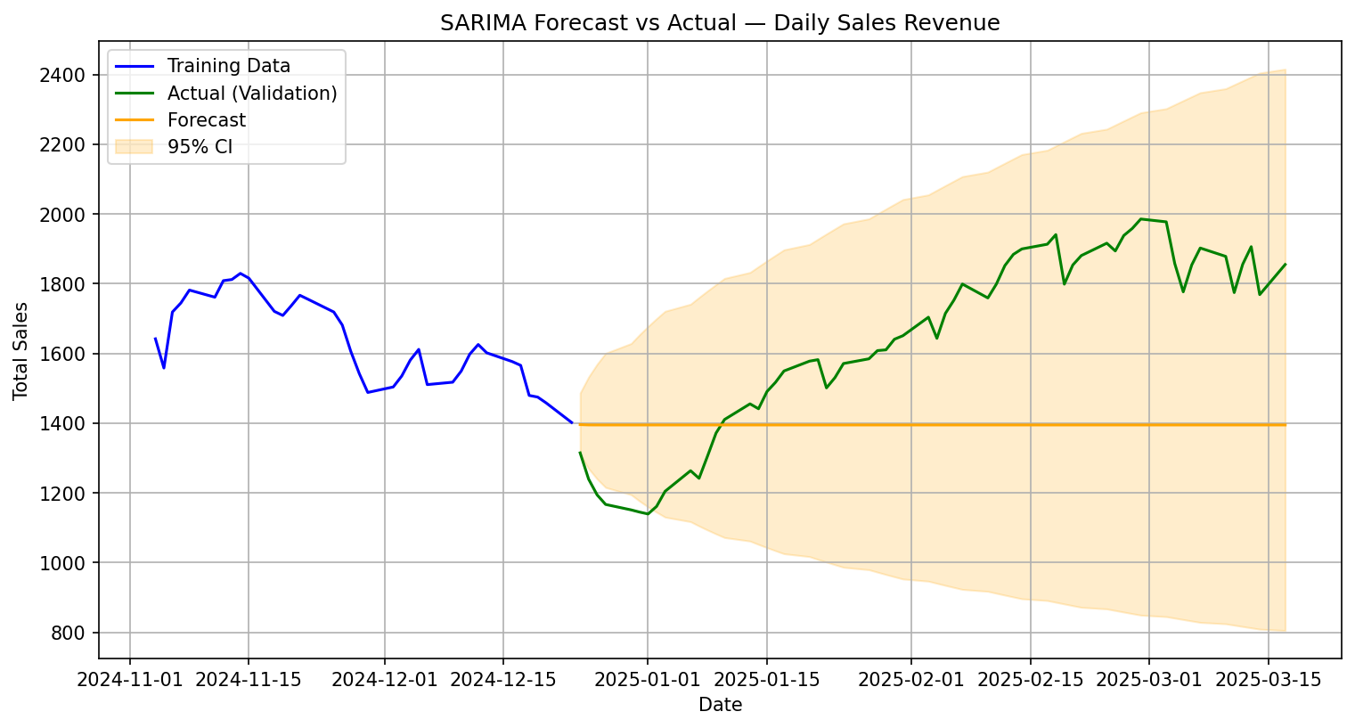
Figure: SARIMA Forecast vs Actual — Daily Sales Revenue

Weekly Jobs Completed

Model | MAPE | MAE | RMSE
SARIMA(1, 1, 1)x(0, 0, 0, 4) | 6.2% | 2.6 | 2.9

Good — reliable signal. Minor variance expected week-to-week.
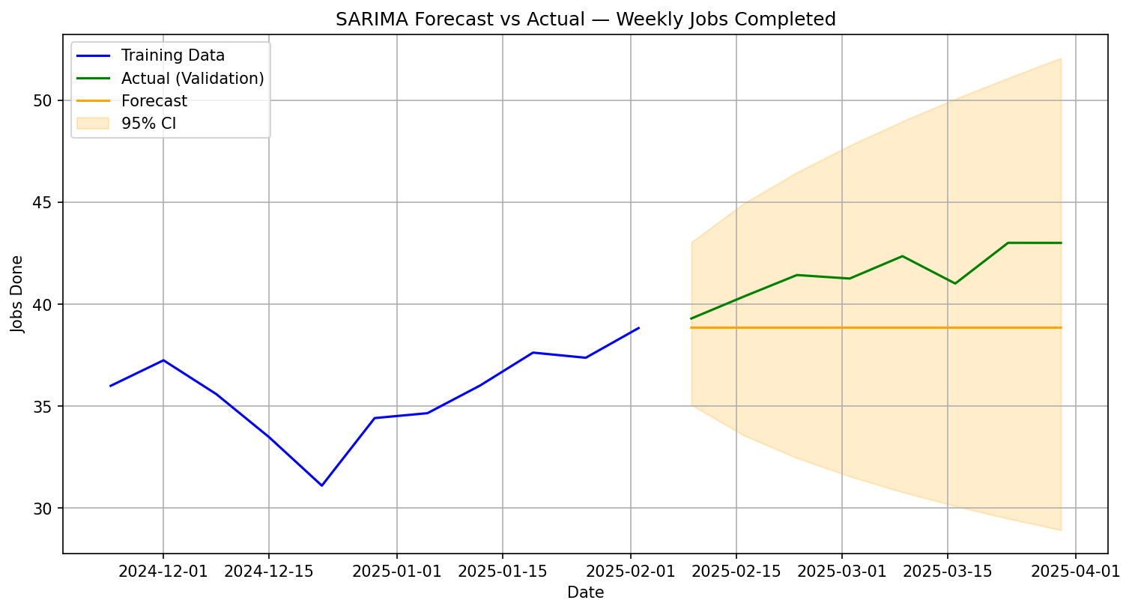
Figure: SARIMA Forecast vs Actual — Weekly Jobs Completed

Weekly Ending Cash Balance

Model | MAPE | MAE | RMSE
SARIMA(1, 1, 1)x(0, 0, 0, 4) | 1.3% | $1,129 | $1,256

Excellent — high-confidence forecast. Use for operational decisions.
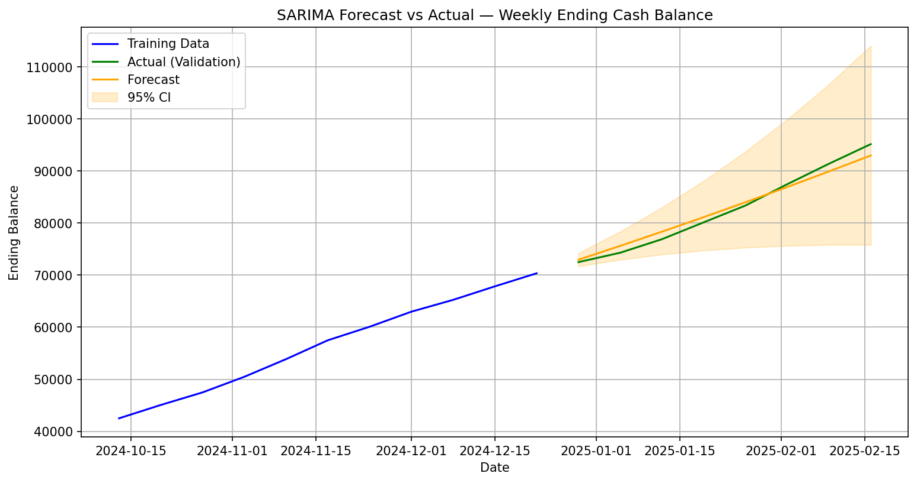
Figure: SARIMA Forecast vs Actual — Weekly Ending Cash Balance

Weekly Pipeline Value

Model | MAPE | MAE | RMSE
SARIMA(1, 1, 1)x(0, 0, 0, 4) | 30.0% | $12,223 | $13,551

Fair — use for trend direction only. More data will improve accuracy.
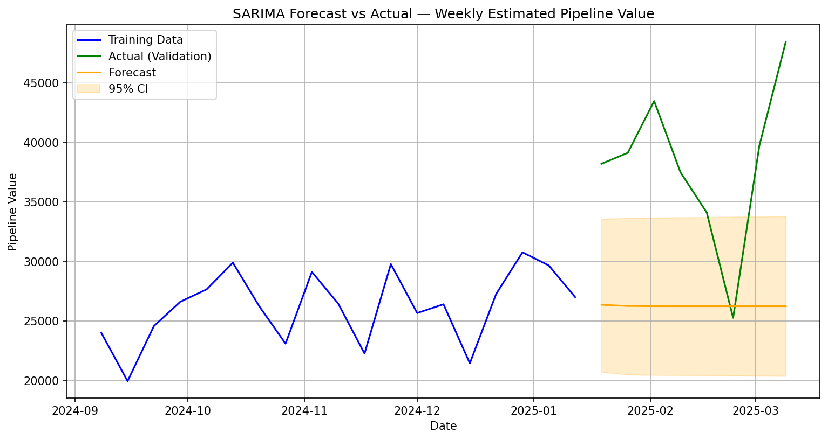
Figure: SARIMA Forecast vs Actual — Weekly Pipeline Value

Weekly Billable Hours

Model | MAPE | MAE | RMSE
SARIMA(1, 1, 1)x(0, 0, 0, 4) | 2.0% | 5.5 | 6.9

Excellent — high-confidence forecast. Use for operational decisions.
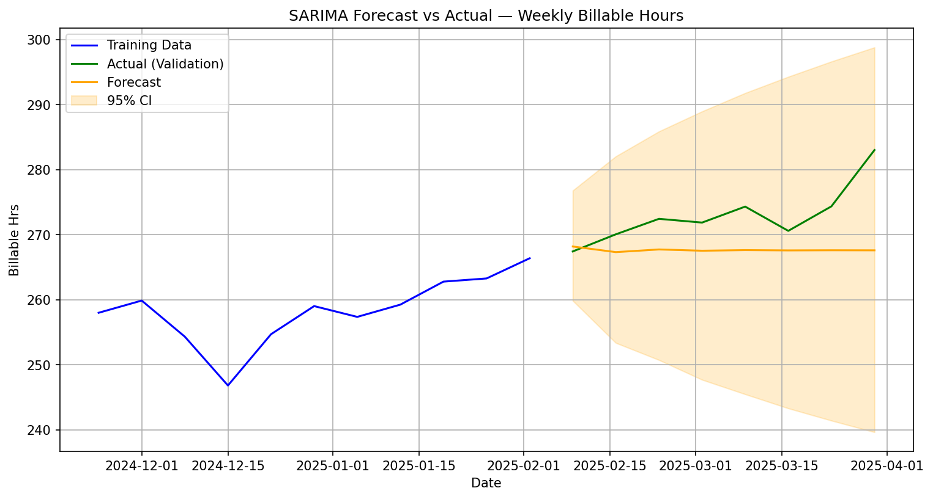
Figure: SARIMA Forecast vs Actual — Weekly Billable Hours

Glossary of Terms

Reference definitions for all metrics, model parameters, and technical terms used in this report.
SARIMA Seasonal AutoRegressive Integrated Moving Average — the statistical model used to learn patterns in time series data and project them forward.
AIC Akaike Information Criterion — a model quality score. Lower AIC = better fit. Used to select the best parameter combination during grid search.
MAE (Mean Absolute Error) Average dollar/unit difference between forecast and actual. Easy to interpret: if MAE = $307, the forecast is off by $307 on average.
RMSE (Root Mean Square Error) Similar to MAE but penalizes large misses more heavily. Higher than MAE means there are occasional big misses.
MAPE (%) Mean Absolute Percentage Error — forecast accuracy expressed as a percentage. 5% MAPE means the model is off by 5% on average. Under 10% is considered good for business forecasting.
Confidence Interval (95% CI) The shaded band on forecast charts. There is a 95% probability the actual value will land inside this band. Wider band = more uncertainty.
Training Data The historical period the model learned from (blue line on charts).
Validation Period The held-out period used to test model accuracy before forecasting the future (green line on charts — this is real data the model had not seen).
Forecast The model's projection beyond the validation period (orange line on charts).
Grid Search The automated process of testing all SARIMA parameter combinations and selecting the one with the lowest AIC. Run once; reuse with --skip-search.
ISO Week A standardized week numbering system (e.g., 2025-W14 = the 14th week of 2025, starting Monday). Used for all weekly SignalStack sources.
EWM Smoothing Exponential Weighted Moving Average — applied during preprocessing to reduce day-to-day noise while preserving trend direction.

SignalStack by True North Data Strategies | jacob@truenorthstrategyops.com | 719-204-6365 | Colorado Springs, CO | SDVOSB

