SIGNALSTACK
Business Intelligence Forecast Report
Generated: March 30, 2026 | Week: 2026-W14 | True North Data Strategies

Executive Summary
This report summarizes the latest SignalStack forecasting results across all active business signals. Each model was trained on historical data and validated against a held-out period before generating forward projections. Use MAPE as the primary accuracy indicator — under 10% is considered strong for small-business operational data.
Signal | Model | MAPE | MAE | Accuracy Assessment
Daily Sales Revenue | (0, 1, 0)x(2, 0, 2, 5) | 12.8% | $208 | Moderate
Weekly Jobs Completed | (0, 1, 1)x(0, 0, 0, 4) | 2.1% | 0.9 jobs | Excellent
Weekly Ending Cash Balance | (2, 1, 0)x(2, 0, 0, 4) | 0.6% | $1,829 | Excellent
Weekly Pipeline Value | (0, 1, 1)x(0, 0, 0, 4) | 10.5% | $7,416 | Moderate
Weekly Billable Hours | (2, 1, 2)x(0, 0, 0, 4) | 2.9% | 8.2 hrs | Excellent

Glossary of Terms

Reference definitions for all metrics, model parameters, and technical terms used in this report.
AIC (Akaike Information Criterion) A model quality score. Lower is better. SignalStack compares models with an adjusted-AIC selection step to discourage overfitting on short series, while still recording the raw AIC in outputs.
Business Day (B) A frequency setting meaning the model runs on weekdays only (Monday–Friday). Used for the Sales signal since transactions happen on business days.
Callback Rate The percentage of completed jobs that required a return visit due to incomplete or incorrect work. A key quality indicator in Ops Pulse.
Confidence Interval (95% CI) The shaded orange band on forecast charts. There is a 95% probability the actual future value will land inside this band. A wider band means more uncertainty. As you add more history, the band typically narrows.
CSV (Comma-Separated Values) A simple text file where each row is a record and columns are separated by commas. SignalStack uses CSVs as the bridge between your Excel workbooks and the forecasting engine. You never need to open or edit these — `export_to_csv.py` creates them automatically.
accuracy_log.csv A persistent run history file in `data/output/` with one row per source per run (timestamp, model, AIC, MAPE, CV metrics, train size, validation size, forecast horizon). Use it to track model improvement over time.
EWM Smoothing (Exponential Weighted Moving Average) Applied before modeling to reduce week-to-week noise while preserving the overall trend. Think of it like a moving average that gives more weight to recent data. Controlled by `smoothing_span` in config.py.
Forecast The model's projection of future values based on historical patterns. Shown as the orange line on charts.
Forecast Horizon How many periods beyond the validation window the model projects. Current defaults are source-specific: `sales=90` business days, and all weekly sources (`ops_pulse`, `cash_flow_compass`, `pipeline_pulse`, `team_tempo`) use `12` weeks.
Grid Search The process of testing SARIMA parameter combinations and selecting the best model. SignalStack rejects non-converged fits, applies an over-parameterization penalty during selection, and includes a validation MAPE guardrail fallback for unstable results. Runtime varies by source and configured search ranges.
Cross-Validation (CV) Rolling-origin backtesting across multiple folds to estimate stability, not just one split. Saved as `CV_Mean_MAPE` and `CV_Std_MAPE` in each source `metrics.txt`.
Convergence A status from statsmodels indicating whether optimizer fitting completed successfully. Non-converged candidates are rejected during grid search.
IQR (Interquartile Range) A statistical measure used to detect outliers. Values that fall far outside the middle 50% of your data are flagged as outliers and handled per your `OUTLIER_REPLACEMENT` setting.
ISO Week A standardized week numbering system where weeks start on Monday. Format: `YYYY-Www`. Example: `2026-W13` = the 13th week of 2026, starting March 23, 2026. Used as the date format for all weekly SignalStack sources.
MAE (Mean Absolute Error) The average difference between what the model predicted and what actually happened, in the signal's native unit. If MAE = $307 for Sales, the model is off by an average of $307 per day. If MAE = 2.6 for Ops Pulse, the model is off by 2.6 jobs per week on average.
MAPE (Mean Absolute Percentage Error) The average error expressed as a percentage of the actual value. This is your primary accuracy metric. Under 10% is strong for small-business data. 10–20% is moderate. Over 20% means use for trend direction only.
Model In SignalStack context, the trained SARIMA statistical model for a given signal. Stored as a `.pkl` file in the `models/` folder. Reloaded on each `--skip-search` run.
Ops Pulse SignalStack's operational health signal. Tracks jobs completed, on-time rate, callback rate, crew utilization, and open work orders per week.
Outlier A data point that falls significantly outside the normal range. Examples: a holiday week with unusually low jobs, a one-time large deal that spikes pipeline value. SignalStack detects and handles these automatically before modeling.
Pipeline Pulse SignalStack's sales pipeline signal. Aggregates the estimated value of prospects entered each week, tracking direction and velocity of new business.
RMSE (Root Mean Square Error) Similar to MAE but penalizes large misses more heavily. If RMSE is significantly higher than MAE, it means the model occasionally makes big misses even if the average error is acceptable.
SARIMA Seasonal AutoRegressive Integrated Moving Average. The statistical model used by SignalStack to learn patterns in time series data and project them forward. The "Seasonal" part means it can detect repeating patterns (weekly, monthly, quarterly rhythms) in your data.
Seasonal Period How long one "season" is in your data. For weekly data with a monthly pattern, seasonal_period = 4 (four weeks per month). For daily business data with a weekly pattern, seasonal_period = 5 (five business days per week).
Signal In SignalStack, a "signal" is one tracked business metric — sales revenue, jobs completed, cash balance, pipeline value, or billable hours. Each signal has its own model, data, and output.
Skip-Search A command flag (`--skip-search`) that tells the pipeline to skip the slow SARIMA grid search and use the parameters already saved in `MANUAL_PARAMS` in `run_pipeline.py`. Use this every week after your first full run.
Team Tempo SignalStack's workforce signal. Tracks headcount, billable hours, overtime hours, utilization rate, turnover, and training hours per week.
Training Data The historical periods the SARIMA model learned from. Shown as the blue line on forecast charts. More training data = better model accuracy.
Validation Period The most recent portion of your history held back from training and used to test how accurate the model is. Shown as the green line on forecast charts. The difference between green and orange is your error rate.
Virtual Environment (venv) A self-contained Python installation specific to this project. Keeps SignalStack's dependencies isolated from other software on your computer. Activated by running `.\venv_tnds-signal-engine\Scripts\Activate.ps1`.
AIC Akaike Information Criterion — a model quality score. Lower AIC = better fit. Used to select the best parameter combination during grid search.
MAPE (%) Mean Absolute Percentage Error — forecast accuracy expressed as a percentage. 5% MAPE means the model is off by 5% on average. Under 10% is considered good for business forecasting.
Ensemble Forecast A blending technique that combines SARIMA with a Weighted Moving Average (WMA) to stabilize volatile signals. The SARIMA component captures seasonality and trend; the WMA anchors the forecast to recent observed levels. Used for pipeline value and similar high-variance signals.
Signal Profile Business context about the data behind a forecast — customer count, transaction volume, revenue concentration. Explains why some signals are inherently harder to forecast than others.
EWM Smoothing Exponential Weighted Moving Average — applied during preprocessing to reduce day-to-day noise while preserving trend direction.

Signal Details

Daily Sales Revenue

Model | MAPE | MAE | RMSE
SARIMA(0, 1, 0)x(2, 0, 2, 5) | 12.8% | $208 | $249

Moderate — directionally accurate. Verify against actuals each week.
The model applies one differencing pass to remove the underlying trend slope before learning patterns. It looks for repeating cycles every 5 business days, which corresponds to one trading week in this data. Active components: seasonal momentum, seasonal error correction.
The average forecast error is $208, which represents 12.1% of the observed average ($1,716). RMSE ($249) is close to MAE, meaning errors are consistent in size without large outlier misses. At 12.8% MAPE, the model captures the right direction but individual period values may vary moderately. Cross-validation (3-fold) confirms this at 14.7% +/- 2.2% average MAPE, indicating stable model performance across different time windows. Note: A V-shaped residual bias was detected during validation, indicating the model's trend-tracking could be improved with additional training data or parameter adjustment.
In the forecast chart below for Daily Sales Revenue, the blue line shows the training period the model learned from, the green line shows real validation data the model had not seen (the honest test), and the orange line is the model's forecast. If green tracks orange closely the model is reliable for that horizon; if they diverge significantly, the business shifted in a way the model did not anticipate. The shaded band represents the 95% confidence interval — a wider band signals greater uncertainty.
Decision Guidance: Use for directional awareness, not precise planning. Verify actuals weekly. Flag if actual values diverge from the forecast by more than $208 for two consecutive periods.
Signal Profile: This forecast is built from 441 historical transactions across 15 unique customers, with total tracked revenue of $790,660. The top 5 customers account for 42% of all revenue. This concentration means individual ordering patterns directly impact daily revenue variance — a structural data characteristic, not a model weakness. Accuracy will improve as customer count grows. Average transaction size is $1,793, indicating bulk/commercial purchasing patterns typical of field service operations.
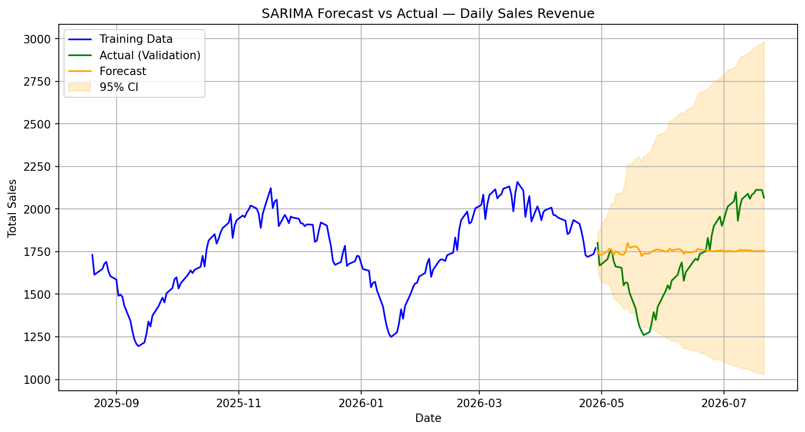
Figure: SARIMA Forecast vs Actual — Daily Sales Revenue

Weekly Jobs Completed

Model | MAPE | MAE | RMSE
SARIMA(0, 1, 1)x(0, 0, 0, 4) | 2.1% | 0.9 | 1.1

Excellent — high-confidence forecast. Use for operational decisions.
The model applies one differencing pass to remove the underlying trend slope before learning patterns. It looks for repeating cycles every 4 weeks, which corresponds to roughly one month in this data. Active components: recent forecast-error correction.
The average forecast error is 0.9 jobs, which represents 2.1% of the observed average (42.7 jobs). RMSE (1.1 jobs) is close to MAE, meaning errors are consistent in size without large outlier misses. At 2.1% MAPE, this forecast is highly precise — expect actual values to land very close to projections. Cross-validation (3-fold) confirms this at 3.2% +/- 1.4% average MAPE, indicating stable model performance across different time windows.
In the forecast chart below for Weekly Jobs Completed, the blue line shows the training period the model learned from, the green line shows real validation data the model had not seen (the honest test), and the orange line is the model's forecast. If green tracks orange closely the model is reliable for that horizon; if they diverge significantly, the business shifted in a way the model did not anticipate. The shaded band represents the 95% confidence interval — a wider band signals greater uncertainty.
Decision Guidance: Use this forecast for operational planning. At 2.1% MAPE it is reliable enough to inform staffing, scheduling, and cash decisions directly.
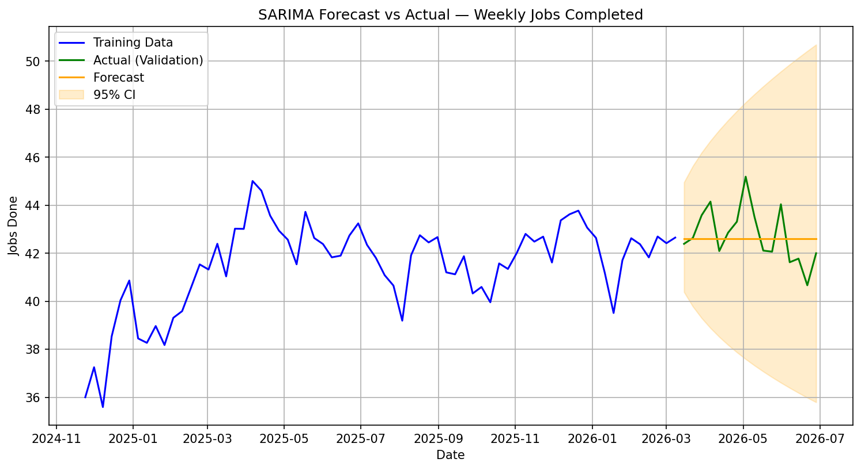
Figure: SARIMA Forecast vs Actual — Weekly Jobs Completed

Weekly Ending Cash Balance

Model | MAPE | MAE | RMSE
SARIMA(2, 1, 0)x(2, 0, 0, 4) | 0.6% | $1,829 | $2,218

Excellent — high-confidence forecast. Use for operational decisions.
The model applies one differencing pass to remove the underlying trend slope before learning patterns. It looks for repeating cycles every 4 weeks, which corresponds to roughly one month in this data. Active components: short-term momentum, seasonal momentum.
The average forecast error is $1,829, which represents 0.6% of the observed average ($290,935). RMSE ($2,218) is close to MAE, meaning errors are consistent in size without large outlier misses. At 0.6% MAPE, this forecast is highly precise — expect actual values to land very close to projections. Cross-validation (3-fold) confirms this at 2.9% +/- 1.7% average MAPE, indicating stable model performance across different time windows.
In the forecast chart below for Weekly Ending Cash Balance, the blue line shows the training period the model learned from, the green line shows real validation data the model had not seen (the honest test), and the orange line is the model's forecast. If green tracks orange closely the model is reliable for that horizon; if they diverge significantly, the business shifted in a way the model did not anticipate. The shaded band represents the 95% confidence interval — a wider band signals greater uncertainty.
Decision Guidance: Use this forecast for operational planning. At 0.6% MAPE it is reliable enough to inform staffing, scheduling, and cash decisions directly.
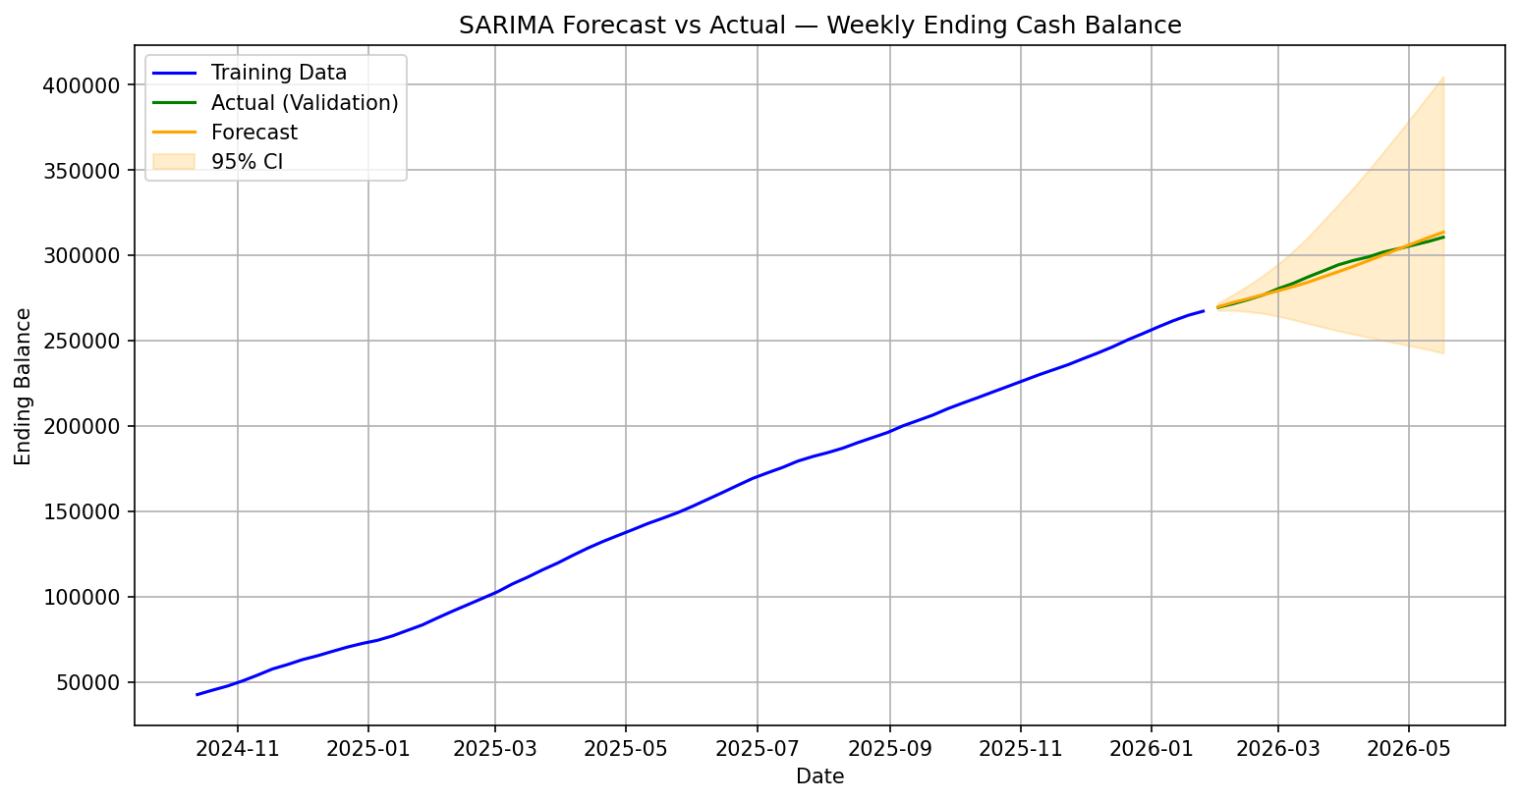
Figure: SARIMA Forecast vs Actual — Weekly Ending Cash Balance

Weekly Pipeline Value

Model | MAPE | MAE | RMSE
SARIMA(0, 1, 1)x(0, 0, 0, 4) | 10.5% | $7,416 | $9,088

Moderate — directionally accurate. Verify against actuals each week.
This signal uses an ensemble approach: the SARIMA forecast is blended with a weighted moving average at a 60/40 ratio. The WMA component anchors the projection to recent observed levels, reducing the impact of week-to-week volatility on the forecast line. The model applies one differencing pass to remove the underlying trend slope before learning patterns. It looks for repeating cycles every 4 weeks, which corresponds to roughly one month in this data. Active components: recent forecast-error correction.
The average forecast error is $7,416, which represents 9.9% of the observed average ($75,218). RMSE ($9,088) is close to MAE, meaning errors are consistent in size without large outlier misses. At 10.5% MAPE, the model captures the right direction but individual period values may vary moderately. Cross-validation (3-fold) confirms this at 18.3% +/- 7.5% average MAPE, indicating variable model performance across different time windows.
In the forecast chart below for Weekly Pipeline Value, the blue line shows the training period the model learned from, the green line shows real validation data the model had not seen (the honest test), and the orange line is the model's forecast. If green tracks orange closely the model is reliable for that horizon; if they diverge significantly, the business shifted in a way the model did not anticipate. The shaded band represents the 95% confidence interval — a wider band signals greater uncertainty.
Decision Guidance: Use for directional awareness, not precise planning. Verify actuals weekly. Flag if actual values diverge from the forecast by more than $7,416 for two consecutive periods.
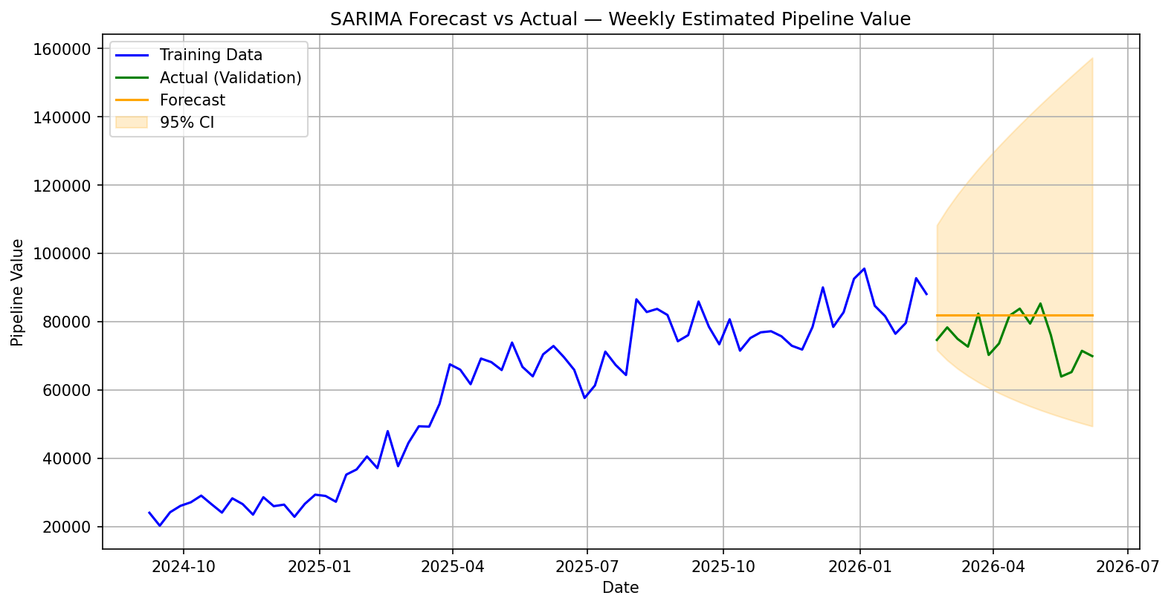
Figure: Ensemble Forecast vs Actual — Weekly Pipeline Value

Weekly Billable Hours

Model | MAPE | MAE | RMSE
SARIMA(2, 1, 2)x(0, 0, 0, 4) | 2.9% | 8.2 | 9.0

Excellent — high-confidence forecast. Use for operational decisions.
The model applies one differencing pass to remove the underlying trend slope before learning patterns. It looks for repeating cycles every 4 weeks, which corresponds to roughly one month in this data. Active components: short-term momentum, recent forecast-error correction.
The average forecast error is 8.2 hrs, which represents 2.9% of the observed average (281.7 hrs). RMSE (9.0 hrs) is close to MAE, meaning errors are consistent in size without large outlier misses. At 2.9% MAPE, this forecast is highly precise — expect actual values to land very close to projections. Cross-validation (3-fold) confirms this at 2.0% +/- 0.5% average MAPE, indicating stable model performance across different time windows.
In the forecast chart below for Weekly Billable Hours, the blue line shows the training period the model learned from, the green line shows real validation data the model had not seen (the honest test), and the orange line is the model's forecast. If green tracks orange closely the model is reliable for that horizon; if they diverge significantly, the business shifted in a way the model did not anticipate. The shaded band represents the 95% confidence interval — a wider band signals greater uncertainty.
Decision Guidance: Use this forecast for operational planning. At 2.9% MAPE it is reliable enough to inform staffing, scheduling, and cash decisions directly.
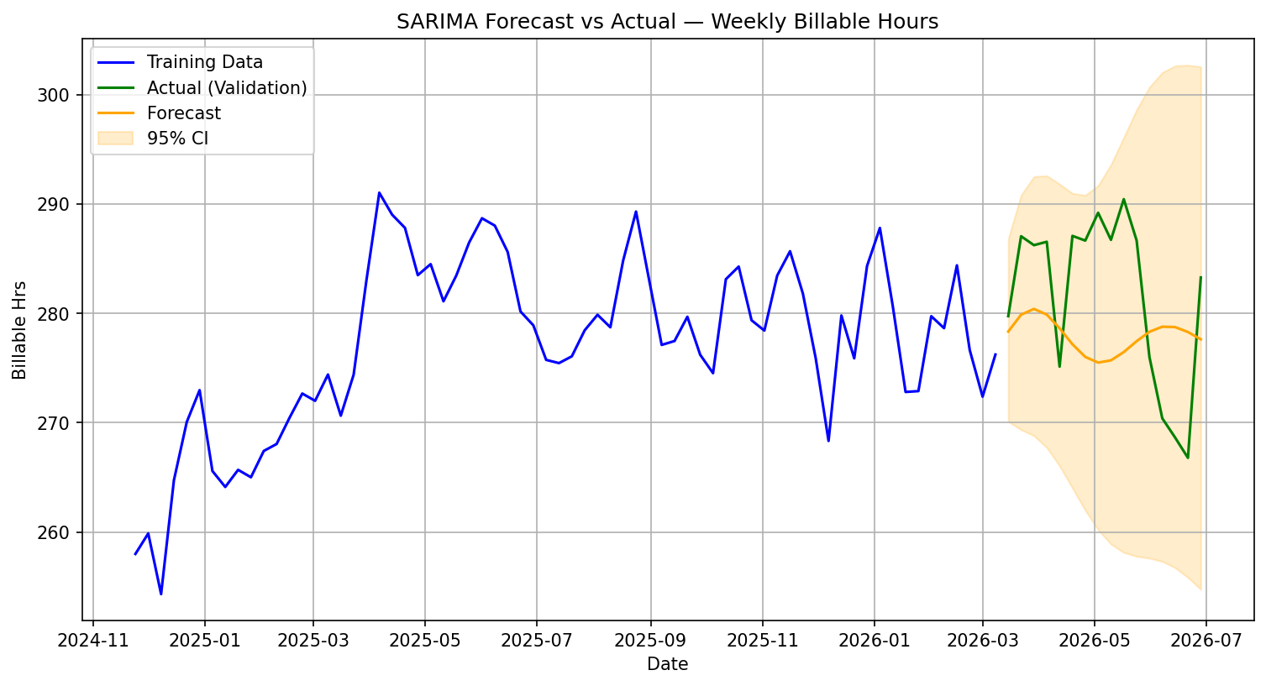
Figure: SARIMA Forecast vs Actual — Weekly Billable Hours

SignalStack by True North Data Strategies | jacob@truenorthstrategyops.com | 719-204-6365 | Colorado Springs, CO | SDVOSB

