The world of scientific development revolves around the use of simulation and experimental measures, call it theoretical and analytical complementation. Based on the insights given through simulation results and the accordance with experimental tests, we as humans help further progress scientific achievement.

AutoNeura focuses on the combination of both these aspects of scientific development to enable the user or person to rapidly further their insight on product focused development projects envisioned. By developing an automatic synergy between simulations and experimental mainframes and combining this with analytical solutions such as artificial intelligence, we will make better decisions on scientific based developments.

The focus is around the human being, equipping the human with tools that enable interaction. Be it through high definition graphics, causality reports, voice command or other media, humans are progressing towards this symbiosis.

The future lies in an environment where our senses, motives and thoughts are enabled through a neural lace. We are progressing towards the binding of man and machine at a rate which is unprecedented. It is inevitable.

The formatting of information such that man may understand machine language is needed. Developments are taking place globally in bettering mankind’s understanding of the human brain. The first well-funded attempt to bridge the link between human thought and digital information is being enabled through NeuraLink.

AutoNeura has the ambition of focusing on the long-term. Its end goal is to be the leader in digitizing and packaging information for the human brain to understand complex ideas.

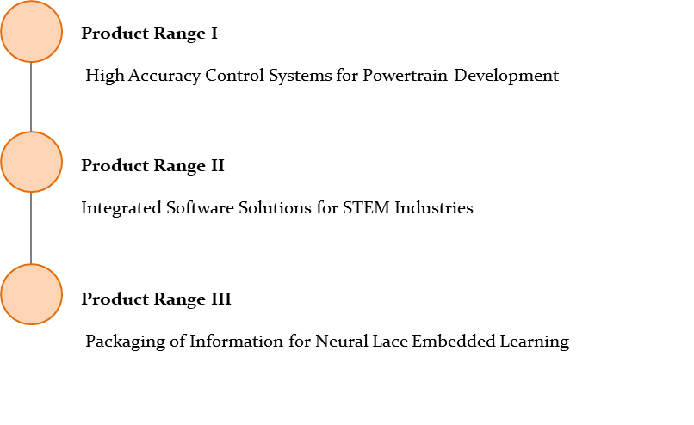**Products**

**Product Range I**

Enabling powertrain testing and development at reduced cost with tailored software made to run on cheaper laboratory hardware. Currently under Technology Readiness Level (TRL) 4/5. AutoNeura is seeking seed investment to reach TRL 6/7 and industrial application.

