MCP4921:

- Voltage: 2.7 --> 5.5V

- Schematic:

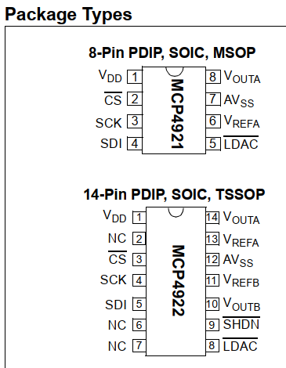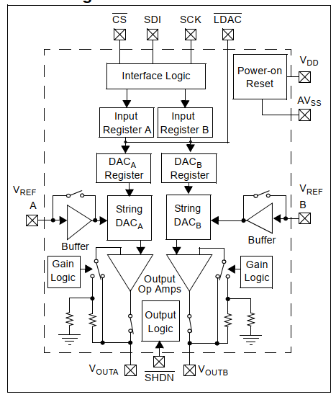

* Maxspeed: 20MHz
* Data frame:

1. CPOL = 0
2. CPHA = 0
3. #of_bit =
4. 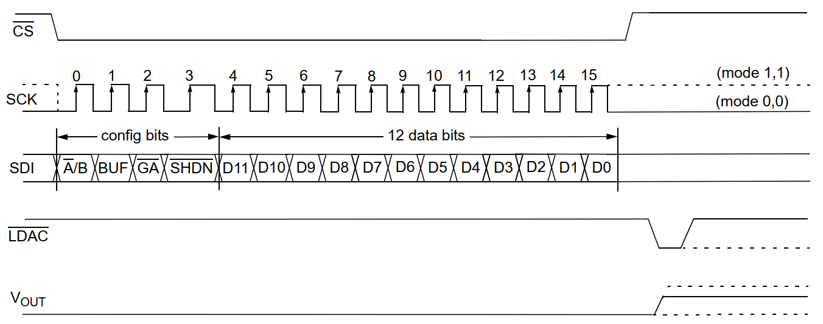
5. 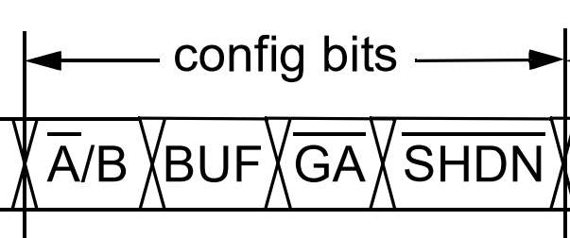MSB/LSB =
6. Regiters

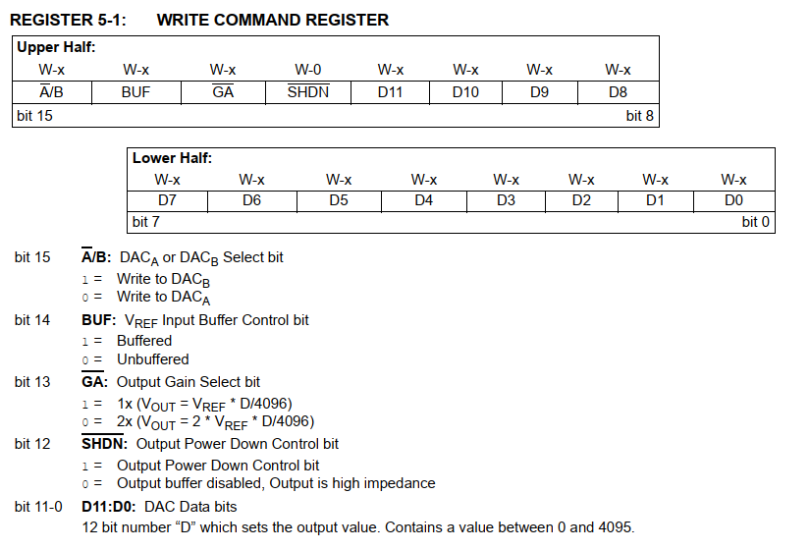

MAX7219:

* Voltage: 4 🡪 5.5V
* Schematic: 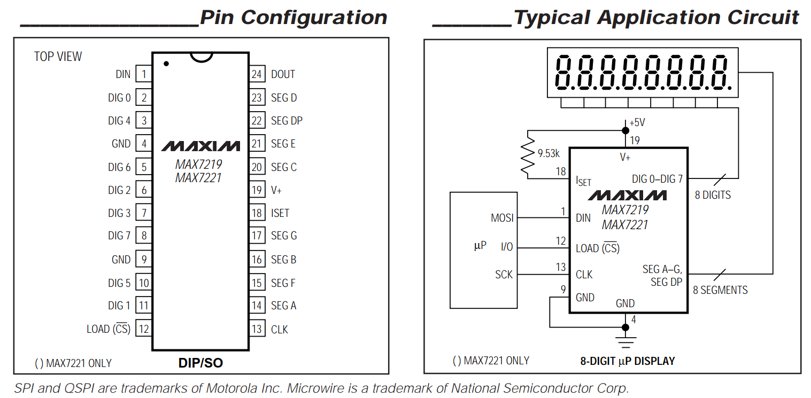
* Maxspeed: 10MHz
* Data frame :

1. CPOL = 0
2. CPHA = 0
3. #of_bits
4. MSB/LSB

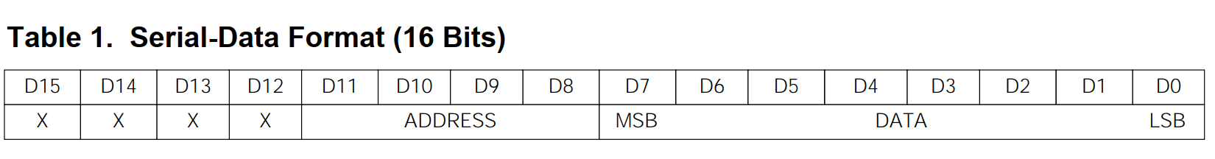

1. Registers:
2. 