2022 Interactive SWP Phase 2 Updates

Post Test – Part 1

# Update WMS type drop-down list order

Thank you for updating the labels and descriptions of the two WMS types to ‘Agricultural Conservation’ and ‘Industrial Conservation’. That update looks fine. What we need updated now is the sort order of the WMS type list so that the labels appear in alphabetical order. ‘Agricultural Conservation’ will now be listed first, and ‘Industrial Conservation’ will be listed after ‘Indirect Reuse’. See image 1 to see where they are currently listed.

Image 1

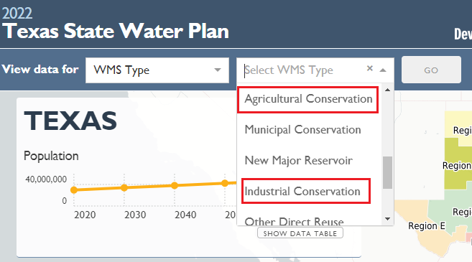

# Update planning Region E’s description

At some point when we were editing the Region E page description for the first 2022 iSWP roll-out, the sentence describing the major cities was accidentally deleted. I’m sorry this was missed in the first round of edits. Please update Region E’s description again (see red box in image 2) using (copy/paste) the following text:

The Far West Texas (Region E) Regional Water Planning Area includes seven counties and lies entirely within the Rio Grande River Basin in the most arid part of the state. Most of the population in this planning area resides in El Paso County, in and around the City of El Paso. The 2021 Regional Water Plans can be found on the TWDB website at: <http://www.twdb.texas.gov/waterplanning/rwp/plans/2021/index.asp>.

Image 2

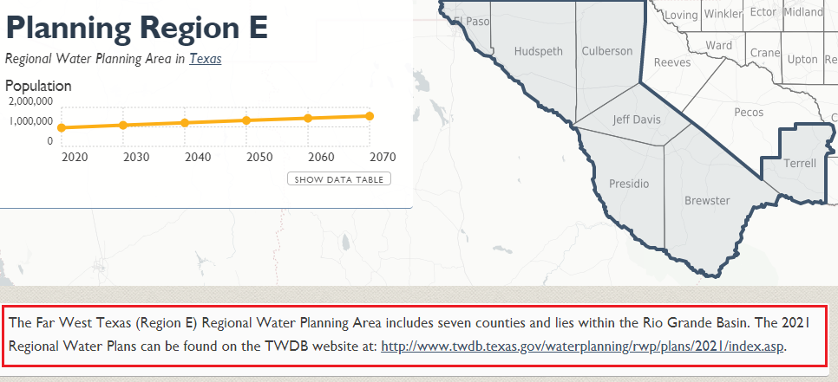

# Update page not found message for unmapped sources

There are four MapSourceIds listed in the table below (image 3) that are not mapped to a specific location in the iSWP because they were not included in the 2017 version shapefile. I proposed to the planning team that we map these sources to the state’s shape but forgot to add the three existing MapSourceIds (169, 412, and 820) to the list of new sources I needed Jean to help map. She added ‘rainwater harvesting’ because that is a new source this time and already in my list. I think someone from TNRIS hid sources that were not mapped from the source name search to prevent the user from getting to a page not found message directly in the 2017 version. Good thinking! However, the user can still see them as a hyperlinked source name which leads them to a page not found message if they go through another page.

For example, if I go to the water user group page for Austin and scroll down to the Raw Data section and look for the ‘Direct Reuse’ source name in their strategy supplies list and click on it (image 4), I am directed to a page not found message (image 5). At some point in the future, we will fix those three sources so they will map to the state level like we have done with the ‘Rainwater Harvesting’ source. For now, I was thinking that we could revise the ‘Page not Found’ message to replace the “We’re sorry, the page you requested cannot be found.” with the following text to provide the user with a way to obtain the data:

This data summary is currently not available. To get data related to this topic, please email [wrpdatarequests@twdb.texas.gov](mailto:wrpdatarequests@twdb.texas.gov).

If that first solution does not work for you, another idea would be to not hyperlink MapSourceIds 169, 412, and 820 as we did with the demand reduction source (arrow in image 4). However, at some point we plan to fix the shapefiles for those MapSourceIds so that the user will not land on the page not found message, so this would be an extra step now that we would have to undo in the future. Just wanted to put it out there as a second option in case the first wouldn’t work.

Image 3

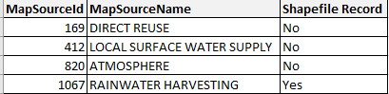

Image 4

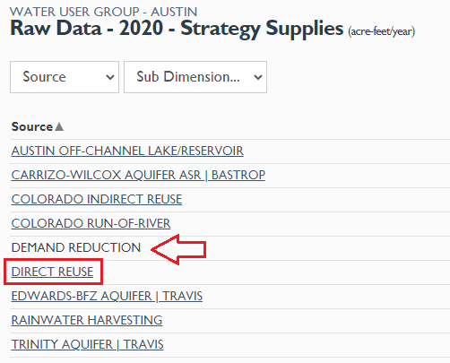

Image 5

