2022 Interactive SWP Phase 2 Updates

Post Test – Part 2

# About Page Update – How do I find the information I’m looking for?

At the bottom of the ‘How do I find the information I’m looking for?’ section, please add the following text:

Wholesale water provider (WWP) contract and sales data is collected, but not displayed in the 2022 Interactive State Water Plan since this application is designed to be a summary of water user group (WUG) data. Water management strategy supply being developed, but not assigned to a specific WUG is also collected and not displayed in the 2022 Interactive State Water Plan because that data is not included in recommended strategy supply totals in the state water plan. Please contact [wrpdatarequests@twdb.texas.gov](mailto:wrpdatarequests@twdb.texas.gov) to request these datasets.

# About Page Update – How do I use the interactive map?

## 2a. How do I use the interactive map section update

Update the bullet show in the image 1 red box to the following text:

Only the following sources are mapped: groundwater, indirect reuse, reservoir, system, run-of-river, and seawater. Sources are mapped using either a point, line, or polygon to the general location of the source which is based on the best information available. For example, the Austin Off-Channel reservoir is mapped to the center of the City of Austin until a more specific location is provided.

Image 1

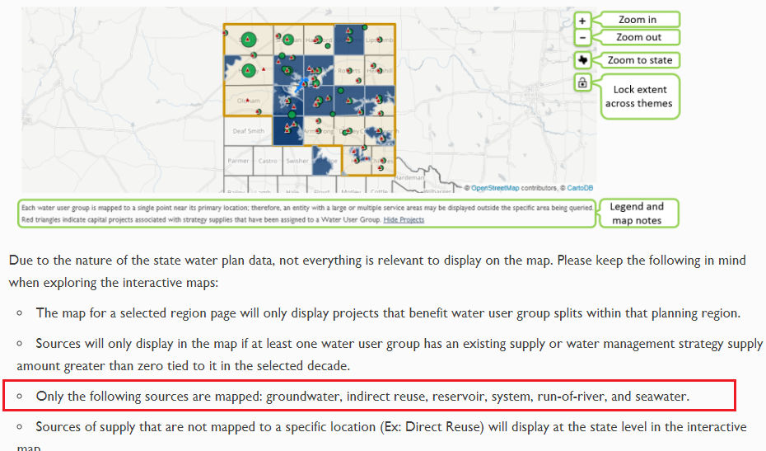

## 2b. How do I use the interactive map section update

Since we have some statewide sources that will not be mapped, we want to update the bullet that references it under the section titled ‘How do I use the interactive map?’ (image 2 – red box) to say:

‘Direct Reuse’, ‘Local Surface Water Supply’, ‘Atmosphere’, and ‘Rainwater Harvesting’ are sources that have their data summarized at the statewide level. Currently, only the ‘Rainwater Harvesting’ source is mapped so that its data will display in the 2022 Interactive State Water Plan source page. The other sources will be mapped in a future version of the 2022 Interactive State Water Plan application. Please contact [wrpdatarequests@twdb.texas.gov](mailto:wrpdatarequests@twdb.texas.gov) if you need a source data summary for ‘Direct Reuse’, ‘Local Surface Water Supply’, and ‘Atmosphere’.

Image

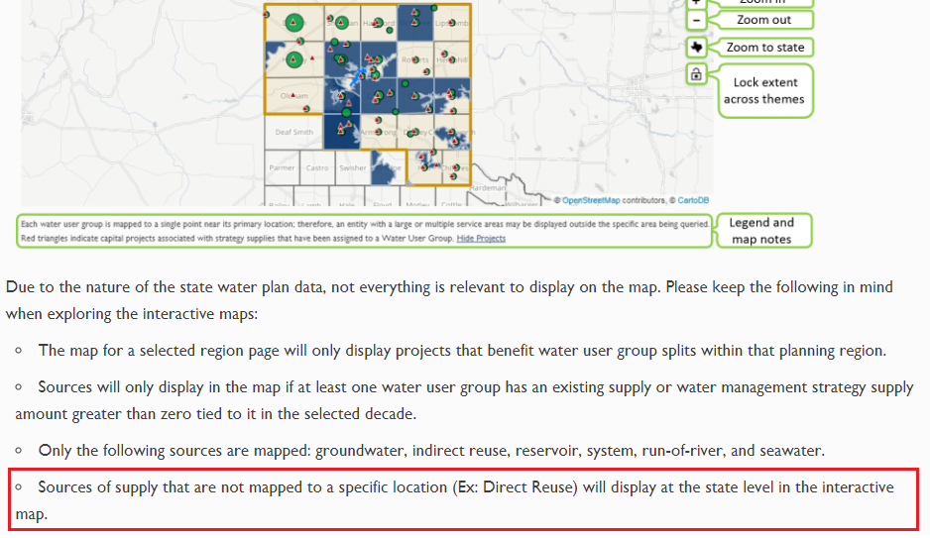

# About Page Update – Where can I access current and previous state water plans?

The ‘Where can I access current and previous state water plans?’ section (image 2) needs to be updated to reflect the addition of the 2022 Interactive State Water Plan. Please add a new first sentence regarding the 2022 iSWP and replace the 2017 iSWP sentence using the ones shown below:

Looking for the most current 2022 Interactive State Water Plan website? View it at <http://2022.texasstatewaterplan.org>.

Looking for the 2017 Interactive State Water Plan website? View it at <http://2017.texasstatewaterplan.org>.

Image

