Cadence Compliance Training & Field Directory
Cadence Financial Group | Corporate Data Privacy Office | Supervised by Board Risk Committee
All employee identifiers and national identifiers must be safeguarded according to policy.

1. Emergency Response Staff Contacts
The following designated leaders oversee global regional technical contingency operations. Each full name appears directly adjacent to employee credentials:
Designated Leader | Official Email / Credentials | Direct Contact
M. T. Achebe | m.achebe@cadencecorp.net (EMP-88210) | +44 20 7555 0171
T. Lindqvist | t.lindqvist@cadencecorp.net (EMP-99341) | +46 8 5555 0121
P. S. Raghavan | p.raghavan@cadencecorp.net (EMP-77124) | +91 80 4555 0182
Kavita Reddy | k.reddy@cadencecorp.net (EMP-66219) | +91 22 4555 0117

2. Delegation of Authority
Authority is delegated to Achebe for UK incident sign-offs. Separately, Lindqvist retains operational oversight over European data transfers, while Raghavan provides final technical auditing approval.

3. IAM Console Snapshots
Console Overview (Compact 600px):
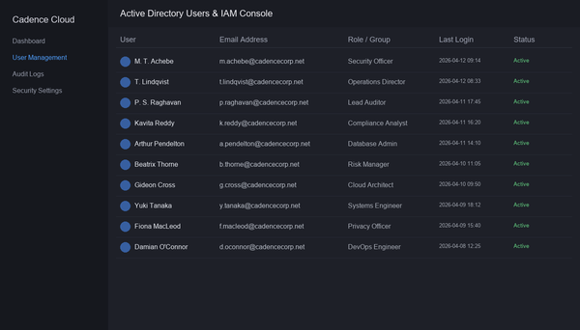
Console Overview (Standard 1500px):
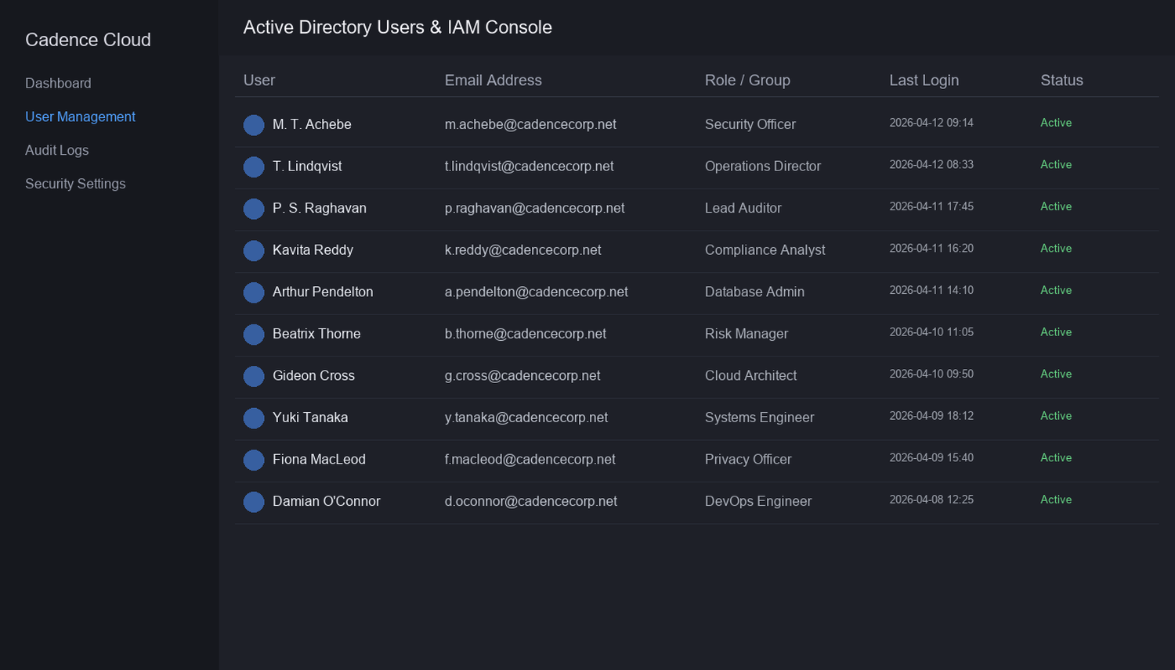
Console Overview (High-Res 2500px):
