Taylor Nairn

8/7/23

1.3 Assignment: Building a Web Page Exercise, Part 1

**GitHub Repository Link:**

<https://github.com/TNairn/csd-340.git>

**Starting Errors:**

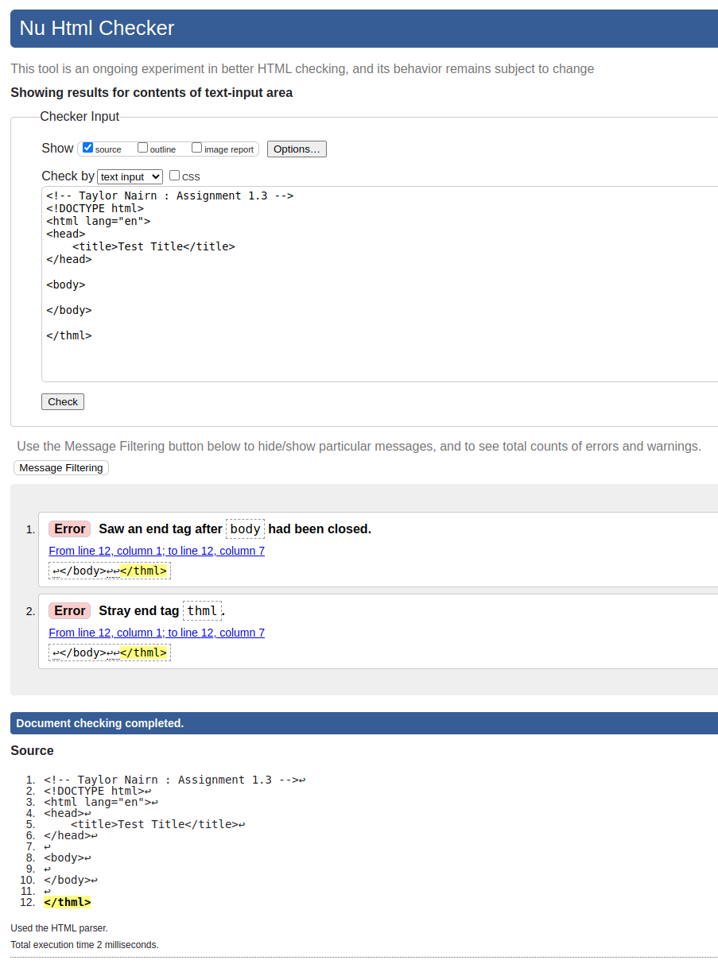

**Errors Corrected:**

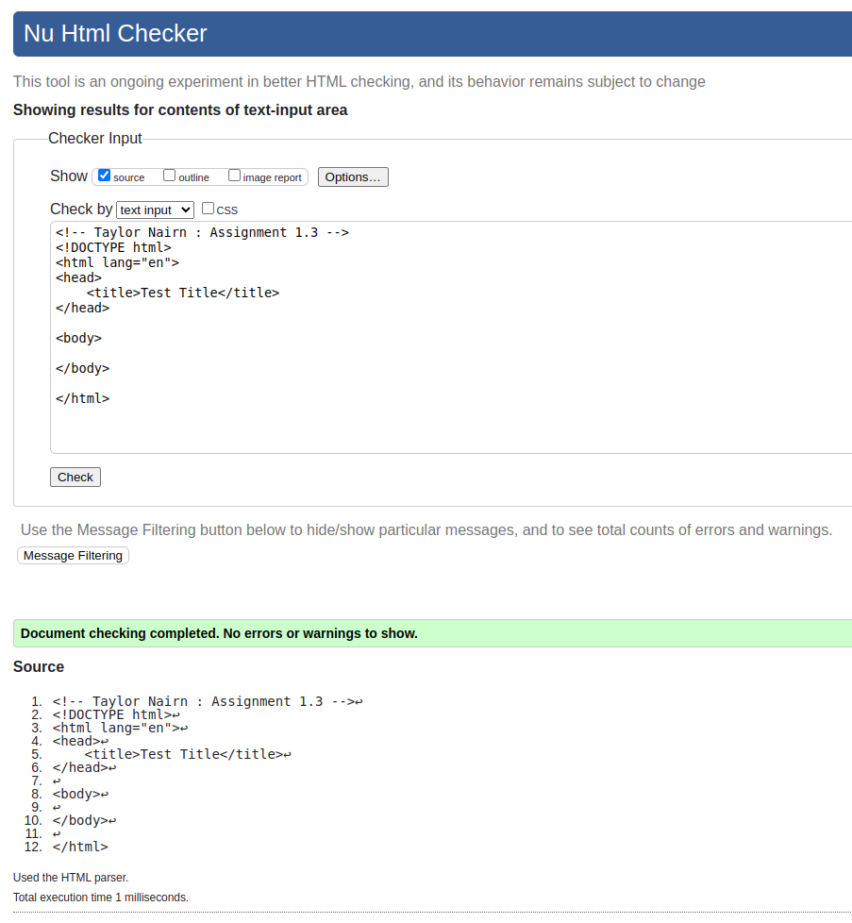

**Changes Made:**

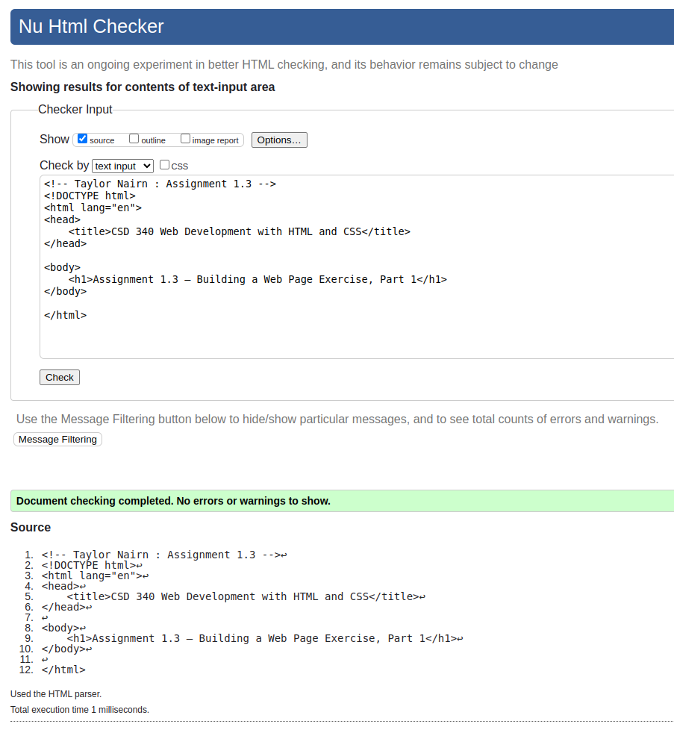

**Open in Browser:**

