Taylor Nairn

8/15/23

Assignment 3.2: GitHub Pages

**GitHub Repository:** <https://github.com/TNairn/csd-340.git>

**GitHub Pages Landing Page:** <https://tnairn.github.io/csd-340/>

**HTML Validation:**

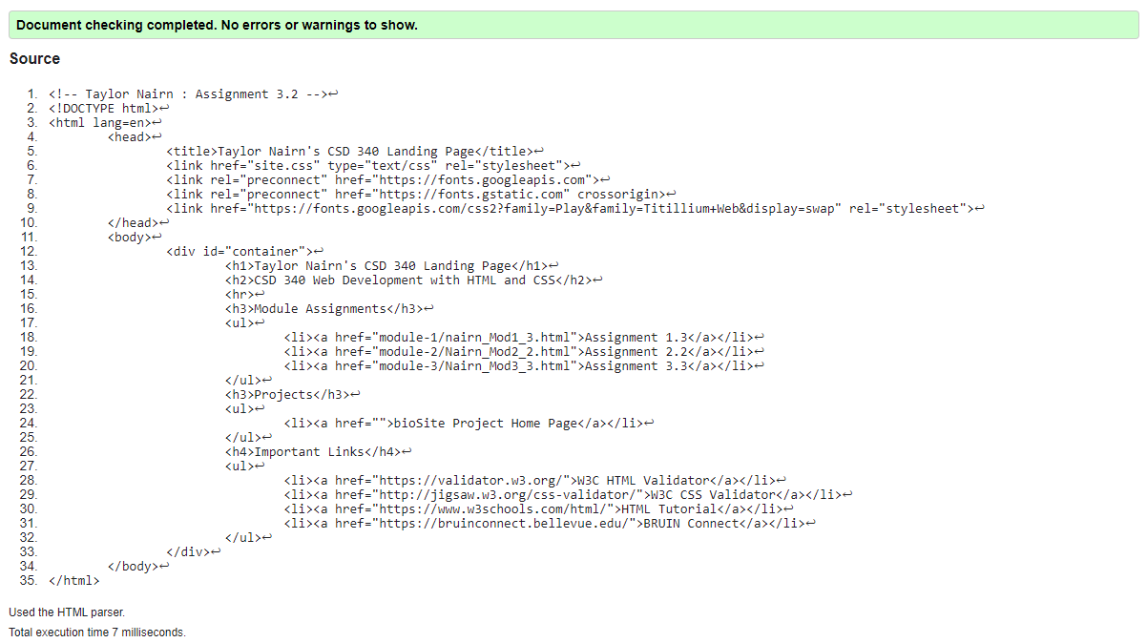

**CSS Validation:**



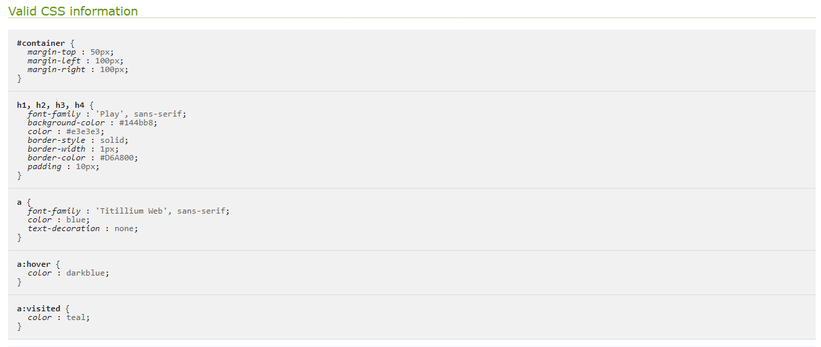

**GitHub Landing Page:**

