Junior Software Engineer Test

**Please Read Carefully Before Beginning**

**Intro**: In lieu of a white board test with LP Technologies, we ask that all applicants complete a quick programming challenge to test their ability. The abilities tested are the following: setting up tooling, read data from databases, interpret and parse data, draw graphics, use of version control.

**Directions**:

1. Included in this zip file is a .sql dump file called test_data.sql. Create a MySQL database (version 5.7.21) on the localhost and import the sql file.
2. Create a program using any language the applicant is familiar with (C++, Python, and JavaScript are used extensively at LPT).
   1. Read each BLOB (trace) from the MySQL database, in sequential order, then draw the data on a 601 point graph.
   2. The program will need to display each trace for 1 second before drawing the next trace.
   3. At the end of the data, the program must return to the beginning of the MySQL data and start again
3. After the program is finished put the source code on GitHub and share with [Support@lptech.com](mailto:Support@lptech.com).
   1. If any special setup is required to run the program include directions in the GitHub project (i.e., what language, what version, what dependencies)

**Time:**

1. This project should take 3 hours or less, though the applicant has as long as the need to finish.
2. Once completed put total amount of time spent in the comments on the main file.

**Resources:**

1. The professional environment is much different than school. You don’t get extra credit at work for knowing rote information. Use any and all resources you have available on the internet.
2. No direct assistance from friends, coworkers, or teachers is allowed.

**Extra Information:**

1. BLOB information:
   1. The BLOBs represent 601 data points that are binary encoded hex and will need to be converted to signed 32 bit integers.
   2. Break each BLOB into 4 byte groups then convert to signed 32 bit integer.
   3. Once the value is interpreted divide by 1000 to get the value to draw (should always be a negative double value).
   4. Example: the first BLOB’s first 4 bytes are **ff ff 33 01** converting to 32 bit signed integer you get **-52479**, divide by 1000 results in **-52.479.**
2. Graphing information
   1. The first BLOB drawn out should look similar to the image below

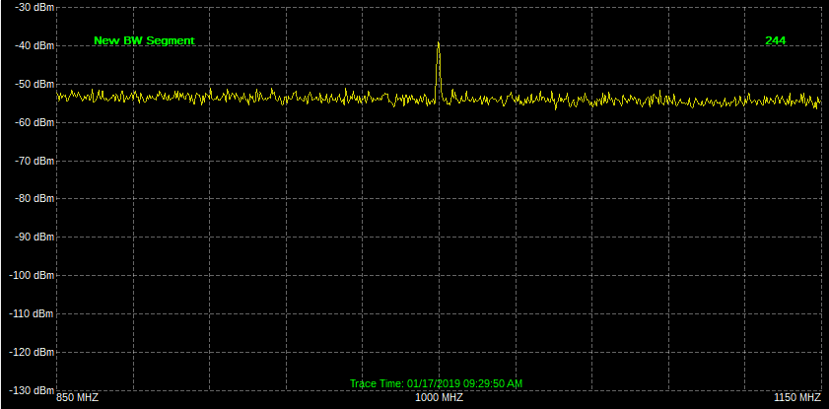

1. Database information:
   1. The SQL file imports a table called test.
   2. In the test table there are 3 Columns: trace_id, trace_data, trace_time.
   3. trace_id starts at 1 and ends at 50, this is the primary key and auto increments.
   4. trace_data holds the BLOB.
   5. trace_time is the timestamp when the BLOB was captured.
   6. There are 50 traces in total, meaning there should be 50 draws before the program resets.

**Grading Criteria:**

1. Clean code practices
2. Well thought out processes
3. Clear and precise comments
4. Completion of challenge
5. Fluidity of drawn graphics

**Items Not Graded:**

1. Language project was coded in
2. Amount of time project took

**Bonus:**

1. Applicants that create the github project and show commit history will receive extra consideration.
2. Applicants that show the timestamps on the graph will receive extra consideration.