Let **A** be a SNP matrix

$$A ∈ {\{0,1,2\}}^{(n × p)}$$

**Power Iteration Algorithm**

**parameter:** A

k <- 0

xk <- N(0, 1)

**while** not converged:

x’k+1 = AATxk

xk+1, _ = TSQR(x’k+1)

k = k + 1

**return** SVD(xk)

**Convergence:**

We measure convergence with two criteria.

1. Successive Ratio of Singular Values (“Q-Values”)
$$\frac{{||S}^{t-1}-S^{t}||}{2\left|\left|S^{t-1}\right|\right|+2|\left|S^{t}\right||}$$

2. Root Mean Squared Error of top k EigenPairs (“RMSE_k”)
   1. This is the metric that FlashPCA2 Uses

$${RMSE}_{K}= {\left[\frac{1}{nK}\sum_{k=1}^{K}{{\left\|\frac{1}{p}AA^{T}u_{k}-u_{k}s_{k}^{2}\right\|}_{2}^{2}}\right]}^{1/2}$$

$$= \frac{1}{\sqrt{nk}}{\left\|\frac{1}{p}AA^{T}u_{1:K}-u_{1:K}s_{1:K}^{2}\right\|}_{F}$$

The relationship between Q-Values and RMSE_K is roughly consistent as follows the trajectory seen in the Figure 1a and Figure 1b. Both figures show the same run. However, figure 1b has an additional plot to show how the RMSE metric relates to the Q-Values metric. (The y scale was removed due to the distortion of squaring RMSE.)

The run was on a 5K by 20K SNP artificially generated matrix with 5 dominate population sub groups. The eigenvalues are roughly as follows:

[74.90554143, 34.5336643 , 34.25206704, 34.14432925, 33.96509327,

11.41418892, 11.40732816, 11.39818389, 11.38732634, 11.37518494]

The Power Method was run for 50 iterations (0 -> 49) to find the top 10 Singular Values. A buffer size of 10 was used. A warm start was used that computed the initial V using 100 rows of the matrix. All computations were performed on my laptop.

We can see that;

$$RMSE ∝ \sqrt{Q Values}$$

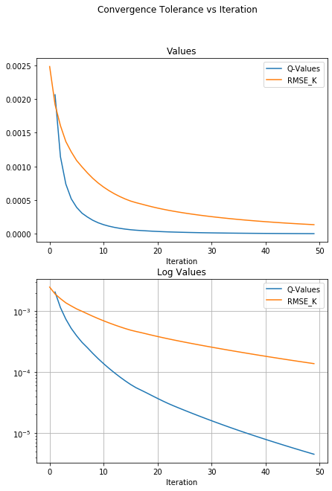

**Figure 1a: RMSE vs Q-Values**

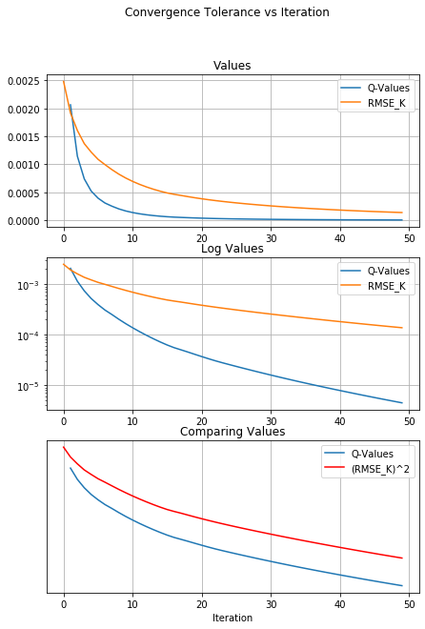

**Figure 1b: RMSE vs Q-Values**

**Large Matrix Testing:**

I ran the **Power Iteration Algorithm** on two large matrices:

* 160K by 640K
  + 102.4 Billion Elements -> 102GBs in Dense Format 1 Byte Integers.
* 120K by 480K
  + 57.6 Billion Elements -> 50Gbs in Dense Format 1 Byte Integers

We expect the 160K by 640K matrix to take roughly twice as long as the 120K by 480K matrix to compute a full pass assuming similar resources.

[NOTE] Standard float and integer in R is 8 Byte. Therefore, would take 8 times more space]

Top 10 Components (k = 10)

Buffer Size of 10 (b = 10)

Full Passes (Not stochastic, p=1)

**Convergence Plots**

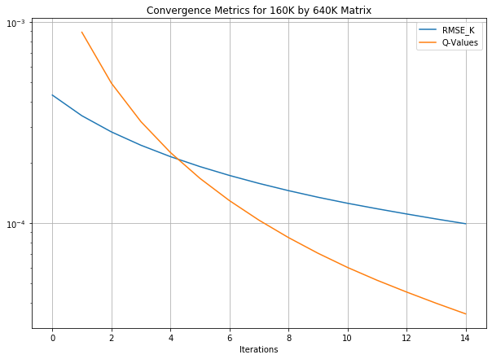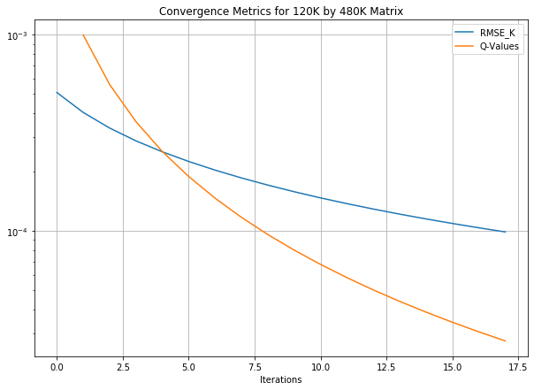

**Runtime Plots**

Runtime for a single iteration.

Allocated Memory was double the amount needed to load the matrix into memory

(To show effect of CPU and not Memory)

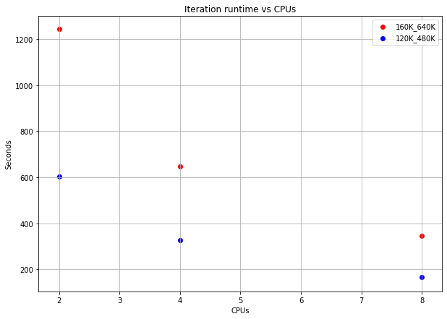

**Growing the Matrix:**

If we are seeking an approximation to the largest *k* singular values and vectors of a matrix, **A**, then purely from a parameter estimation perspective, a subset of the rows of **A** could be sufficient if there is an underlying distribution for the rows of **A**.

**Notion**:

Let **I** be the set of row indices of **A**

$$I=\{1, 2, 3, …,n\}$$

Let **Ii** be the individual disjoint (pairwise) non-empty subsets of **I** whose union is **I.**

$$I= \bigcup_{i}{I_{i}}$$

$∅= I_{i}∩I_{j} ∀ i≠j$

Let **f** be a fractional size of **I**i

**V** **Power Iteration Algorithm**

**parameter:** A

**parameter:** V

k <- 0

xk <- V

**while** not converged:

x’k+1 = AATxk

xk+1, _ = TSQR(x’k+1)

k = k + 1

**return** SVD(xk)

**Successive Stochastic Power Method**

**parameter:** A

**parameter: 0 < f < 1**

create **I**1, **I**2, …, **I**c such that c = 1\f

V0 <- N(0, 1)

**for** i in {1, 2, …, c}:

Ai = A[{**I**1, **I**2, …, **I**i}, :]

Ui, Si, Vi = **V** **Power Iteration Algorithm(**Ai, Vi-1**)**

**If** converged:

**return** Ui, Si, Vi

**return** Uc, Sc, Vc

Comparing the convergence characteristics of the **Successive Stochastic Power Method** (SSPM/SSPI) vs the **Power Method** we see the relationship in the following charts below.

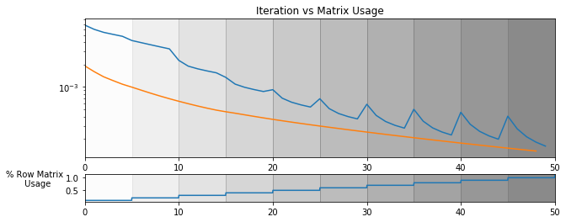

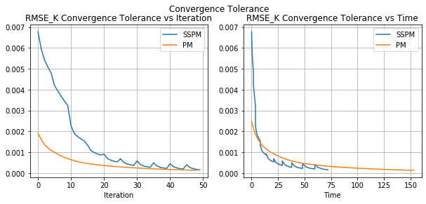

**Figure 2a: SSPM vs PM Convergence**

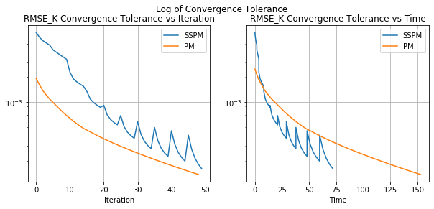

**Figure 2b: SSPM vs PM Convergence**

The SSPM takes more iterations to converge primarily due to the large increase in error when the previous right singular vectors, **V**i-1, are used to seed the next **V Power Iteration**. The explanation for this error increasing so drastically is still unknown. It is worth noticing that the log increase in error when using **V**i-1 to seed the ith iteration of the **V Power Iteration** increases as the overall solution accuracy increases. (This is the increasingly large jump in the RMSE metric every time the array is “grown”). This argues against the idea that the SVD parameters can be learned with a fraction of the observations. However, if this increase in error each time the matrix is “grown” could be decreased then it could be possible to use a small fraction of the matrix to find a great solution for the full matrix. Then when growing the matrix the solution accuracy would not deteriorate as much.

However, the first iterations take much less time than the later iterations which can be seen in the graphs on the right side of the figure. The initial iterations when only 1/10th of the data is being used in the power iterations are almost 10 times faster than the full iterations.

The point of this experiment is to show:

1. Suppose you want to get SVD solutions for a sequence of matrices B_{n \times p} [n = samples, p=features] for different values of p (p increases p1 < p2< p3 <…).
2. Then warm-starting SVDs as we increase p-values costs less than not warm-starting.

I believe that we are scaling up n, [n = samples], for different values of n (n increases n1 < n2 < n3 < …) to find how many samples we need to get a good estimate on V before diminishing returns “start/kick-in”. The dimensions of V are {k \times p} so V should be “blind” to [n = samples].

Warm starting seems to be beneficial. A lot of the information in the right subspace can be captured very efficiently with smaller subsets of the rows of B. (Similarly, this would work for the left hand subspace and subsets of the columns of B).

However, V found from SVD([B1; B2]) seems to have some significant “issue” for warm starting the SVD([B1; B2; B3]). (This is my explanation for the large jump in RMSE error every time the matrix is “grown”. For example, from [B1; B2] -> [B1; B2; B3].