**ONLINE RESTAURENT**

I have developed a user-friendly online restaurant website using HTML that seamlessly guides customers through their dining experience. The website is structured in a two-page format. The first page elegantly presents the restaurant's enticing menu, showcasing a delectable array of dishes. Users can explore the diverse culinary options, each described with enticing details. Once a choice is made, a simple click leads them to the second page dedicated to smooth and intuitive ordering. Here, customers can effortlessly place their orders, providing necessary details like quantity and preferences. The website's minimalist design ensures a seamless journey from menu exploration to order placement, enhancing the overall dining experience for customers seeking convenience and delectable cuisine.

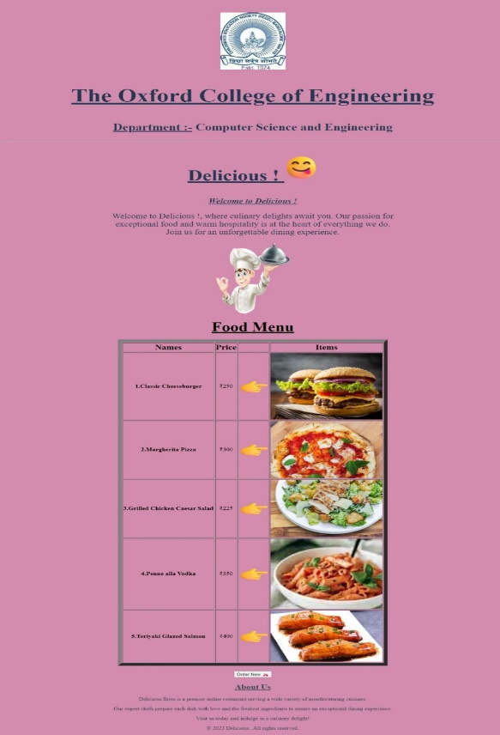 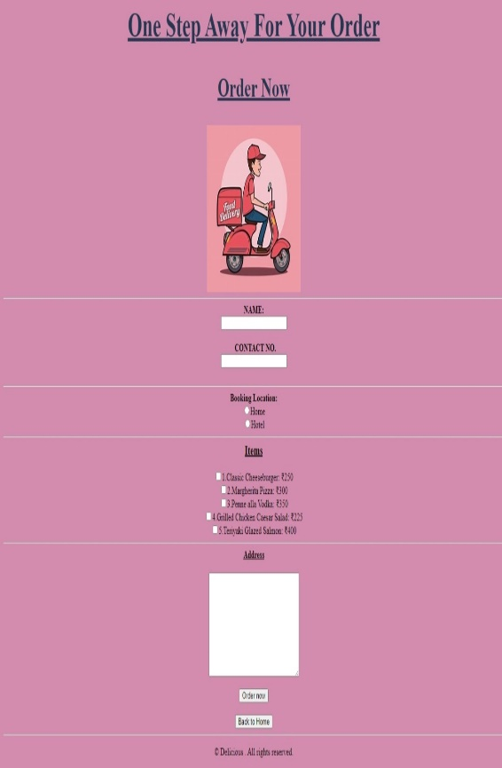

**BOOKMYSHOW CLONE**

I have meticulously crafted a static website using HTML and CSS, closely resembling the popular platform BookMyShow. This clone offers a familiar and user-friendly interface, catering to entertainment enthusiasts. The homepage welcomes visitors with a dynamic layout, displaying featured movies and events, just like the original website. Navigating further, users can explore different categories, each elegantly presented with captivating images and concise descriptions. The seamless integration of CSS ensures a visually appealing experience, with color schemes and fonts mirroring the BookMyShow website .While the website doesn't possess functional backend capabilities, its faithful replication through HTML and CSS offers a snapshot of the BookMyShow experience, providing users with a glimpse of the exciting world of entertainment and ticket booking.

 